Tourism Research Australia crest. 
Australian Government
Australian Trade and Investment Commission
Tourism Research Australia

# Quarterly tourism labour statistics

## TRA summary – June quarter 2025

## Key figures

The number of filled jobs in the tourism sector:

* was 702,800 in the June quarter 2025
* decreased by 3,900 jobs (-0.6%) from March quarter 2025
* the quarterly decline was in line with the seasonal pattern of tourism jobs
* was 30,900 (4.6%) higher than the number of jobs a year ago (June quarter 2024)
* was 21,200 (3.1%) higher than the pre-pandemic peak (tourism jobs peaked at 681,600 in the December quarter 2019)
* represents 1 in 23 filled jobs in the economy (or 4.4%).

Infographic of summary figures stating: 
702,800 filled jobs;
up 21,200 jobs vs. pre-pandemic;
up 30,900 jobs vs 1 year ago;
down 3,900 jobs vs last quarter;
1 in 23 filled jobs in the Australian economy. 

Data provided by the Australian Bureau of Statistics (ABS) – [Tourism Satellite Accounts: quarterly tourism labour statistics, Australia | Australian Bureau of Statistics](https://www.abs.gov.au/statistics/economy/national-accounts/quarterly-tourism-labour-statistics/latest-release)

## Overview

As at 30 June 2025, the tourism sector had 702,800 filled jobs (Figure 1). This represents a slight decline from the previous quarter, down 3,900 jobs (-0.6%)[1]. Compared with the same period last year (June quarter 2024), tourism jobs have increased by 30,900 (4.6%). While there is a minor decrease in jobs since last quarter, the June 2025 figures represent 3 consecutive quarters of progressively stronger year-on-year growth in tourism jobs, which is a positive sign for the sector.

The number of tourism filled jobs in the June quarter 2025 was 12.4% higher than the equivalent pre-pandemic figure (June 2019).

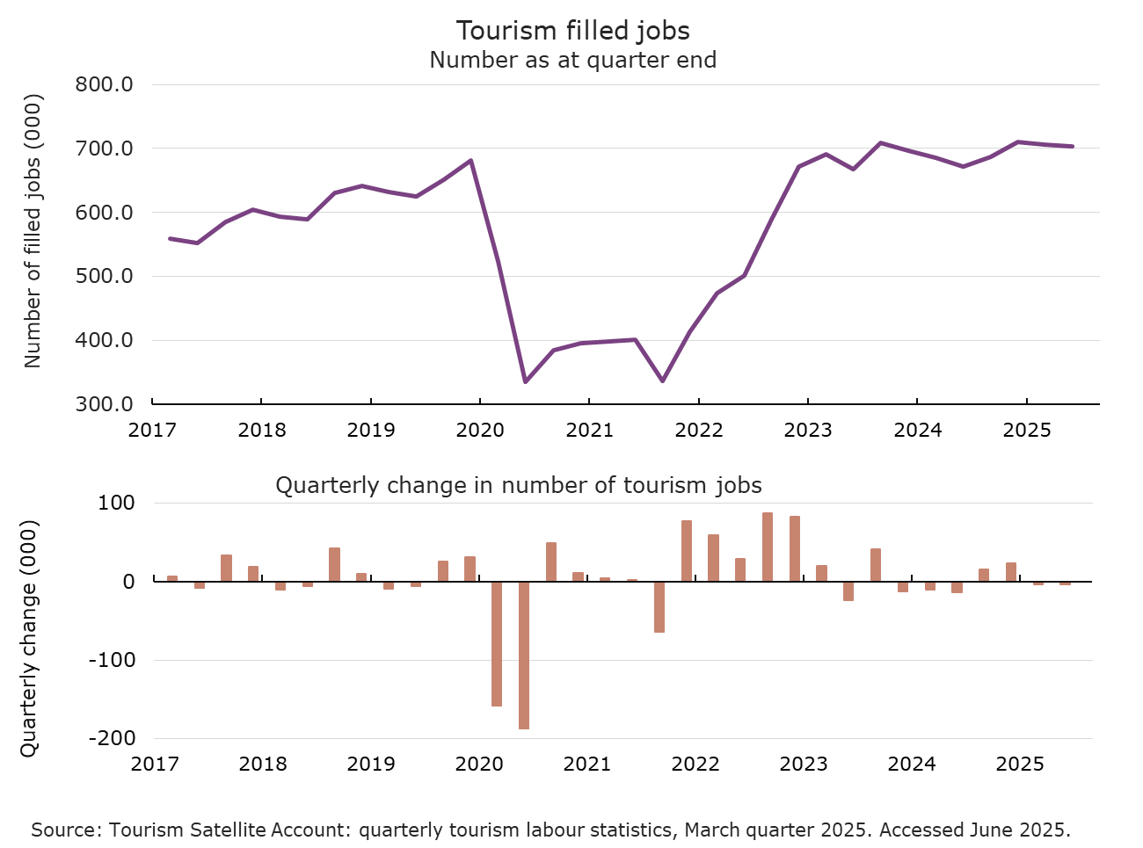**Figure 1.** Number of tourism filled jobs (top panel) and quarterly change (bottom panel), March quarter 2017 to June quarter 2025.

Source: ABS. Tourism Satellite Accounts: quarterly tourism labour statistics, Australia, June 2025. Accessed September 2025.

## Key insights and outlook

Tourism accounted for 4.4% of total filled jobs in the economy in the June quarter 2025, unchanged from recent quarters and only slightly below the pre-pandemic level (4.6% on average in 2019). Tourism jobs have therefore nearly recovered their historical share of total jobs in Australia, supported by faster year-on-year growth in tourism jobs than economy-wide jobs recently. Tourism jobs increased by 4.6% over the past year, while total economy wide filled jobs increased by 1.7% in June quarter 2025 compared with June quarter 2024 (Figure 2).

Tourism Research Australia (TRA) expects tourism job numbers to trend slightly higher going forward in line with the outlook for demand for domestic travel and the ongoing increase in international visitor numbers, which should support tourism-related employment. However, this pace of growth in tourism employment is expected to be modest, including as a result of ongoing labour supply challenges for key occupations within the industry.

**Figure 2.** Economy wide jobs and tourism filled jobs, March quarter 2017 to June quarter 2025.

Chart shows the number of jobs in the entire Australian economy (values on the left axis) and the number of jobs in tourism (values on the right axis) from March 2017 to June 2025 . There are also dotted lines showing the peak number of jobs in 2019 for each of the two series for comparison. Data sourced from the Australian Bureau of Statistics (ABS) Tourism Satellite Account: quarterly tourism labour statistics.

### Tourism jobs by sector

In the June quarter 2025, most tourism-related industries (9 of the 12 industries) recorded small declines in filled jobs compared with the previous quarter. The tourism-related industries with the largest decreases in jobs in the June quarter 2025 were: retail trade (down 2,200 jobs, -1.8%), travel agency and information centre services (down 1,300 jobs, -4.8%) and accommodation (down 1,000 jobs, -0.8%).

Two tourism-related industries recorded increases in the number of filled jobs in the June quarter 2025. These were the ‘cafés, restaurants and takeaway food services’ (up 2,000 jobs, +1.0%) and ‘air, water and other passenger transport’ (up 700 jobs, +2.2%) industries.

Over the past year, the increase in tourism filled jobs was led strongly by increases in the accommodation (up 20,300 jobs, 19%) industry. This industry alone accounted for 66% of the increase in jobs for all tourism-related industries combined between June 2024 and June 2025.

There were also substantial increases in the ‘education and training’ (up 5,800 jobs, 12%), ‘cafes, restaurants and takeaway food services’ (up 3,900 jobs, +1.9%), ‘sports and recreation services’ (up 2,500 jobs, 7.3%), and ‘air, water and other passenger transport’ (up 1,800 jobs, +5.8%) industries.

On the other hand, 4 industries experienced declines in tourism filled jobs between June 2024 and June 2025 (Figure 3).

**Figure 3.** Change in tourism filled jobs, by tourism-related industry, over the period from June quarter 2024 to June quarter 2025 (i.e. change over the year).

Chart shows the change in the number of tourism filled jobs from June quarter 2024 to June quarter 2025 by tourism-related industry. It also shows the change over this period, by tourism-related industry, as a percentage. Data sourced from the Australian Bureau of Statistics (ABS) Tourism Satellite Account: quarterly tourism labour statistics.

While the total number of tourism filled jobs was higher in June 2025 than it was at the end of 2019 (before the pandemic), filled jobs in several tourism-related industries remain below their pre-pandemic level (Figure 4). These industries and number of filled jobs compared to pre-pandemic levels include:

* Air, water and other passenger transport (11,300 fewer jobs, -25%)
* Clubs, pubs, taverns & bars (3,000 fewer jobs, -7%)
* Education and training (1,700 fewer jobs, -3%)
* Cultural services (1,400 fewer jobs, -11%)
* Casinos and other gambling services (500 fewer jobs, -19%).

The delayed recovery in these industries indicates ongoing challenges from recent economic conditions, workforce and skills shortages, changing customer preferences and potentially some lingering pandemic effects.

**Figure 4.** Change in tourism filled jobs, by tourism-related industry, over the period from December quarter 2019 to June quarter 2025 (i.e. change from pre-pandemic peak).

Chart shows the change in the number of tourism filled jobs from December quarter 2019 to June quarter 2025 by tourism-related industry. It also shows the change over this period, by tourism-related industry, as a percentage. Data sourced from the Australian Bureau of Statistics (ABS) Tourism Satellite Account: quarterly tourism labour statistics.

### Tourism job characteristics

The decline in tourism jobs in the June quarter 2025 relative to the previous quarter was led by a fall in the number of full-time tourism jobs (down 9,500 jobs, -2.7%), which was only partly offset by an increase in the number of part time jobs (up 5,600 jobs, +5.6%). Full-time jobs are now up by 4,300 (1.2%) compared with the pre-pandemic peak, while part-time jobs are up by considerably more (up 16,900 jobs, 5.0%).

As was the case in the March quarter 2025, in the June quarter 2025, tourism main jobs increased (by 800 jobs, 0.1%), while tourism secondary jobs decreased (by 4,700 jobs, -8%). The number of tourism main jobs has now increased in 4 consecutive quarters and were 31,600 higher in the June quarter 2025 than in the June quarter 2024, up by 5.1%.

As a result, the share of secondary jobs in tourism declined sharply in the June quarter 2025 (Figure 5). The secondary job share for the economy overall has also trended lower recently. Secondary jobs account for a larger share of tourism jobs than they do in the overall economy – 7.9% of jobs in the June quarter 2025 for tourism and 6.5% of economy-wide jobs.

**Figure 5.** Share of secondary jobs in tourism and in the whole economy. March quarter 2017 to June quarter 2025.

Chart shows the number of tourism jobs classified as main jobs or secondary jobs from March 2017 to June 2025. The number of main jobs is signficantly higher than the number of secondary jobs. On the lower panel, the secondary job share of total filled jobs in tourism and for the economy as a whole are shown. These shares have been trending lower for the past 2 quarters and the tourism secondary job share is higher than the economy-wide secondary job share . Data sourced from the Australian Bureau of Statistics (ABS) Tourism Satellite Account: quarterly tourism labour statistics.

1. The June quarter is typically a seasonal low for tourism jobs, while December is the seasonal high. In the June quarters of 2023 and 2024, tourism filled jobs declined by 23,500 (-3.4%) and 14,000 (-2.0%) respectively from the previous quarter.