Travel by australians

Year Ending September 2020
OVERNIGHT SPEND |  | OVERNIGHT TRIPS |  | NIGHTS
FIGURE | % | FIGURE | % | FIGURE | %
$51.9 billion | Down 34% | 80.3 million | Down 31% | 300.0 million | Down 27%
September Quarter 2020
OVERNIGHT SPEND |  | OVERNIGHT TRIPS |  | NIGHTS
FIGURE | % | FIGURE | % | FIGURE | %
$9.7 billion | Down 53% | 16.5 million | Down 42% | 62.2 million | Down 40%

Results for the year ending September 2020 continue to show the impacts of a year devastated by bushfires and the COVID-19 pandemic. Domestic overnight trips fell 31% to 80.3 million resulting in a decline in spend of 34% or $27.2 billion to $51.9 billion.
With intrastate travel leading the way, September quarter 2020 showed some encouraging signs relative to June quarter 2020. While spend was down 53% or $11.1 billion to $9.7 billion and overnight trips fell 42% to 16.5 million this was a marked improvement on the 80% and 67% falls in spend and overnight trips in the June quarter.
Larger declines in spend than trips continued to be observed in the September quarter. This can be attributed to continued border closures negatively impacting the lucrative interstate market, a second wave of COVID-19 in Victoria stifling improvement at the national level and social distancing measures limiting the capacity for travellers to undertake a range of activities.
Year to date (January – September 2020) losses for domestic overnight travel amount to $28.8 billion. Adding to this losses of $7.3 billion for domestic day travel sees a total loss of $36.1 billion for domestic tourism when compared to the same period in 2019 (Table 1). Additionally, international travel observed losses of 68% or $23 billion, bringing the overall loss for Australian tourism in the year to date to $59.1 billion.

TABLE 1: DOMESTIC TRAVEL, JANUARY TO SEPTEMBER

spend ($ billions)
 | 2019 | 2020 | Change
Overnight | 60.3 | 31.5 | -48%
Day Trip | 19.3 | 12.0 | -38%
Total | 79.6 | 43.5 | -45%

Visitors (millions)
 | 2019 | 2020 | Change
Overnight | 88.0 | 50.8 | -42%
Day Trip | 186.2 | 116.6 | -37%
Total | 274.2 | 167.4 | -39%

In a boost to tourism operators across the nation, early national data on domestic overnight trip rates suggest there will be a noticeable improvement in the December quarter 2020 (Figure 1). While this is likely to extend through the peak Christmas and New Year holiday season in many areas, an impact can be expected from the onset of a COVID-19 outbreak in Sydney leading into Christmas.
FIGURE 1: DOMESTIC OVERNIGHT TRIPS AND TRIP RATES, JANUARY TO DECEMBER 2020¹
¹ The trip rate for December is based on interviews undertaken in week 1 and week 2 only.

INTERSTATE and INTRASTATE TRAVEL
During the September quarter 2020, there were changes made to border closures and restrictions. These saw most states and territories ease restrictions to varying degrees allowing increased travel movements particularly within state borders.
This led to improved results in the September quarter 2020 that were driven by intrastate travel. In many states including QLD, WA, TAS and NT intrastate trips and/or spend were on par or up in September quarter 2020. In contrast, the large domestic tourism markets of Victoria (with its second wave lockdown) and NSW continued to see large falls in intrastate trips and spend in September quarter 2020 (Figure 2).
While nationally intrastate trips still fell 20% or 3.6 million and spend was down by just 2% or $203 million, these declines were much less than those observed for interstate travel. Interstate trips were down 83% or 8.2 million to 1.7 million and spend 87% or $10.9 billion to $1.6 billion.
FIGURE 2: INTRASTATE PER CENT CHANGES IN OVERNIGHT TRIPS AND SPEND, BY STATE, SEPTEMBER QUARTER 2020²² Due to an insufficient sample of intrastate visitors, the ACT is not shown.

Capital Cities and Regional Travel
Although there were still declines in the September quarter 2020, regional areas continued to fare better than capital cities (Figure 3). Regional areas have not only benefited from being less reliant on interstate travel but from those in capital city population centres looking to enjoy a break in their home state as COVID-19 constraints continue to ease.
Overall, overnight trips to regional areas declined 29% to 12.3 million and spend fell 32% to $7.4 billion in September quarter 2020. In comparison, overnight trips to capital cities fell 63% to 4.6 million and spend was down 77% to $2.3 billion.
FIGURE 3: PER CENT CHANGE IN OVERNIGHT TRIPS TO CAPITAL CITIES AND REGIONAL AREAS, JUNE AND SEPTEMBER QUARTERS 2020

Purpose of Visit
Although the impacts of COVID-19 continue to be significant across all reasons for travel, the September quarter showed improvement in comparison to the June quarter 2020. While holiday travel still saw a fall of 32% in overnight trips (3.4 million) and a fall of 46% in spend ($4.7 billion), this was a much better result than the 78% and 87% falls in overnight trips and spend observed in the June quarter.
During the January to September 2020 period domestic overnight spend fell 48% to $31.5 billion. This included losses of 44% or $12.8 billion for holiday, 50% or $5.8 billion for those visiting friends and family (VFR) and 56% or $9.4 billion for business (Figure 4).
FIGURE 4: CHANGE IN DOMESTIC OVERNIGHT TRIPS AND SPEND, JANUARY TO SEPTEMBER 2020

STATE OF RESIDENCE
Due to the varied border restrictions across Australia, the ability of those from different states and territories to travel domestically has been impacted differently. In the year to date (January to September 2020) Victorians have had the largest decline in the taking of both overnight (-56%) and day trips (-51%). This is largely due to the lockdown imposed on Victorians as a result of a second wave of COVID-19. In comparison, with less rigorous restrictions on intrastate travel Western Australians and Northern Territorians have seen the lowest rate of decline in overnight trips (-25%) and South Australians the lowest rate of decline in day trips (-21%) (Figure 5).
FIGURE 5: PER CENT CHANGE IN OVERNIGHT AND DAY TRIPS BY STATE OF RESIDENCE, JANUARY TO SEPTEMBER 2020

AccomModation
Visitor nights fell 27% for the year ending September 2020 and 40% or 41.4 million nights for the September quarter 2020. Due to their reliance on interstate and business travel, hotels, motels and resorts observed the largest decline in the September quarter 2020, with a fall in nights of 58% or 16.0 million, down to 11.8 million.
Nights spent in rented apartments and units were down 23% or 1.8 million to 5.9 million, while nights spent in caravan parks and commercial camping grounds fell 35% or 3.6 million to 6.5 million. There was also a 39% or 12.4 million fall in nights spent at a friend or relatives property (Figure 6).
FIGURE 6: PER CENT CHANGE IN NIGHTS BY ACCOMMODATION TYPE, YEAR ENDING SEPTEMBER AND SEPTEMBER QUARTER 2020

ACTIVITIES
COVID-19 continued to have an impact on the travel activities undertaken in the September quarter 2020. As seen in June quarter 2020, overnight trips involving outdoor activities fared better. Participation in these types of activities ranged from declines of 27% for visiting beaches and national and state parks to increases of 11% for cycling and 15% for surfing compared to the September quarter 2019. In contrast, overnight trips involving activities impacted more by social distancing measures showed larger declines. These ranged from 57% for dining out to declines of 92% for attending the theatre, concerts, festivals and events (Figure 7).
FIGURE 7: PER CENT CHANGE IN OVERNIGHT TRIP ACTIVITIES, SEPTEMBER QUARTER 2020

TRAVEL MODE
When compared with the same period in 2019, the two quarters hardest hit by the COVID-19 pandemic (June and September 2020) have seen a significant change in the travel modes used for domestic overnight trips. Travel by self-drive vehicle accounted for 90% (24 million) of all domestic overnight trips in the June and September 2020 quarters up from 72% on the same period in 2019. In contrast, overnight trips involving air travel accounted for only 7% (1.8 million) in the June and September 2020 quarters, down from 25% in 2019.

STATES AND TERRITORIES
With COVID-19 effects from March 2020 onwards, all states and territories had a fall in overnight visitors and spend for the year ending September 2020 (Figure 8).

FIGURE 8: OVENIGHT TRIPS AND SPEND BY STATE, YE SEPTEMBER 2020³
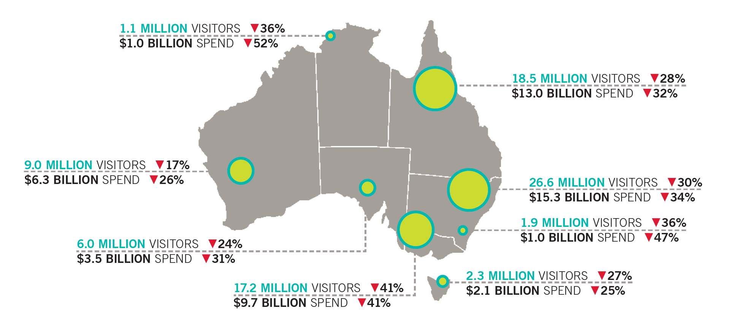
³ The sum of the total number of visitors for each state will be greater than the total number of visitors for Australia due to individuals who visited more than one state.

