


Know

NATIONAL VISITOR SURVEY RESULTS


DECEMBER QUARTER 2024

December quarter 2024

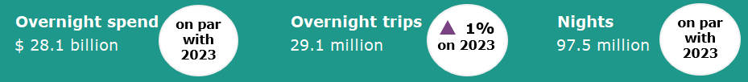

Year ending December 2024
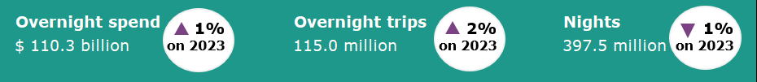

Domestic tourism results remain stable
Domestic tourism results remained stable in the December quarter 2024 when compared with the same quarter last year. Overnight visitor spend and nights away were flat, while overnight trips were up 1%. Business travel spend increased, supported by an increase in business trips. In contrast, while trips for holiday purposes increased, holiday travel spend fell. This suggests Australians remain eager to undertake holiday travel, while being more cautious with their spending.
The Year ending December 2024 saw a similar pattern of results. Spend was up 1%, overnight trips were up 2% and nights were down 1%, when compared with the year ending December 2023. The results for the December quarter 2024 and the Year ending December 2024 continue to show that domestic travel growth remains stable. Consistent with previous quarters, the results indicate that while Australians continue to travel, they are taking shorter trips to reduce costs.
Figure 1. Percent change for spend, trips and nights compared the same period in the previous year, March quarter 2024 to December quarter 2024

Travel to capital cities
December quarter 2024 saw positive results for travel to capital cities. Spend was up $264 million or 2%, overnight trips were up 59,000 or 1% and nights away were up 426,000 or 1%, compared with the December quarter 2023 (Figure 3). Travellers to capital cities spent more per trip in the December quarter 2024 than in the same period last year, with average spend up by 1% to $1,211 per trip (from $1,194).
This was offset by softer results for travel to regional Australia in the December quarter 2024. In the regions, while overnight trips were up 361,000 or 2%, spend was down $244 million or 2% and nights away were down 383,000 or 1% compared with the December quarter 2023.
Figure 3: Change in capital city and regional Australia spend, trips and nights, December Quarter 2024 compared with December Quarter 2023

Reason for travel*
Business travel spend continued to strengthen, however this was partially offset by softer holiday travel spend in the December quarter 2024 (Figure 2). Business travel spend was up $276 million or 4% to $7.8 billion, supported by an increase in business trips which were up 221,000 or 3% to 6.9 million. This was partially offset by softer holiday travel spend, which was down $562 million or 4% compared with the December quarter 2024. The number of trips for holiday purposes increased by 3%.
Figure 2: Travel by reason, December quarter 2024 compared to the December quarter 2023

* Main reason used for trip expenditure, stopover reason used for trips and nights.

States and territories
At a state and territory level, results for overnight trips and spend were mixed in the year ending December 2024 when compared with the year ending December 2023 (Figure 4).
Increases in spend were seen in New South Wales (up $810 million or 3%), Queensland (up $793 million or 3%) and South Australia (up $40 million or 1%). This was offset by decreases in Western Australia (down $563 million or 5%), Tasmania (down $37 million or 1%), the Northern Territory (down $21 million or 1%), Australian Capital Territory (down $28 million or 1%) and Victoria (down $10 million or broadly flat in percentage terms).
Increases in trips were observed in all states and territories, except for Western Australia and the Australian Capital Territory.
Figure 4. Overnight trips and spend by state and territory, year ending December 2024 compared to year ending December 2023
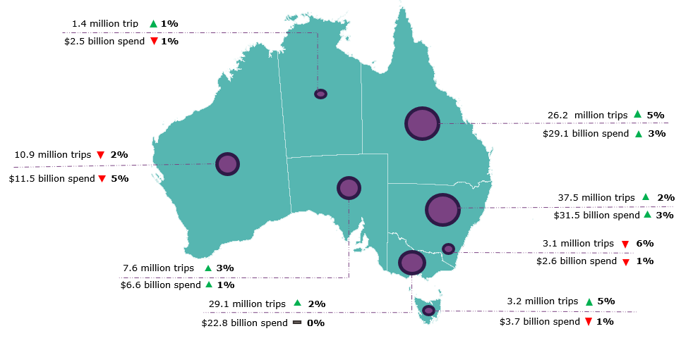

Daytrips
In the Year ending December 2024, Australians took 200.6 million daytrips and spent $30.7 billion during those day trips. Compared with the year ending December 2023 this was:
- down 15.6 million or 7% for trips
- down $2.3 billion or 7% for spend.

This report has been prepared by the Commonwealth of Australia represented by the Australian Trade and Investment Commission (Austrade). The report is a general overview and is not intended to provide exhaustive coverage of the topic. The information is made available on the understanding that the Commonwealth of Australia is not providing professional advice. While care has been taken to ensure the information in this report is accurate, the Commonwealth does not accept any liability for any loss arising from reliance on the information, or from any error or omission, in the report.

