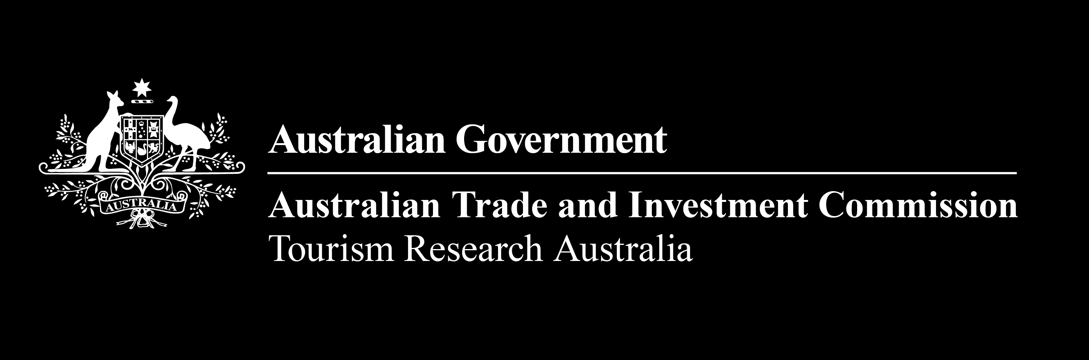


Visitor Economy Profile 2025: Vietnam

Vietnam is Australia’s 16th largest inbound market. In 2025 Vietnam saw a -5% year-on-year decrease in visitation, and a 9% increase in spend in Australia.

Visitor numbers
- Total visitors: 164,990
- Change vs last year: -5%
- Rank: 16th

Visitor group type
- Solo traveller: 64% (Total INT: 54%)
- Adult couple: 15% (Total INT: 20%)
- Family and or friends’ group: 21% (Total INT: 23%)
- Other: 1% (Total INT: 3%)

*Total INT = The average for total international visitors to Australia

Visitor spend
- Average visitor spend: $5,891
- Total spend in Australia: $906.4 million
- Change in total spend vs last year: +9%

Visitors from Vietnam are forecast to grow to 205,000 in 2030. Half of Vietnamese visitors visit friends and relatives, predominately visiting New South Wales and Victoria.

Forecast visitor growth
Table 1: Forecast visitors to Australia, from 2015 to 2030
Year | Vietnamese visitors to Australia
2015 | 58,000
2016 | 70,000
2017 | 94,000
2018 | 111,000
2019 | 123,000
2020 | 28,000
2021 | 1,000
2022 | 70,000
2023 | 167,000
2024 | 173,000
2025 | 163,000
2026 | 169,000
2027 | 179,000
2028 | 188,000
2029 | 197,000
2030 | 205,000

Main reason for visitation
Table 2: Main reason for visitation
Reason | Number of visitors from Vietnam | Percentage of visitors from Vietnam | Total INT percentage of visitors*
Visiting Friends or Relatives (VFR) | 76,500 | 50% | 34%
Holiday | 38,970 | 25% | 43%
Education | 20,550 | 13% | 7%
Business | 9,260 | 6% | 9%
Employment | 3,810 | 2% | 4%
Other | 4,780 | 3% | 3%

Where visitors stay
Table 3: Where visitors stay
Location | Percentage of visitors from Vietnam | Total INT percentage of visitors*
Capital cities & Gold Coast | 95% | 92%
Rest of Australia | 15% | 29%
New South Wales | 49% | 50%
Victoria | 42% | 34%
Queensland | 13% | 29%
Western Australia | 11% | 13%
South Australia | 9% | 5%
ACT | 6% | 2%
Northern Territory | 2% | 3%
Tasmania | 1% | 3%
Vietnamese visitors stay longer compared to the average international visitor. Visitors from Vietnam are more likely to be returning visitors. Key demand-driving experiences include eating out, shopping, going to the beach and markets.

Nights stayed
Table 4: Nights stayed
Nights | Percentage of visitors from Vietnam | Total INT percentage of visitors*
1–7 nights | 23% | 34%
8–14 nights | 26% | 23%
15–30 nights | 17% | 17%
31 or more nights | 35% | 25%

Visitor experience rating and trip type
- Positive trip sentiment (7+ out of 10): 94% (Total INT: 97%)
- First trip to Australia: 31% (Total INT: 41%)
- Return trip to Australia: 69% (Total INT: 59%)

What visitors do
Table 5: What visitors do
Activity | Percentage of visitors from Vietnam | Total INT percentage of visitors*
Eat out / dine at a restaurant and/or cafe | 90% | 88%
Go shopping for pleasure | 84% | 76%
Sightseeing/looking around | 64% | 73%
Go to the beach | 62% | 63%
Go to markets | 56% | 46%
Visit botanical or other public gardens | 49% | 42%
Visit national parks / state parks | 43% | 45%
Visit museums or art galleries | 37% | 35%
Visit history / heritage buildings, sites or monuments | 30% | 30%
Visit wildlife parks / zoos / aquariums | 26% | 34%

Aviation capacity from Vietnam continued growing in FY2024-25, significantly above historic levels, however load factors have declined slightly year on year. Almost 520,000 Australians visited Vietnam in 2025, an increase of 19% on 2024.

Aviation capacity
Table 6: Aviation capacity
Year | Passenger Load Factor | Seats Available
2015–16 | 84% | 202,828
2016–17 | 79% | 231,960
2017–18 | 80% | 352,634
2018–19 | 81% | 353,792
2019–20 | 84% | 259,287
2020–21 | 9% | 22,884
2021–22 | 49% | 95,722
2022–23 | 88% | 407,089
2023–24 | 79% | 772,470
2024-25 | 78% | 889,230

Australians in Vietnam
- Australians in country: 519,780
- Vietnamese residents coming into Australia: 164,990
- NET visitor balance: -354,790

Data sources
- Tourism Research Australia, International Visitor Survey (IVS)
- Australian Bureau of Statistics, Overseas Arrivals and Departures
- Tourism Research Australia, forecasts (arrivals to Australia forecasts)
- Bureau of Infrastructure and Transport Research Economics, Aviation Statistics
Data may not sum to 100% for all measures due to rounding and visitors can visit more than one location and/or experienced more than one activity. Updated March 2026.
Prepared by Tourism Research Australia, Australian Trade and Investment Commission (Austrade).
Visit the Tourism Research Australia website at: www.tra.gov.au.
Email us at: Tourism.Research@tra.gov.au

