INTERNATIONAL VISITOR SURVEY RESULTS

JUNE QUARTER 2024

## June quarter 2024

In June quarter 2024,
Spend in Australia was $6.5 billion, 115% of 2019 levels
Number of trips were 1.6 million, 88% of 2019 levels
Nights spend in Australia were 60.5 million, 112% of 2019 levels
Total trip spend was $9.6 billion, 117% of 2019 levels

## Year ending June 2024

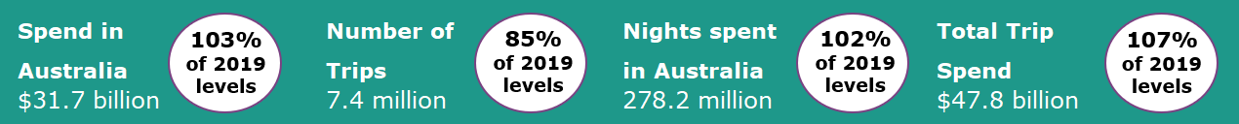

**Quarterly international tourism spend exceeds pre-COVID levels**

The June quarter 2024 international tourism results saw spend in Australia exceed pre-COVID levels. Spend in Australia reached 115% pre COVID levels (up from 99% in March quarter 2024) driven by travel for education and business-related purposes. The continued recovery of travel from China also supported growth. Nights spent in Australia reached 112% of pre-COVID levels (compared to 105% in the March quarter 2024), while trips were slightly down at 88% of pre-COVID levels (compared to 89% in the March quarter 2024) due to relatively fewer holiday travellers.

The 2023-24 financial year results saw international tourism to Australia continue to approach pre-COVID levels. Spend, trips and nights away all saw improvements as a percentage of pre-COVID levels, relative to year ending March 2024 as a percentage of pre-COVID levels.

**Figure 1: Percentage of spend, nights and trips in Australia compared to 2019 levels, June quarter 2023 to June quarter 2024**

**Education and Business travel supports growth**

June quarter 2024 results were supported by an unseasonal increase in visitors here for education and business purposes, offset by softer results for travel by those here for the purposes of a holiday or visiting friends and relatives. When compared with March quarter 2024, the results for the June quarter 2024, as a percentage of pre-COVID levels, saw:

* Trips for education purposes increase by 18%
* Trips for business purposes increase by 20%

This was partially offset by:

* Trips for visiting friends and relatives decrease by 11%
* Trips for holiday travel decrease by 3%

**Figure 2: Percentage of trips in Australia by selected purpose compared to 2019 levels, June quarter 2023 to June quarter 2024**

## Top 5 Visitor Markets

In the 2023-24 financial year, the top 5 visitor markets were New Zealand, China, the United States of America, the United Kingdom and India. China saw the largest improvement as a percentage of pre‑COVID levels on a year-ending basis, compared with last quarter’s data, with spend at 77% (up from 73%), trips at 56% (up from 51%) and nights at 74% (up from 68%). China was also the largest contributor to spend in Australia in 2023-24, making up 24% of the total, followed by the United Kingdom at 6.7% and New Zealand and the United States of America both contributing 6.5%.

Australia’s top 5 international visitor markets in the 2023-24 financial year were (2019 comparison in brackets):

1. New Zealand with:

* 1.2 million trips (97%)
* $2.1 billion spent (129%)
* 14.2 million nights (111%)

2. China

* 746 thousand trips (56%)
* $7.6 billion spent (77%)
* 41.9 million nights (74%)

3. United States of America with:

* 670 thousand trips (88%)
* $2.1 billion spent (104%)
* 11.5 million nights (88%)

4. United Kingdom with:

* 581 thousand trips (86%)
* $2.1 billion spent (112%)
* 21.2 million nights (98%)

5. India with:

* 395 thousand trips (113%)
* $1.4 billion spent (113%)
* 25.4 million nights (115%)

**Figure 3. Top 5 markets by spend in Australia (percentage of 2019 levels), year ending June 2021 to year ending June 2024**

## States and Territories

In the 2023-24 financial year, over half of the states and territories saw improvements in spend and trips compared with the year ending March 2024.

New South Wales (108%, up from 105%), Victoria (95%, up from 91%), Queensland (103%, up from 102%), Tasmania (96%, up from 85%) and the Northern Territory (96%, up from 83%) all saw increases in the 2023-24 spend results as a proportion of pre COVID levels compared with the year ending March 2024 results. This was partially offset by South Australia (119%, down from 120%), Western Australia (107%, down from 111%) and the Australian Capital Territory (94%, down from 96%).

**Figure 4. Number of trips and spend in Australia by state and territory, year ending June 2024 & year ending March 2024 (as percentages of 2019 levels)**

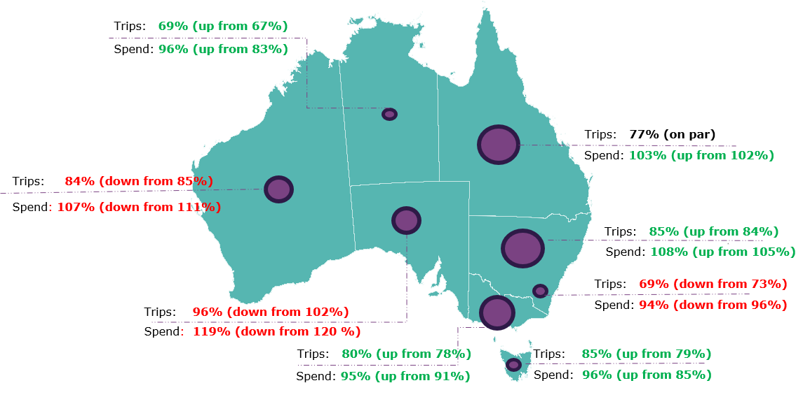

This report has been prepared by the Commonwealth of Australia represented by the Australian Trade and Investment Commission (Austrade). The report is a general overview and is not intended to provide exhaustive coverage of the topic. The information is made available on the understanding that the Commonwealth of Australia is not providing professional advice. While care has been taken to ensure the information in this report is accurate, the Commonwealth does not accept any liability for any loss arising from reliance on the information, or from any error or omission, in the report.