



INTERNATIONAL VISITOR SURVEY RESULTS


SEPTEMBER QUARTER 2025

September quarter 2025
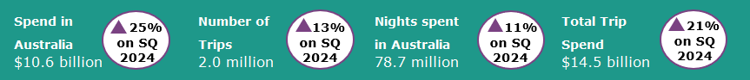

Year ending September 2025
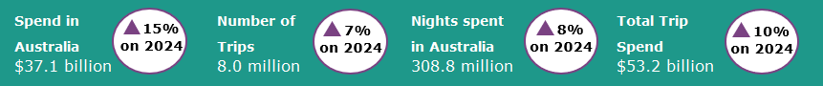
International tourism shows sustained growth
In the September quarter 2025 international tourism saw strong results compared with the September quarter 2024, continuing the trend of strong growth in international tourism in 2025. Trips to Australia were up by 13%, nights spent in Australia were up by 11% and spend in Australia was up by 25% when compared with the previous year. The large increase in spend was driven by travel for educational purposes (up by 30% or $1.0 billion) and holiday travel (up by 25% or $651 million).
Travel by visitors from China and the United Kingdom (UK) was notably strong in the September quarter 2025. Trips by Chinese visitors were up by 16%, nights spent in Australia were up by 14% and spend in Australia was up by 34% (or $909 million), driven by travel for education and holiday purposes compared with the September quarter 2024. Trips by UK visitors were up by 32%, nights spent in Australia were up by 59% and spend in Australia was up by 74% compared with the previous September quarter 2024. The strong increase in UK holiday visitors was buoyed by those visiting Australia for the 2025 Australia-wide British & Irish Lions tour.
Figure 1: Change in spend, nights and trips in Australia compared with previous corresponding quarters
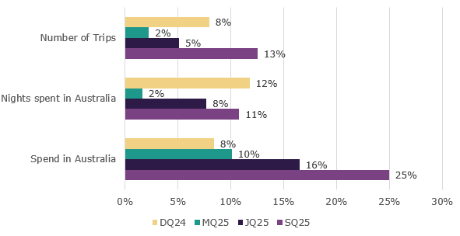

Top 5 Visitor Markets
The top 5 visitor markets in the year ending September 2025 were New Zealand, China, the United States of America, the United Kingdom and India. China saw the largest improvement in spend in Australia, which was up by 33% on the same period last year, while trips and nights were up by 17%. The United Kingdom also saw strong results, with nights spent in Australia up by 25% on the year ending September 2024, while spend in Australia was up 23% and trips were up by 13%.
China continues to be the largest contributor to spend in Australia, making up 28% of the total in the year ending September 2025. This was followed by the United Kingdom, making up 7% of the total, and the United States of America and New Zealand both making up 6%.
Australia’s top 5 international visitor markets in the year ending September 2025 were (percentage change on year ending September 2024 in brackets):

1. New Zealand with:
- 1.3 million trips (up 3%)
- $2.2 billion spent (up 6%)
- 14.9 million nights (up 4%)
2. China with:
- 928 thousand trips (up 17%)
- $10.5 billion spent (up 33%)
- 52.4 million nights (up 17%)
3. United States of America with:
- 682 thousand trips (up 4%)
- $2.3 billion spent (up 15%)
- 12.2 million nights (up 7%)
4. United Kingdom with:
- 666 thousand trips (up 13%)
- $2.6 billion spent (up 23%)
- 26.1 million nights (up 25%)
5. India with:
- 432 thousand trips (up 7%)
- $1.9 billion spent (up 29%)
- 29.8 million nights (up 10%)

Figure 2. Top 5 markets by spend in Australia, change compared with previous corresponding year ending periods
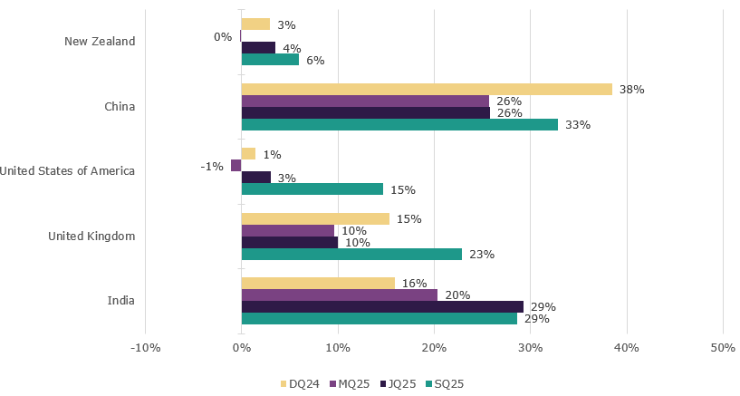

States and Territories
In the year ending September 2025, international visitor spend was up across most states and territories when compared with the year ending September 2024. Western Australia saw the largest percentage increase in spend, up by 36% compared with the same period last year. This was followed by South Australia (up 23%), New South Wales (up 17%), Queensland (up 13%), Victoria (up 8%) and Tasmania (up 5%).
For trips to Australia, all states and territories apart from Tasmania (down 2%) and South Australia (on par) showed improvement compared with the year ending September 2024. Western Australia saw the largest improvement by percentage increase, up by 17%.
Figure 3. Number of trips and spend in Australia by state and territory, year ending September 2025 (year ending September 2024 comparison in brackets)
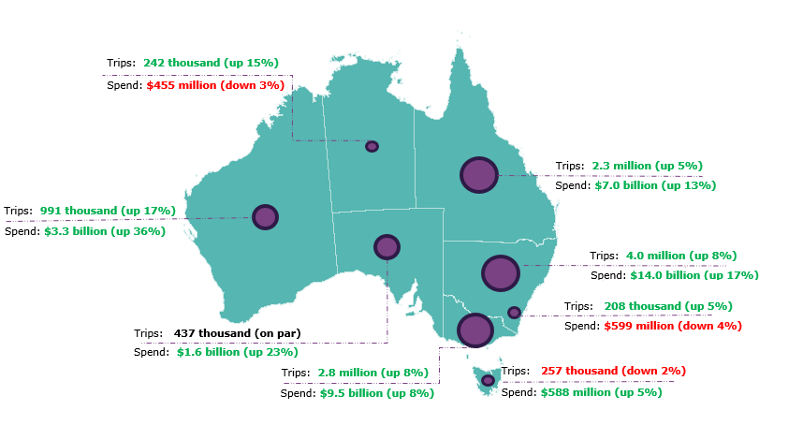

Pre-COVID-19 comparison
Spend in Australia and nights spent in Australia have both fully recovered and remain above pre-COVID levels. Trips to Australia continue to approach pre-COVID levels but remained slightly below in the September quarter 2025.
In the September quarter 2025:
- spend in Australia was $10.6 billion, up 31% on pre-COVID levels when compared with the September quarter 2019
- the number of trips were 2.0 million, 97% of pre-COVID levels when compared with the September quarter 2019
- nights spent in Australia were 78.7 million, up 13% on pre-COVID levels when compared with the September quarter 2019.

This report has been prepared by the Commonwealth of Australia represented by the Australian Trade and Investment Commission (Austrade). The report is a general overview and is not intended to provide exhaustive coverage of the topic. The information is made available on the understanding that the Commonwealth of Australia is not providing professional advice. While care has been taken to ensure the information in this report is accurate, the Commonwealth does not accept any liability for any loss arising from reliance on the information, or from any error or omission, in the report.

