



INTERNATIONAL VISITOR SURVEY RESULTS


MARCH QUARTER 2026

March quarter 2026
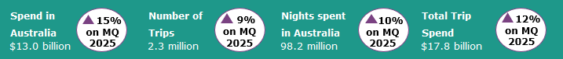

Year ending March 2026
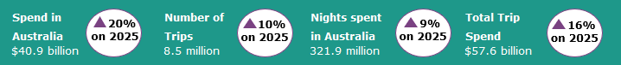
International tourism shows continued strength
In the March quarter 2026, international tourism delivered strong results compared with the March quarter 2025, despite flight disruptions resulting from the initial stages of the Middle East conflict. Spend in Australia was up by 15%, nights spent in Australia were up by 10% and trips to Australia were up by 9%, when compared with the same quarter a year ago. The strength in spend was driven by travel for educational purposes (up by 15% or $768 million) and holiday travel (up by 17% or $562 million).
Strong growth in travel by visitors from China drove the results in the March quarter 2026. Trips by Chinese visitors were up by 25% (or 71,000), nights spent in Australia were up by 34% (or 6.1 million) and spend in Australia was up by 14% (or $556 million) compared with the March quarter 2025. Chinese holiday travellers’ trips and spend rose significantly (48% and 53% respectively), driven by the longest Lunar New Year holiday on record, creating strong demand for premium summer experiences such as those offered in Australia.
Figure 1: Change in spend, nights and trips in Australia compared with previous corresponding quarters
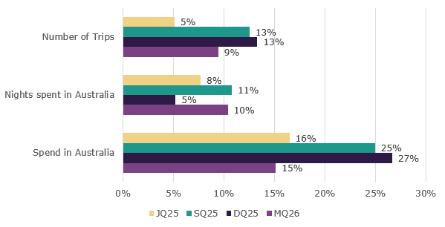

Spend behaviour of traveller types

International travellers’ spend behaviours differ across their main purpose for visiting Australia. In the year ending March 2026, travellers here for educational purposes spend the largest proportion of their total on food, drink & accommodation at 78%; while spending the least amount on other expenditure groups such as transportation and shopping. This is likely due to these travellers staying in Australia longer on average than other traveller types.

Holiday travellers have the most diverse spend profile across all traveller types, with spend more widely spread across the expenditure groups. Holiday travellers spend a higher proportion of their total spend in Australia on tours (13%) than those visiting Australia for other reasons such as business (4%) or to visit friends and relatives (3%) but spend a lower proportion on food, drink and accommodation (57%) than visitors here for employment (74%) and educational purposes (78%). This is likely due to holiday travellers exploring and going on tours in Australia, going to attractions and shopping more compared with other traveller types, despite predominately eating out and staying at hotels and other types of paid accommodation.

Travellers who visit friends and relatives spend a much higher proportion of their total on shopping and entertainment (30%) than other types of travellers. This is because these travellers are more likely to stay with their friends or relatives, saving on accommodation and meals.

Figure 2: Proportion of spend by selected expenditure groups by traveller type in year ending March 2026
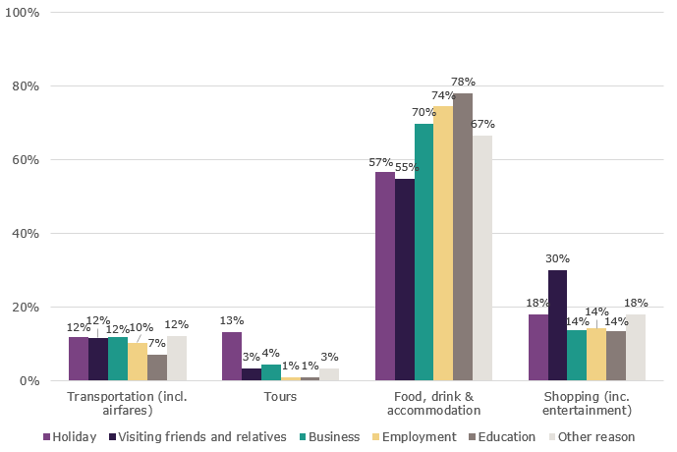
Note: Expenditure items omitted from figure 2 include Education fees and Other expenditure.

Top 5 Visitor Markets

The top 5 visitor markets in the year ending March 2026 were New Zealand, China, the United Kingdom, the United States of America and India. Spend in Australia showed improvements in all key markets compared with the year ending March 2025. The largest proportional improvement in spend was by travellers from Hong Kong (47%), followed by United Kingdom (35%), Malaysia (34%) and China (30%). Trips to Australia improved in all key markets except for Vietnam, when compared with the year ending March 2025. Hong Kong, Taiwan and China saw the largest proportional improvements, at 22% respectively, and while the United Kingdom market grew by 19%.

China continues to be the largest contributor to spend in Australia, making up 29% of the total spend in Australia in the year ending March 2026. This was followed by the United Kingdom (7%), the United States of America (6%), New Zealand (6%), and India (5%).
Figure 3. Top 5 markets by spend in Australia, per cent change compared with previous corresponding year ending periods
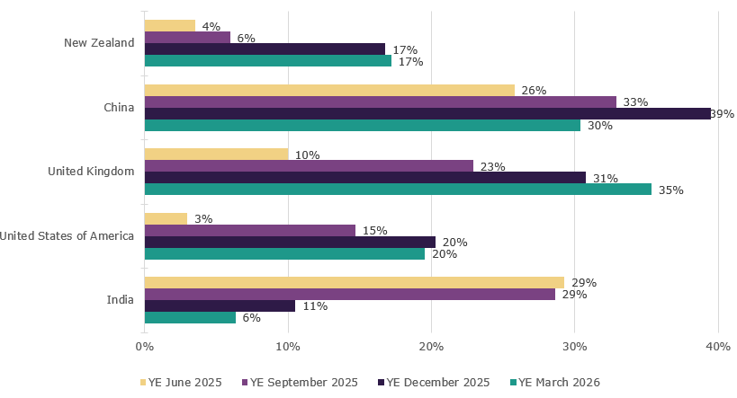

States and Territories
In the year ending March 2026, international visitor spend was up across all states and territories when compared with the year ending March 2025. Tasmania saw the largest percentage increase in spend, up by 36% compared with the same period last year. This was followed by Queensland (up 35%), Northern Territory (up 27%), New South Wales (up 18%), Victoria (up 17%), South Australia (up 16%), Western Australia and the Australia Capital Territory (both up 12%, respectively).
For trips to Australia, all states and territories apart from Australian Capital Territory (down 11%) showed improvement compared with the year ending March 2025. Western Australia saw the largest improvement, up by 20%. This was followed by the Northern Territory (up 16%) and Queensland (up 13%).
Figure 4. Number of trips and spend in Australia by state and territory, year ending March 2026 (year ending March 2025 comparison in brackets)
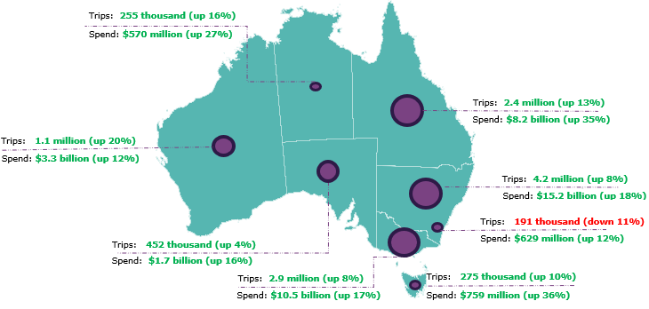
This report has been prepared by the Commonwealth of Australia represented by the Australian Trade and Investment Commission (Austrade). The report is a general overview and is not intended to provide exhaustive coverage of the topic. The information is made available on the understanding that the Commonwealth of Australia is not providing professional advice. While care has been taken to ensure the information in this report is accurate, the Commonwealth does not accept any liability for any loss arising from reliance on the information, or from any error or omission, in the report.

