



INTERNATIONAL VISITOR SURVEY RESULTS


MARCH QUARTER 2025

March quarter 2025
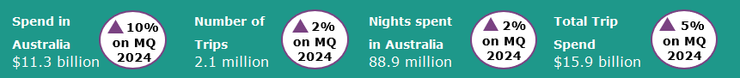

Year ending March 2025
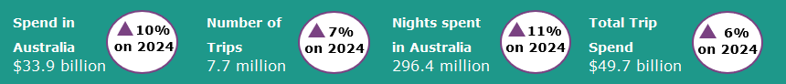
International tourism saw strong growth in spend
March quarter 2025 international tourism results saw strong spend compared with the March quarter 2024 results. Spend in Australia was $11.3 billion, up 10% or $1.0 billion when compared with the previous year, driven by travel for education purposes (up by 21% or $0.9 billion) and employment (up by 21% or $0.2 billion). Travel for education purposes ($5.1 billion) was the largest contributor to spend in Australia in the March quarter 2025, making up almost half of the spend in Australia total. The average spend per night in Australia in the March quarter 2025 was $127, an increase of 8% when compared with the March quarter 2024. This increase was largely driven by travellers in Australia for educational purposes, with their average spend per night up by 22% to $194.
Trips to Australia and nights spent in Australia improved slightly, both up by 2% compared with the March quarter 2024. The average number of nights spent in Australia by international visitors in the March quarter 2025 remained unchanged when compared with March quarter 2024, at 42 nights.
Figure 1: Spend, nights and trips in Australia compared with previous corresponding quarters
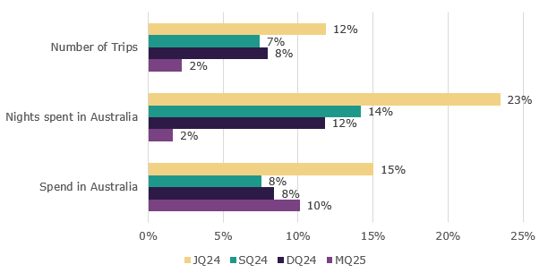

Top 5 Visitor Markets
The top 5 visitor markets in the year ending March 2025 were New Zealand, China, the United States of America, the United Kingdom and India. China saw the largest improvement on the previous year with spend up by 26%, trips to Australia up by 26% and nights away up by 22% on the year ending March 2024. China continues to be the largest contributor to spend in Australia, making up 27% of the total in the year ending March 2025, followed by the United Kingdom at 6.5% and the New Zealand at 6.1%.
Australia’s top 5 international visitor markets in the year ending March 2025 were (percentage change on year ending March 2024 in brackets):

1. New Zealand with:
- 1.2 million trips (up 2%)
- $2.1 billion spent (on par)
- 14.6 million nights (up 2%)
2. China
- 860 thousand trips (up 26%)
- $9.1 billion spent (up 26%)
- 47.5 million nights (up 22%)
3. United States of America with:
- 672 thousand trips (up 1%)
- $2.1 billion spent (down 1%)
- 11.8 million nights (up 5%)
4. United Kingdom with:
- 613 thousand trips (up 6%)
- $2.2 billion spent (up 10%)
- 22.3 million nights (up 11%)
5. India with:
- 427 thousand trips (up 10%)
- $1.8 billion spent (up 20%)
- 28.9 million nights (up 21%)

Figure 2. Top 5 markets by spend in Australia compared with previous corresponding year ending periods
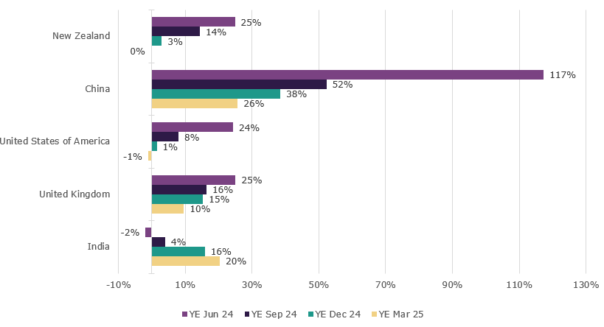

States and Territories
In the year ending March 2025, international visitor spend rose across most states and territories when compared with the year ending March 2024. Tasmania saw the largest percentage increase in spend, up by 25% compared with the same period last year. This was followed by Western Australia (up 19%), Victoria (up 16%), and South Australia (up 15%). Queensland was the only state to fall in spend (down 3%).
For trips to Australia, all states and territories apart from South Australia (down 6%) showed improvement compared with the year ending March 2024. Western Australia and the ACT saw the largest improvement, both up 13%.
Figure 3. Number of trips and spend in Australia by state and territory, year ending March 2025 (year ending March 2024 comparison in brackets)
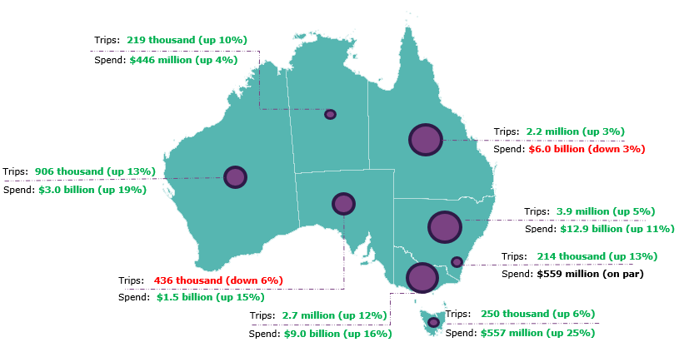

Pre-COVID-19 comparison
Spend in Australia and nights spent in Australia have both fully recovered and are now above pre-COVID levels. Trips to Australia remain moderately below pre-COVID levels, with growth moderating in recent quarters.
In the March quarter 2025:
- spend in Australia was $11.3 billion, up 9% on pre-COVID levels when compared with the March quarter 2019
- the number of trips were 2.1 million, 91% of pre-COVID levels when compared with the March quarter 2019
- nights spent in Australia were 88.9 million, up 7% on pre-COVID levels when compared with the March quarter 2019.

This report has been prepared by the Commonwealth of Australia represented by the Australian Trade and Investment Commission (Austrade). The report is a general overview and is not intended to provide exhaustive coverage of the topic. The information is made available on the understanding that the Commonwealth of Australia is not providing professional advice. While care has been taken to ensure the information in this report is accurate, the Commonwealth does not accept any liability for any loss arising from reliance on the information, or from any error or omission, in the report.

