



INTERNATIONAL VISITOR SURVEY RESULTS


JUNE QUARTER 2026

June quarter 2026
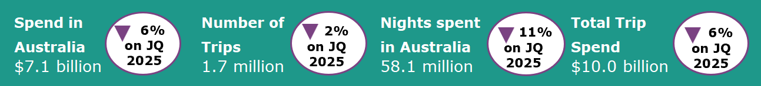

Year ending June 2026
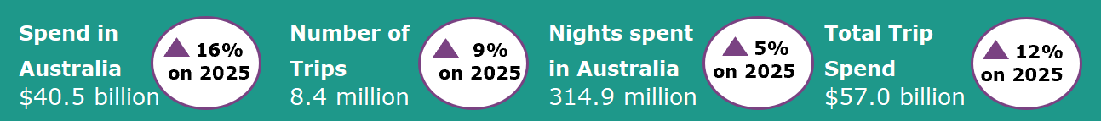
International tourism slows in the most recent quarter
In the June quarter 2026, international tourism recorded a softer performance compared with the June quarter 2025. Spend in Australia was down by 6%, nights spent in Australia were down by 11% and trips to Australia were down by 2%, when compared with the same quarter a year earlier. The decline in spend was primarily driven by travel to visit friends and relatives (VFR) (down by 23% or $290 million) and for education-related purposes (down by 8% or $184 million).
China (down by $42 million or 26%), India (down by $41 million or 35%) and New Zealand (down by $37 million or 22%) were the largest contributors to the weaker spending outcome for travel to visit friends and relatives (VFR) in the June quarter 2026, accounting for 41% of the overall decrease in VFR spend in Australia since the June quarter last year. Travellers from China were the main driver of the decrease in spend in Australia for educational purposes (down by 8% or $99 million) which also contributed to the overall softening of spend in Australia in the June quarter 2026.
Figure 1: Change in spend, nights and trips in Australia compared with previous corresponding quarters
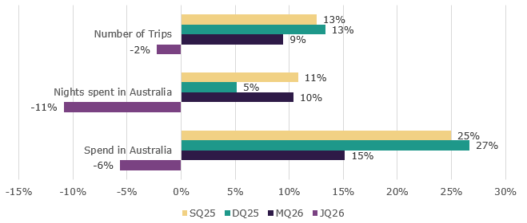

Return VFR visitors remain stable

June quarter 2026 saw a decline in travellers coming to Australia to visit friends and relatives (VFR) (down by 9% or 52,000 trips). The decline was primarily driven by a decrease in trips for first time visitors (down by 31% or 51,000 trips), while the number of return visitors to Australia stayed relatively steady. As a result in the decline of first time VFR visitors, the proportion of international visitors returning to visit friends and relatives increased steadily across quarters in the 2025-26 financial year (Figure 2), from 70% in the September quarter 2025 to 79% in the June Quarter 2026.

In the June quarter 2026, older international visitors were more likely to return to Australia to visit friends and relatives. Across the age groups, the proportion of return visits was 59% for travellers aged 15 to 29 compared with 88% for those aged 60 and above (Figure 3).

When compared with the June quarter 2025, June quarter 2026 saw returning VFR visitors in Australia:

- Staying for a shorter time, with the average nights per trip decreasing by 5% from 32 to 30 nights;
- Spending less, with the average spend per trip declining by 15% from $2,098 to $1,776

Figure 2. Proportion of VFR trips by First/Return visit by quarter for year 2025-26

Figure 3. Proportion of VFR trips by First/Return visit by age group in June quarter 2026

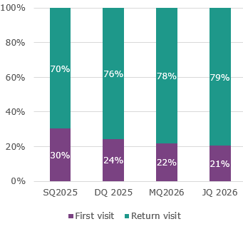
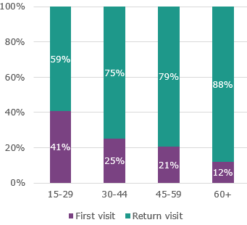

Top 5 Visitor Markets

The top 5 visitor markets in the year ending June 2026 were New Zealand, China, the United Kingdom, the United States of America and India. Spend in Australia showed improvements in most of the key markets, except for India and Switzerland, when compared with the year ending June 2025. The largest proportional improvement in spend relative to the June quarter last year was by travellers from Hong Kong (34%), followed by Scandinavia (33%), Malaysia (32%) and France (29%). Trips to Australia improved in all key markets except for India and Vietnam in the year ending 2026, when compared with the same period last year. Taiwan saw the largest improvement in visitor numbers, up by 22%, followed by China (up 18%), France and Italy (both up 16%).
China continued to be the largest contributor to spend in Australia, making up 29% of the total spend in Australia in the year ending June 2026. This was followed by the United Kingdom (7%), the United States of America (6%), New Zealand (6%), and India (4%).
Figure 4. Top 5 markets by spend in Australia, per cent change compared with previous corresponding year ending periods
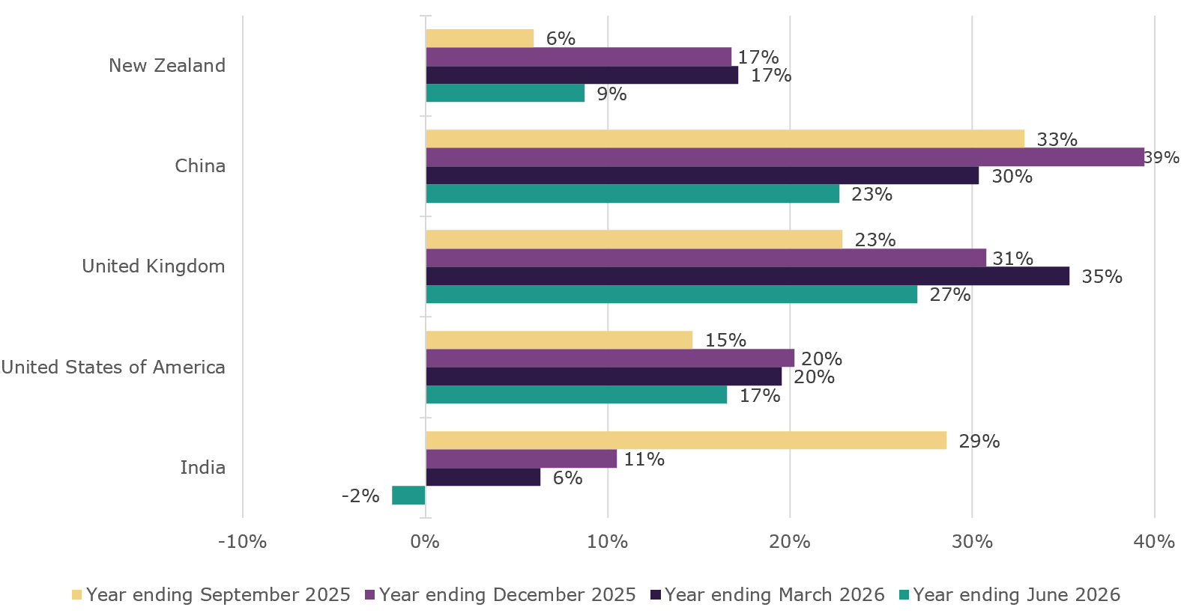

States and Territories
In the year ending June 2026, international visitor spend was up across all states and territories when compared with the year ending June 2025. The Northern Territory saw the largest percentage increase in spend, up by 33% compared with the same period last year. This was followed by Queensland (up 28%), Tasmania (up 25%), New South Wales (up 14%), Victoria (up 13%), South Australia (up 6%), Western Australia (up 5%) and the Australia Capital Territory (up 2%).
For trips to Australia, all states and territories apart from the Australian Capital Territory (down by 18%) showed improvement compared with the year ending June 2025. Western Australia saw the largest improvement, up by 14%. This was followed by Queensland (up by 11%) and the Northern Territory (up by 9%).
Figure 5. Number of trips and spend in Australia by state and territory, year ending June 2026 (year ending June 2025 comparison in brackets)
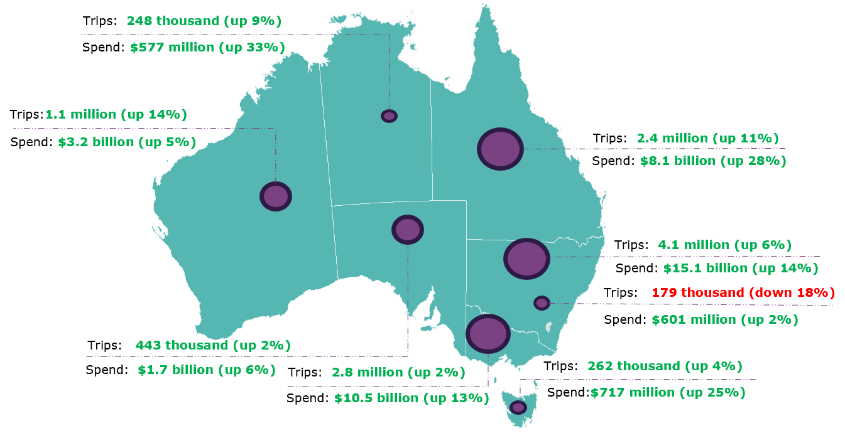
This report has been prepared by the Commonwealth of Australia represented by the Australian Trade and Investment Commission (Austrade). The report is a general overview and is not intended to provide exhaustive coverage of the topic. The information is made available on the understanding that the Commonwealth of Australia is not providing professional advice. While care has been taken to ensure the information in this report is accurate, the Commonwealth does not accept any liability for any loss arising from reliance on the information, or from any error or omission, in the report.

