



INTERNATIONAL VISITOR SURVEY RESULTS


JUNE QUARTER 2025

June quarter 2025
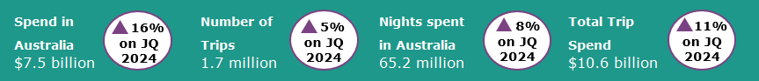

Year ending June 2025
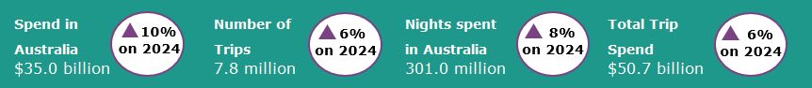
International tourism continues to see strong growth
In the June quarter 2025 international tourism saw strong results compared with the June quarter 2024. Trips to Australia were up by 5%, nights spent in Australia were up by 8% and spend in Australia was up 16% ($1.1 billion) to $7.5 billion when compared with the previous year. The large increase in spend was driven by holiday travel (up by 16% or $346 million) and travel for educational purposes (up by 15% or $295 million). Travel for holidays ($2.6 billion) and education purposes ($2.3 billion) were the largest contributors to spend in Australia in the June quarter 2025, making up almost two thirds of the spend in Australia total.
Travel by visitors from China and the United Kingdom (UK) was particularly strong in the June quarter 2025. Trips by Chinese visitors were up by 20%, nights spent in Australia up by 38% and spend in Australia up by 39% ($522 million) compared with the June quarter 2024. China has historically been one of Australia’s highest spending markets but has been slower to return towards pre-pandemic visitor numbers than other markets given the later reopening of its international border. Trips by travellers from the UK were up by 23%, nights spent in Australia were up by 35% and spend in Australia was up by 26% ($102 million) compared with the June quarter 2024. This was mainly driven by increases in holiday travel (particularly working holiday makers), and to visit friends and relatives.
Figure 1: Spend, nights and trips in Australia compared with previous corresponding quarters
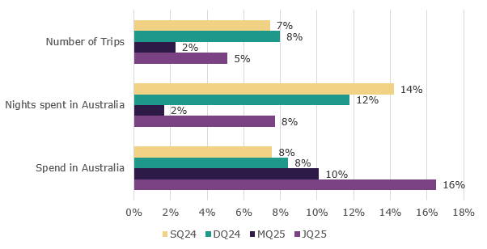

Top 5 Visitor Markets
The top 5 visitor markets in the year ending June 2025 were New Zealand, China, the United States of America, the United Kingdom and India. China saw the largest improvement in trips to Australia up by 20% on the year ending June 2024, with nights up by 20% and spend in Australia up 26%. India saw the largest increase in spend in Australia, up 29% on the same period last year, with trips up 9% and nights spent in Australia up 16%. China continues to be the largest contributor to spend in Australia, making up 27% of the total in the year ending June 2025. This was followed by the United Kingdom, making up 7% of the total, and the United States of America and New Zealand both making up 6%.
Australia’s top 5 international visitor markets in the year ending June 2025 were (percentage change on year ending June 2024 in brackets):

1. New Zealand with:
- 1.3 million trips (up 2%)
- $2.1 billion spent (up 4%)
- 14.6 million nights (up 3%)
2. China
- 892 thousand trips (up 20%)
- $9.6 billion spent (up 26%)
- 50.5 million nights (up 20%)
3. United States of America with:
- 669 thousand trips (on par)
- $2.1 billion spent (up 3%)
- 11.6 million nights (up 1%)
4. United Kingdom with:
- 663 thousand trips (up 9%)
- $2.3 billion spent (up 10%)
- 23.7 million nights (up 12%)
5. India with:
- 429 thousand trips (up 9%)
- $1.8 billion spent (up 29%)
- 29.5 million nights (up 16%)

Figure 2. Top 5 markets by spend in Australia compared with previous corresponding year ending periods
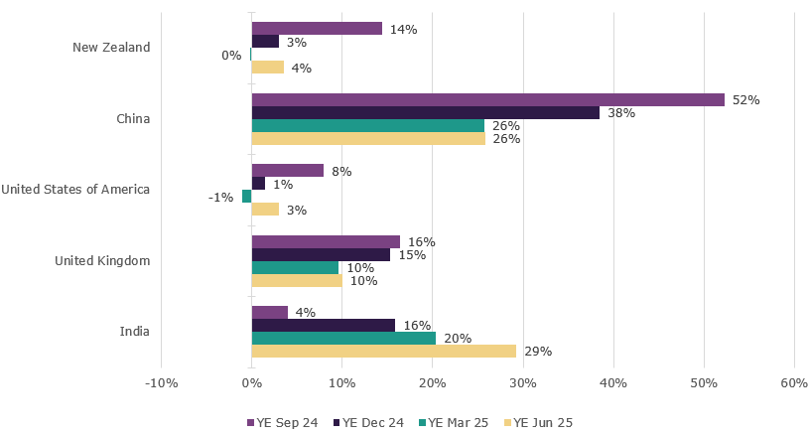

States and Territories
In the year ending June 2025, international visitor spend was up across most states and territories when compared with the year ending June 2024. Western Australia saw the largest percentage increase in spend, up by 26% compared with the same period last year. This was followed by South Australia (up 23%), Victoria (up 14%), New South Wales (up 9%), and Tasmania (up 9%).
For trips to Australia, all states and territories apart from South Australia (down 4%) and Tasmania (down 1%) showed improvement compared with the year ending June 2024. The ACT saw the largest improvement, up by 18%.
Figure 3. Number of trips and spend in Australia by state and territory, year ending June 2025 (year ending June 2024 comparison in brackets)

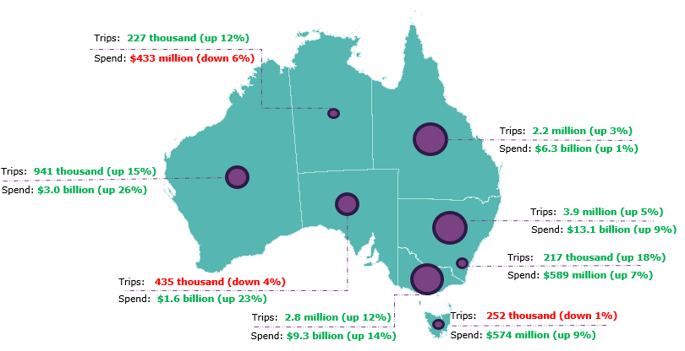

Pre-COVID-19 comparison
Spend in Australia and nights spent in Australia have both fully recovered and are now above pre-COVID levels. Trips to Australia remain moderately below pre-COVID levels, with growth moderating in recent quarters.
In the June quarter 2025:
- spend in Australia was $7.5 billion, up 34% on pre-COVID levels when compared with the June quarter 2019
- the number of trips were 1.7 million, 93% of pre-COVID levels when compared with the June quarter 2019
- nights spent in Australia were 65.2million, up 20% on pre-COVID levels when compared with the June quarter 2019.

This report has been prepared by the Commonwealth of Australia represented by the Australian Trade and Investment Commission (Austrade). The report is a general overview and is not intended to provide exhaustive coverage of the topic. The information is made available on the understanding that the Commonwealth of Australia is not providing professional advice. While care has been taken to ensure the information in this report is accurate, the Commonwealth does not accept any liability for any loss arising from reliance on the information, or from any error or omission, in the report.

