



INTERNATIONAL VISITOR SURVEY RESULTS


DECEMBER QUARTER 2025

December quarter 2025
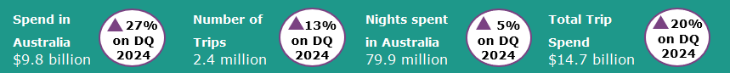

Year ending December 2025
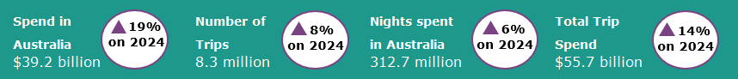
International tourism shows strong growth
In the December quarter 2025 international tourism delivered strong results compared with the December quarter 2024, continuing the trend of strong growth in international tourism in 2025. Trips to Australia were up by 13%, nights spent in Australia were up by 5% and spend in Australia was up by 27%, when compared with the same quarter a year ago. The large increase in spend was driven by holiday travel (up by 30% or $891 million) and travel for educational purposes (up by 37% or $706 million).
Growth in travel by visitors from China and the United Kingdom (UK) remained strong in the December quarter 2025. Trips by Chinese visitors were up by 25%, nights spent in Australia were up by 13% and spend in Australia was up by 63% (or $763 million) compared with the December quarter 2024. This was driven by travel for education and holiday purposes. Trips by UK visitors were up by 27%, nights spent in Australia were up by 30% and spend in Australia was up by 38% compared with the December quarter 2024. The strong increase in UK visitors was buoyed by working holiday trips and travel to Australia for the 2025-26 Ashes Series.
Figure 1: Change in spend, nights and trips in Australia compared with previous corresponding quarters

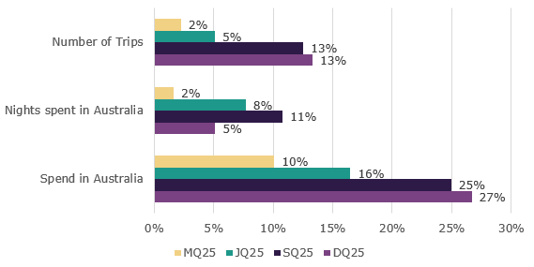
Older international visitors travel to visit friends and relatives

Older international travellers to Australia are more likely to report visiting friends and relatives as the main purpose of their trip than younger age groups.

In the year ending December 2025, travel to Australia to visit friends and relatives reached 2.8 million. Of these 41% were aged 60 and over. Older travellers visiting friends and relatives also stayed longer. In the year ending December 2025, the average length of stay was 37 nights for travellers aged 60 and over compared to only 23 nights for travellers aged 30 to 44.

Across age groups the proportions of trips to visit friends and relatives increased from 18% for travellers aged between 15-29 to 58% for those aged 60 and over, for the year ending December 2025.

Figure 2: Proportion of trips by main reason of visit, age group in year ending December 2025
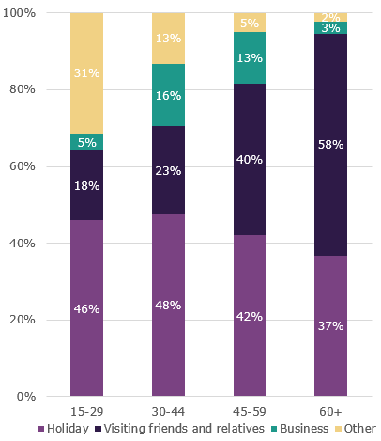

Top 5 Visitor Markets

The top 5 visitor markets in the year ending December 2025 were New Zealand, China, the United Kingdom, the United States of America and India. Chinese visitors delivered the largest improvement in spend in Australia, which was up by 39% on the same period last year, while trips and nights were up by 18% and 19% respectively. The United Kingdom also displayed strong results, with spend in Australia up by 31% on the year ending December 2024, while nights were up 29% and trips were up by 19%.
China continues to be the largest contributor to spend in Australia, making up 29% of the total in the year ending December 2025. This was followed by the United Kingdom, making up 7% of the total, and New Zealand and the United States of America both making up 6%.

Figure 3. Top 5 markets by spend in Australia, change compared with previous corresponding year ending periods

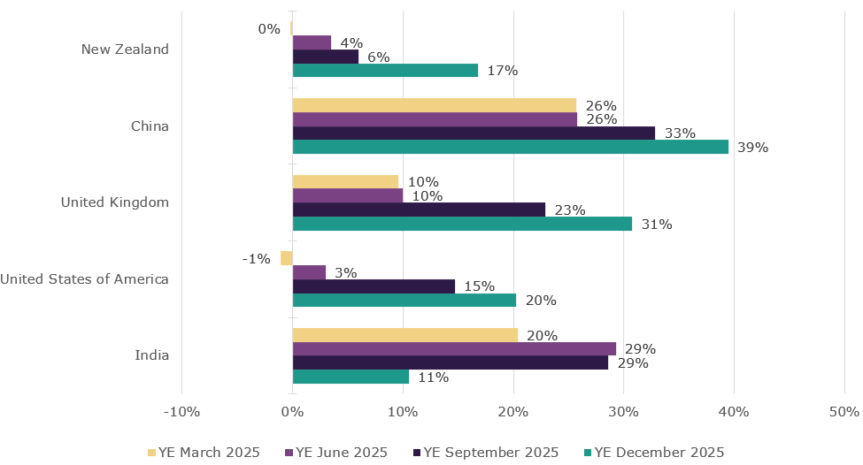

States and Territories
In the year ending December 2025, international visitor spend was up across most states and territories when compared with the year ending December 2024. South Australia saw the largest percentage increase in spend, up by 31% compared with the same period last year. This was followed by Western Australia (up 30%), Tasmania (up 29%), New South Wales (up 25%), Queensland (up 20%), Northern Territory (up 12%) and Victoria (up 7%). In contrast, the Australian Capital Territory recorded a 6% fall in spend.
For trips to Australia, all states and territories apart from Australian Capital Territory (down 8%) showed improvement compared with the year ending December 2024. Western Australia saw the largest improvement by percentage increase, up by 23%. This was followed by the Northern Territory (up 15%) and Queensland (up 10%).
Figure 4. Number of trips and spend in Australia by state and territory, year ending December 2025 (year ending December 2024 comparison in brackets)
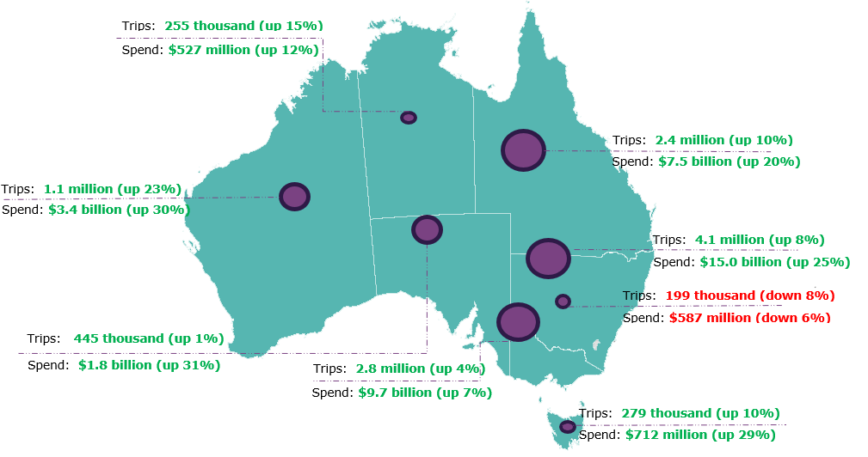

Pre-COVID-19 comparison
Spend in Australia and nights spent in Australia have both fully recovered and remain above pre-COVID levels. Trips to Australia continue to approach pre-COVID levels but remained slightly below in the December quarter 2025.
In the December quarter 2025:
- spend in Australia was $9.8 billion, up 33% on pre-COVID levels when compared with the December quarter 2019
- the number of trips were 2.4 million, 99% of pre-COVID levels when compared with the December quarter 2019
- nights spent in Australia were 79.9 million, up 18% on pre-COVID levels when compared with the December quarter 2019.

This report has been prepared by the Commonwealth of Australia represented by the Australian Trade and Investment Commission (Austrade). The report is a general overview and is not intended to provide exhaustive coverage of the topic. The information is made available on the understanding that the Commonwealth of Australia is not providing professional advice. While care has been taken to ensure the information in this report is accurate, the Commonwealth does not accept any liability for any loss arising from reliance on the information, or from any error or omission, in the report.

