



DOMESTIC TOURISM STATISTICS RESULTS


MARCH QUARTER 2026

March quarter 2026
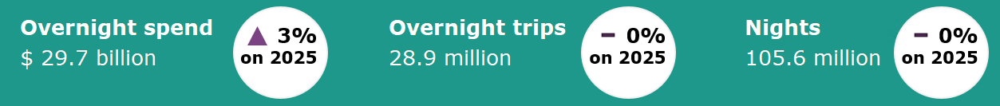

Year ending March 2026*
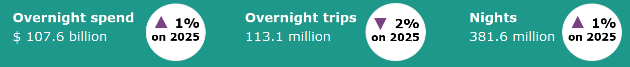

Domestic tourism results remain stable*
Domestic overnight results in the March quarter 2026 were largely unchanged from same period last year. Overnight spend was up by 3%, while overnight trips and nights were on par compared with the March quarter 2025. Domestic tourism in the March quarter 2026 was supported by stronger results in the month of March 2026 when compared with the weak March results last year due to the impacts of Tropical Cyclone Alfred.
The year ending March 2026 showed mixed results for overnight travel when compared with the same period last year. Spend and nights away were up by 1%, while overnight trips were down by 2%.
Figure 1. Percent change for spend, trips and nights compared with the same period in the previous year, June quarter 2025 to March quarter 2026

*Results prior to 2025 are backcast and adjusted to account for differences in methodology between the National Visitor Survey (NVS) and the new Domestic Tourism Statistics which came into effect January 2025. Due to data limitations and the complexity of measuring the differences in spend caused by the methodology changes, TRA recommends exercising caution when interpreting comparisons incorporating the use of backcast spend data. For more information please visit: Changes to the Australian resident tourism statistics collection in 2025 | Tourism Research Australia
Solo and group travellers diverge in their travel purpose
In the March quarter 2026, domestic overnight travel was led by couples, who took 8.7 million trips, followed by family groups (parents and children) with 6.9 million trips, those travelling alone with 6.6 million trips, and friends or relatives travelling together with 5.5 million trips.

Those travelling alone were more likely to travel to visit friends and relatives. Solo travellers took 3.5 million trips (52%) to visit friends and relatives, more than double the 1.4 million trips for a holiday (22%). Business travel also made up a notable share for solo travellers, with 1.2 million trips (18%).

Comparatively, group travel parties were more likely to travel for a holiday. Adult couples recorded 4.7 million holiday trips (54%), followed by family groups with 4.0 million (57%) and friends or relatives travelling together with 3.6 million (65%).

Couples and families also contributed substantially to trips taken to visit friends and relatives. Couples took 3.2 million trips (36%), while family groups accounted for 2.6 million trips (37%), although this remained secondary to holiday travel for both groups as the primary travel purpose.
Figure 2: Proportion of trips by travel party and main purpose of trip, March quarter 2026
np. Data is not publishable as the error is too high for most practical purposes.
Older Australians more likely to travel outside capital cities
In the March quarter 2026, travellers aged 65 and over recorded the highest share of overnight trips to regional Australia, with 4.0 million or 69% of trips travelling outside of capital cities and the Gold Coast. This compares with 2.4 million or 41% of trips to capital cities.  Younger age groups showed a more balanced distribution between city and regional travel. Travellers aged:  - 14 to 24 took 61% of trips to regional areas and 47% to capital cities  - 24 to 34 took 63% of trips to regional areas and 46% to capital cities  - 35 to 44 took 65% of trips to regional areas and 47% to capital cities  - 45 to 54 took 64% of trips to regional areas and 46% to capital cities  - 54 to 64 took 65% of trips to regional areas and 44% to capital cities.  Overall, while regional travel makes up the majority of trips across all age groups, the preference is most pronounced among older Australians, suggesting they are more likely to seek out regional and rural destinations compared with younger travellers. | Figure 3: Capital cities vs rest of Australia by age group, March quarter 2026*  *Percentages may not add to 100% due to trips including both capital cities and regional areas.

States and territories*
At a state and territory level, results for overnight trips and expenditure were mixed in the year ending March 2026 compared with the same period the previous year.
The number of overnight trips were mostly up. Queensland had the largest increase, up 614,000 (2%), followed by New South Wales (up 542,000 or 1%), Victoria (up 287,000 or 1%), Western Australia (up 259,000 or 3%) and the Australian Capital Territory (up 33,000 or 1%). Trips for South Australia and Tasmania were on par with the previous year. The Northern Territory saw a mild fall in the number of trips, down 5,000 or 1%.
Overnight spend showed mixed results. New South Wales saw the largest increase in spend, up $1.9 billion or 6%. This was followed by Western Australia (up $1.2 billion or 12%), the Northern Territory (up $491 million or 38%) and Tasmania (up $385 million or 13%). In contrast, Victoria saw the largest decrease in spend, down $1.4 billion or 6%. This was followed by Queensland (down $1.1 billion or 4%), the Australian Capital Territory (down $608 million or 22%) and South Australia (down $169 million or 2%).
Figure 4. Overnight trips and spend by state and territory, year ending March 2026 compared with year ending March 2025 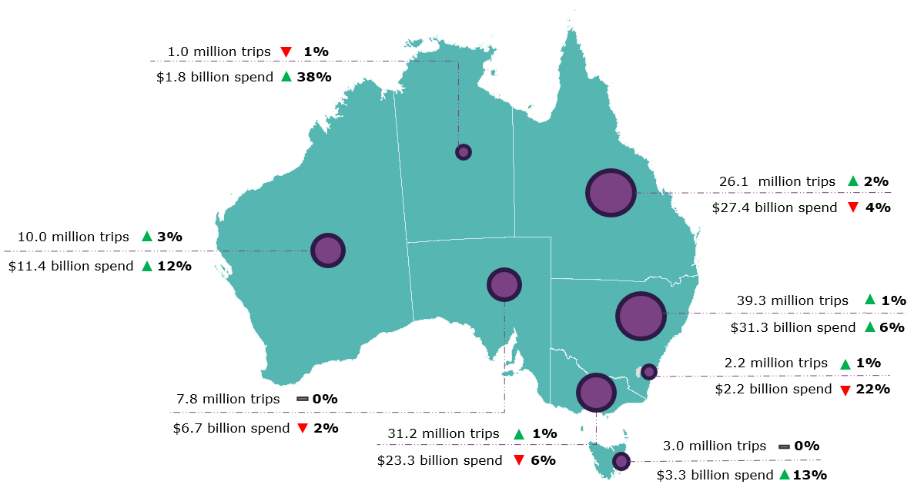
*Results prior to 2025 are backcast and adjusted to account for differences in methodology between the National Visitor Survey (NVS) and the new Domestic Tourism Statistics which came into effect January 2025. Due to data limitations and the complexity of measuring the differences in spend caused by the methodology changes, TRA recommends exercising caution when interpreting comparisons incorporating the use of backcast spend data. Greater caution should be used for less populated states and regions, as the statistical error is higher due to low sample numbers in the underlying survey data. For more information please visit: Changes to the Australian resident tourism statistics collection in 2025 | Tourism Research Australia
Day trips
In the March quarter 2026, Australians took 71.2 million day trips, spending $13.0 billion.
Of these:
- 36.8 million day trips were for holidays
- 21.7 million day trips were for visiting friends and relatives
- 5.1 million day trips were for business.
In the year ending March 2026, Australians took 283.2 million day trips, spending $49.4 billion.
This report has been prepared by the Commonwealth of Australia represented by the Australian Trade and Investment Commission (Austrade). The report is a general overview and is not intended to provide exhaustive coverage of the topic. The information is made available on the understanding that the Commonwealth of Australia is not providing professional advice. While care has been taken to ensure the information in this report is accurate, the Commonwealth does not accept any liability for any loss arising from reliance on the information, or from any error or omission, in the report.

