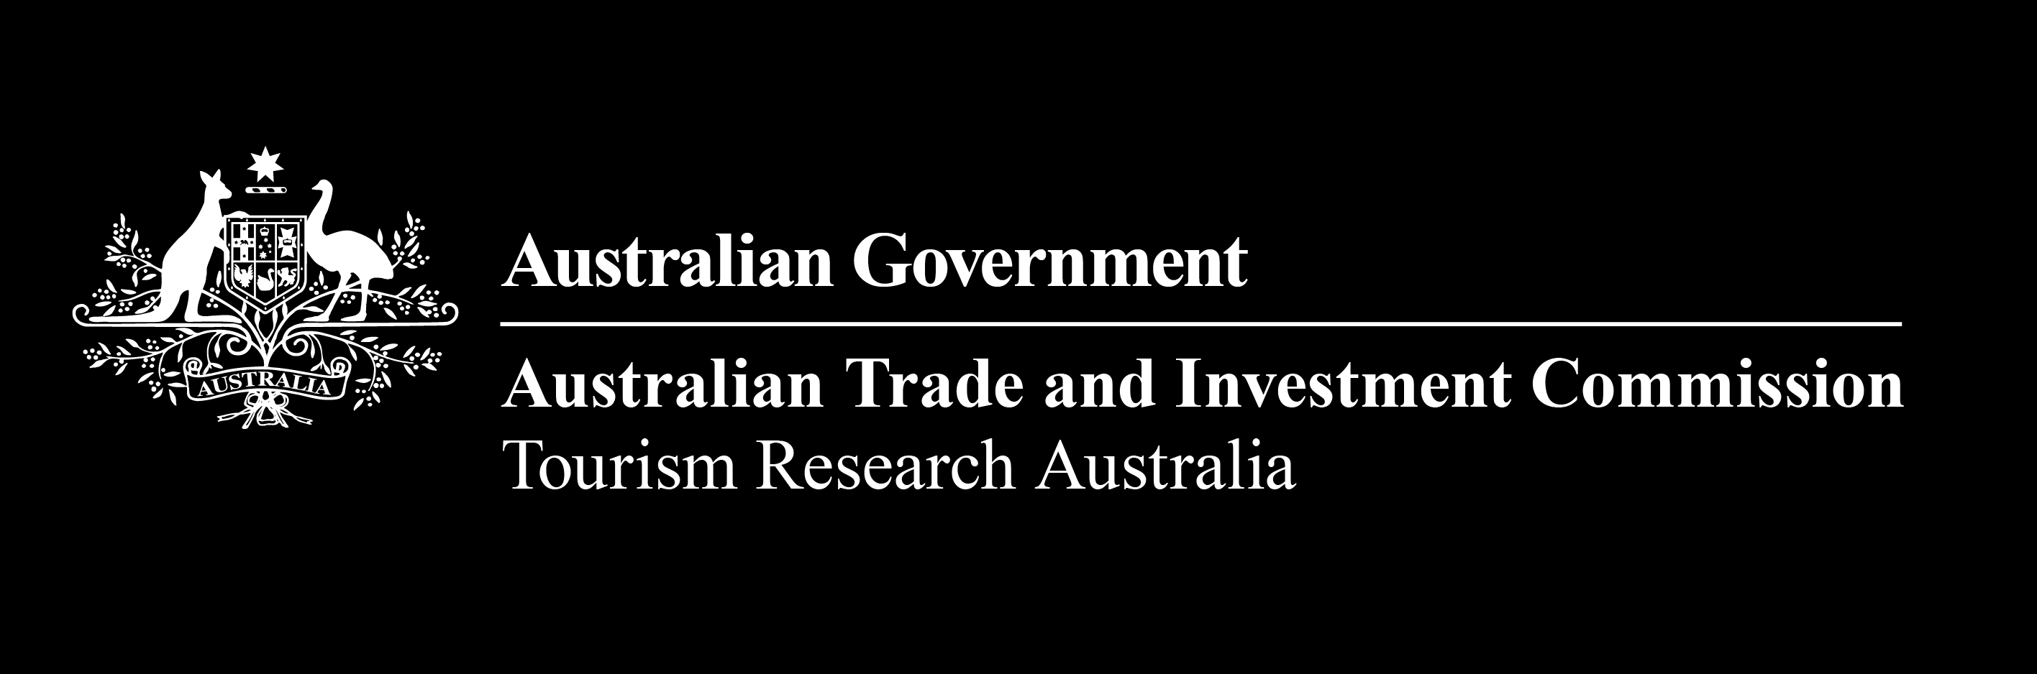
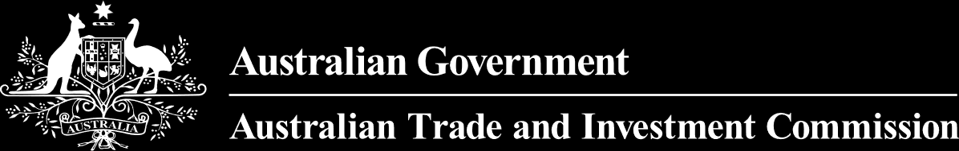


DOMESTIC TOURISM STATISTICS RESULTS


JUNE QUARTER 2026

June quarter 2026
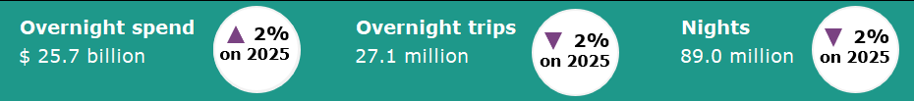

Year ending June 2026*
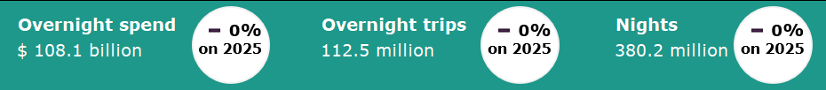

Domestic tourism results remain stable*
Domestic overnight tourism exhibited only modest changes in the June quarter 2026 compared with the same period last year. Overnight spend was up by 2%, while overnight trips and nights were both down by 2% compared with the June quarter 2025. The quarter itself saw mixed results within the component months of the quarter, with April 2026 down on the same period last year, likely due to impacts on fuel pricing and availability caused by the Middle East conflict, in contrast to May 2026 results which were stronger compared to a weakened May 2025 which was impacted by adverse weather events.
The year ending June 2026 results for overnight travel were stable when compared with the same period last year. Spend, overnight trips and nights away were all on par with the year ending June 2025.
Figure 1. Percent change for spend, trips and nights compared with the same period in the previous year, September quarter 2025 to June quarter 2026

*Results prior to 2025 are backcast and adjusted to account for differences in methodology between the National Visitor Survey (NVS) and the new Domestic Tourism Statistics which came into effect January 2025. Due to data limitations and the complexity of measuring the differences in spend caused by the methodology changes, TRA recommends exercising caution when interpreting comparisons incorporating the use of backcast spend data. For more information please visit: Changes to the Australian resident tourism statistics collection in 2025 | Tourism Research Australia

Travel parties with children more likely to take longer holidays
In the June quarter 2026, domestic overnight holiday travellers most commonly took trips of two to three nights, regardless of whether the travel party included children. Half of holiday trips taken by travel parties with children lasted two to three nights (2.3 million trips), similar to the 48% of holiday trips taken by parties without children (4.0 million trips).  Travel parties with children were more likely to take longer holidays than travel parties that did not include children. More than a quarter of their holiday trips lasted four to seven nights (27% or 1.2 million trips), compared with 21% of holiday trips taken by travel parties without children (1.8 million trips).  Comparatively, travel parties without children were more likely to take shorter holidays than those that included children. Almost a quarter of their holiday trips lasted a single night (23% or 2.0 million trips), compared with 17% of holiday trips taken by parties with children (781,000 trips).  Trips of eight nights or more accounted for a relatively small share of holiday travel for both groups, at 8% for parties without children (637,000 trips) and 6% for parties with children (282,000 trips). | Figure 2: Share of holiday trips by trip length, with and without children, June quarter 2026
Non-accommodation spending was highest among hotel travellers

In the June quarter 2026, 5.1 million domestic holiday trips included a stay in hotels and similar accommodation, accounting for 39% of all holiday trips and making it the most common accommodation type. These trips recorded the highest average expenditure at $476 per night, of which $310 was spent on non-accommodation items.  Comparatively, holiday trips that included a stay in other types of accommodation spent less on non-accommodation items. Travellers who stayed in commercial accommodation, such as guest houses, rented houses or apartments, and backpacker or hostels, spent an average of $243 per night excluding accommodation costs, which was $67 less than those that stayed in hotels or similar. Those that stayed in caravan parks or commercial camping grounds spent $154 less per night on non-accommodation costs ($156 per night) and those that stayed in private accommodation spent $130 less per night on non-accommodation costs ($180 per night).  The differences in the amount spent on non-accommodation costs across the differing accommodation types may reflect differences in travel behaviour, such as greater levels of self-catering or participation in lower-cost activities. | Figure 3: Average spend per night by accommodation type, including and excluding accommodation spend, June quarter 2026  $

States and territories*
For overnight trips, Queensland had the largest increase in the number of trips, up 368,000 (1%) in the year ending June 2026 when compared with the year ending 2025. Western Australia also recorded an increase in trips (up 98,000 or 1%) over the same period, while trips for New South Wales, Victoria and the Australian Capital Territory were on par with the previous year. South Australia (down 99,000 or 1%), Tasmania (down 30,000 or 1%) and the Northern Territory (down 15,000 or 2%) saw small declines in overnight trips for the year ending June 2026.
Western Australia saw the largest increase in spend on overnight trips for the year ending June 2026, up $1.2 billion or 12%. This was followed by New South Wales (up $1.1 billion or 4%), the Northern Territory (up $318 million or 22%), Tasmania (up $261 million or 9%) and South Australia (up $228 million or 3%). In contrast, Queensland saw the largest decrease in spend, down $1.4 billion or 5%. This was followed by Victoria (down $678 million or 3%) and the Australian Capital Territory (down $323 million or 13%).
Figure 4. Overnight trips and spend by state and territory, year ending June 2026 compared with the year ending June 2025
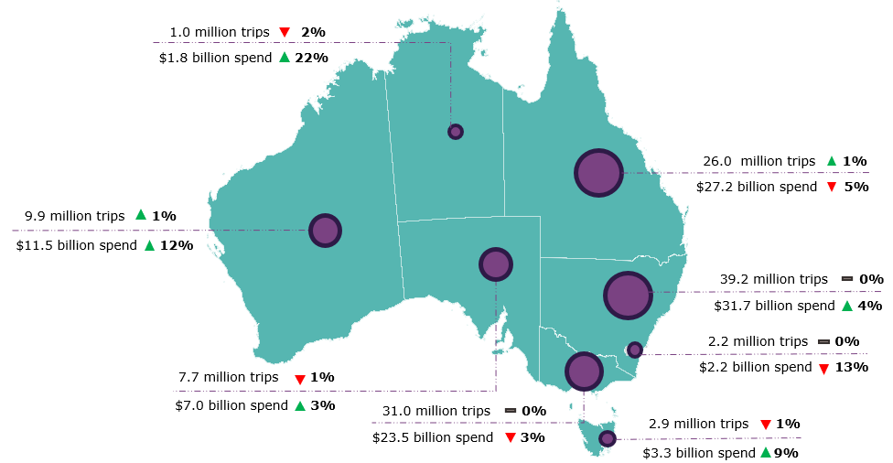
*Results prior to 2025 are backcast and adjusted to account for differences in methodology between the National Visitor Survey (NVS) and the new Domestic Tourism Statistics which came into effect January 2025. Due to data limitations and the complexity of measuring the differences in spend caused by the methodology changes, TRA recommends exercising caution when interpreting comparisons incorporating the use of backcast spend data. Greater caution should be used for less populated states and regions, as the statistical error is higher due to low sample numbers in the underlying survey data. For more information please visit: Changes to the Australian resident tourism statistics collection in 2025 | Tourism Research Australia
Day trips
In the June quarter 2026, Australians took 74.2 million day trips, spending $13.8 billion. Day trips were up by 8% and spend was up by 23% compared with the June quarter 2025.
Of these:
- 37.9 million day trips were for holidays
- 22.8 million day trips were for visiting friends and relatives
- 5.1 million day trips were for business.
In the year ending June 2026, Australians took 288.4 million day trips, spending $52.0 billion. Day trips were up by 8% and spend was up by 25% compared with the year ending June 2025.
This report has been prepared by the Commonwealth of Australia represented by the Australian Trade and Investment Commission (Austrade). The report is a general overview and is not intended to provide exhaustive coverage of the topic. The information is made available on the understanding that the Commonwealth of Australia is not providing professional advice. While care has been taken to ensure the information in this report is accurate, the Commonwealth does not accept any liability for any loss arising from reliance on the information, or from any error or omission, in the report.

