


Know

DOMESTIC TOURISM STATISTICS RESULTS


SEPTEMBER QUARTER 2025

September quarter 2025*

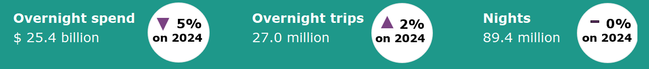

Year ending September 2025*
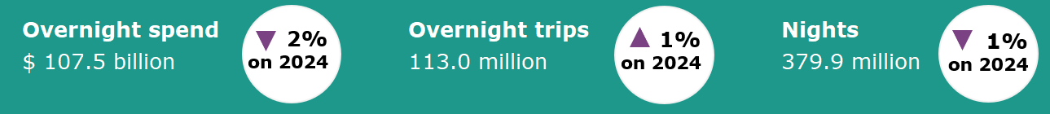

Domestic tourism results remain stable*
Domestic tourism results show a small increase in overnight trips but lower spend when compared with the same period last year. Overnight spend was down by 5%, overnight trips were up by 2% and nights away were on par. This continues the trend observed in recent quarters of Australians continuing to travel domestically but continuing to remain cautious with their spending.
The year ending September 2025 results remained relatively stable compared with the year ending September 2024. Overnight spend was down by 2%, overnight trips were up by 1% and nights were down by 1%.
Figure 1. Percent change for spend, trips and nights compared with the same period in the previous year, December quarter 2024 to September quarter 2025

*Results prior to 2025 are backcast and adjusted to account for differences in methodology between the National Visitor Survey (NVS) and the new Domestic Tourism Statistics which came into effect January 2025. Due to data limitations and the complexity of measuring the differences in spend caused by the methodology changes, TRA recommends exercising caution when interpreting comparisons incorporating the use of backcast spend data. For more information please visit: Changes to the Australian resident tourism statistics collection in 2025 | Tourism Research Australia

Holiday travel to regional Australia higher than capital cities
Australians are more likely to visit regional Australia for a holiday than travelling for other reasons. In the September quarter 2025, Australians took 12.7 million trips to capital cities and 16.8 million trips to regional Australia.  Visitors to capital cities were most likely to be visiting friends or relatives, accounting for 5.2 million trips or 41% of all visits to capital cities in the September quarter. This was followed closely by trips for holiday purposes, accounting for 4.8 million or 38% of visits to capital cities.  In contrast, visitors to regional Australia were more likely to be travelling for holiday purposes, accounting for 8.4 million trips or half of all trips to regional Australia. Travel to visit friends and families in regional Australia accounted for 6.2 million or 37% of trips in the September quarter.  The amount of travel for business purposes was similar across both capital cities and regional Australia, recording 1.5 million and 1.3 million trips respectively. | Figure 2: Proportion of trips by capital cities and rest of Australia and visit reason, September quarter 2025

Staying at a friends’ or relatives’ property leads the way for accommodation type
Most nights in the September quarter were spent in commercial accommodation when all categories are taken together. This accounted for 46.4 million nights or 52% of total nights spent away.  However, for a single type of accommodation, staying at a friends’ or relatives’ property leads the way. In the September quarter, 31.0 million nights or 35% of total nights were spent in a friends’ or relatives’ property. This is followed by nights in hotels, resorts, motels or motor inns which accounted for 25.0 million nights or 28% of total nights.  Caravan and camping was also popular among Australians. In the September quarter 2025 Australians spent 13.5 million nights or 15% of total nights across caravan parks, commercial camping grounds, and non-commercial caravan and camping. | Figure 3: Top 5 accommodation types by number of nights, September quarter 2025

States and territories*
Results for overnight trips remained stable for most states and territories in the year ending September 2025 when compared with the year ending September 2024, except for the Northern Territory which saw an increase of 219,000 trips or by 28%. Small increases were also seen in trips in Victoria (up 229,000 or 1%), Western Australia (up 172,000 or 2%) and Tasmania (up 42,000 or 1%). Trips in New South Wales, Queensland and South Australia were on par with the year ending September 2024. The Australian Capital Territory saw a slight decrease of 18,000 trips or by 1%.
Overnight spend results were mostly down on the previous year. Victoria saw the largest decrease ($943 million or 4%). This was followed by Western Australia (down $559 million or 5%), Queensland (down $548 million or 2%), South Australia ($487 million or 7%), the Australian Capital Territory (down $350 million or 14%) and Tasmania (down $39 million or 1%). Spend results for New South Wales were on par with the year ending September 2024 and the Northern Territory saw a strong increase of $445 million or 38%.
Figure 4. Overnight trips and spend by state and territory, year ending September 2025 compared with year ending September 2024
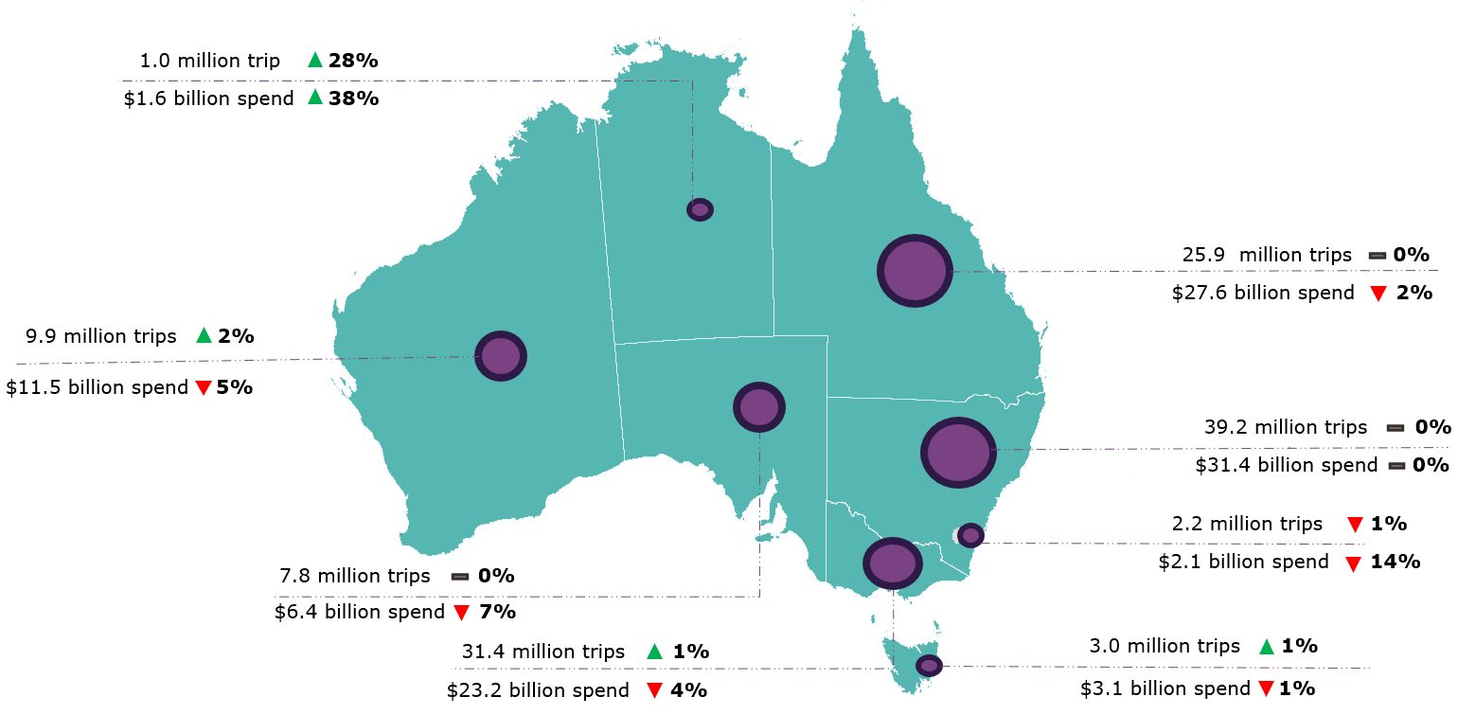
*Results prior to 2025 are backcast and adjusted to account for differences in methodology between the National Visitor Survey (NVS) and the new Domestic Tourism Statistics which came into effect January 2025. Due to data limitations and the complexity of measuring the differences in spend caused by the methodology changes, TRA recommends exercising caution when interpreting comparisons incorporating the use of backcast spend data. Greater caution should be used for less populated states and regions, as the statistical error is higher due to low sample numbers in the underlying survey data. For more information please visit: Changes to the Australian resident tourism statistics collection in 2025 | Tourism Research Australia
Daytrips
In the September quarter 2025, Australians took 72.3 million daytrips, spending $12.5 billion.
Of these:
- 36.7 million daytrips were for holidays
- 22.0 million daytrips were for visiting friends and relatives
- 5.4 million daytrips were for business.
In the year ending September 2025, Australians took 273.4 million daytrips, spending $44.4 billion.
This report has been prepared by the Commonwealth of Australia represented by the Australian Trade and Investment Commission (Austrade). The report is a general overview and is not intended to provide exhaustive coverage of the topic. The information is made available on the understanding that the Commonwealth of Australia is not providing professional advice. While care has been taken to ensure the information in this report is accurate, the Commonwealth does not accept any liability for any loss arising from reliance on the information, or from any error or omission, in the report.

