


Know

DOMESTIC TOURISM STATISTICS RESULTS


MARCH QUARTER 2025

March quarter 2025*

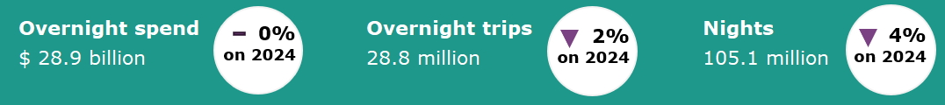

Year ending March 2025*
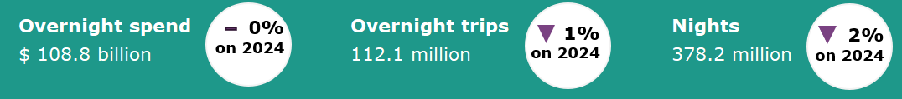

Domestic tourism results soften*
Domestic tourism results were softer in the March quarter 2025 across key measures when compared with the same quarter last year. Overnight visitor spend was on par, trips were down by 2% and nights away were down by 4%. March quarter 2025 results were impacted by significant natural disasters in key tourism regions. These included flooding in Central and North Queensland, Cyclone Alfred and the Grampians bushfire. The timing of Easter, a key driver for domestic tourism, also had an impact on the March quarter results. It fell in the March quarter in 2024 but in the June quarter in 2025.
The year ending March 2025 data was also softer. Spend was on par, overnight trips were down by 1% and nights were down by 2%, when compared with the year ending March 2024.
Figure 1. Percent change for spend, trips and nights compared with the same period in the previous year, June quarter 2024 to March quarter 2025
* Results prior to 2025 are backcast and adjusted to account for differences in methodology between the National Visitor Survey (NVS) and the new Domestic Tourism Statistics which came into effect January 2025. Due to data limitations and the complexity of measuring the differences in spend caused by the methodology changes, TRA recommends exercising caution when interpreting comparisons incorporating the use of backcast spend data.
For more information please visit: Changes to the Australian resident tourism statistics collection in 2025 | Tourism Research Australia
Main reason for travel, by interstate and intrastate trips*
In the March quarter 2025 there were 7.4 million interstate and 21.4 million intrastate trips. Intrastate trips have a larger proportion of leisure travel (holiday and visiting friends and relatives) than interstate trips, whereas interstate trips have a relatively larger proportion of business travel.
In the March quarter 2025:
- For holiday travel, there were 3.0 million interstate trips (40% of total interstate) and 9.4 million intrastate trips (44% of total intrastate)
- For visiting friends and relatives, there were 2.6 million interstate trips (35% of total interstate) and 8.2 million intrastate trips (38% of total intrastate)
- For business, there were 1.6 million interstate trips (21% of total interstate) and 2.5 million intrastate (12% of total intrastate).
Figure 2: Proportion of reason for trip by interstate and intrastate trips, March quarter 2025

* Using Main reason for trip and Trip inter/intrastate.
millions
Overnight trips reporting a disability
In the March quarter 2025, there were 5.8 million trips which reported one or more disabilities or long-term health conditions in the travel party. The most common disability or long-term health condition reported was chemical sensitivity or food allergies, with 2.0 million trips. This was followed by those reporting a mental health condition with 1.7 million trips, a hearing impairment with 1.3 million trips, and other mobility limitations not requiring a wheelchair or scooter with 1.2 million trips.
Figure 3: Trips with a disability or long-term health condition reported for travel party, March quarter 2025

States and territories*
In the year ending March 2025, results for overnight trips and spend were mixed when compared with the year ending March 2024.
Results for trips were mostly flat. Mild decreases were seen in New South Wales (down 560,000 or 1%), Queensland (down 460,000 or 2%), Victoria (down 212,000 or 1%) and the Australian Capital Territory (down 30,000 or 1%). South Australia and Western Australia were on par, while Tasmania saw a slight increase of 29,000 or 1%. Trips were strong in the Northern Territory, up 95,000 or 12%.
Results for spend were mixed. Victoria recorded the largest increase (up $926 million or 4%), followed by New South Wales (up $333 million or 1%) and the Australian Capital Territory (up $327 million or 16%). Decreases in spend were seen in other states, with Western Australia seeing the largest decrease (down $553 million or 5%). This was followed by South Australia (down $437 million or 6%), Queensland (down $176 million or 1%), Northern Territory (down $108 million or 8%) and Tasmania (down $880,000 or 3%).

Figure 4. Overnight trips and spend by state and territory, year ending March 2025 compared with year ending March 2024
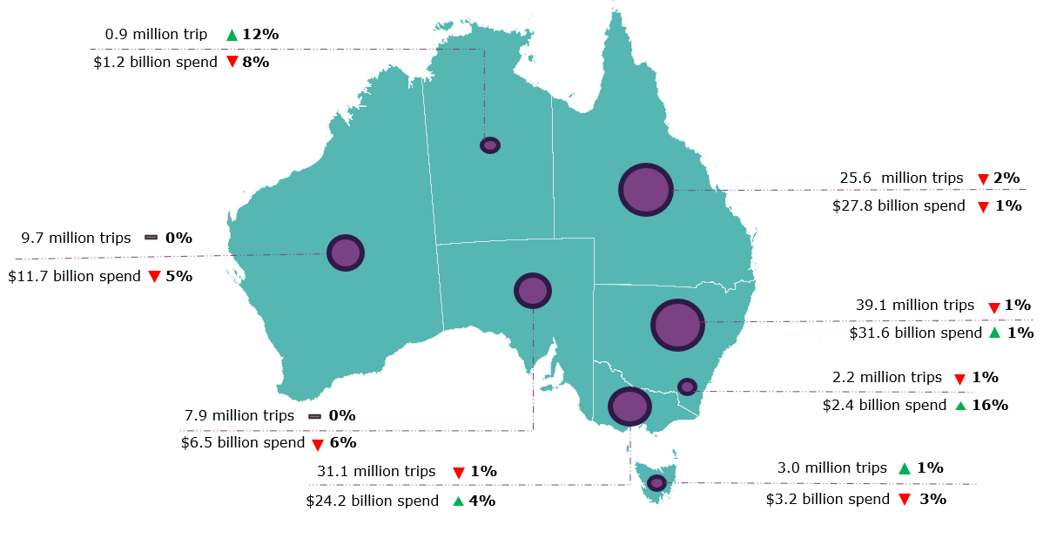

*Results prior to 2025 are backcast and adjusted to account for differences in methodology between the National Visitor Survey (NVS) and the new Domestic Tourism Statistics which came into effect January 2025. Due to data limitations and the complexity of measuring the differences in spend caused by the methodology changes, TRA recommends exercising caution when interpreting comparisons incorporating the use of backcast spend data. Greater caution should be used for less populated states and regions, as the statistical error is higher due to low sample numbers in the underlying survey data.
For more information please visit: Changes to the Australian resident tourism statistics collection in 2025 | Tourism Research Australia

This report has been prepared by the Commonwealth of Australia represented by the Australian Trade and Investment Commission (Austrade). The report is a general overview and is not intended to provide exhaustive coverage of the topic. The information is made available on the understanding that the Commonwealth of Australia is not providing professional advice. While care has been taken to ensure the information in this report is accurate, the Commonwealth does not accept any liability for any loss arising from reliance on the information, or from any error or omission, in the report.

