


Know

DOMESTIC TOURISM STATISTICS RESULTS


JUNE QUARTER 2025

June quarter 2025*

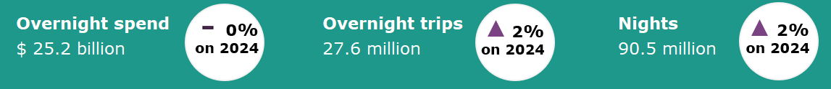

Year ending June 2025*
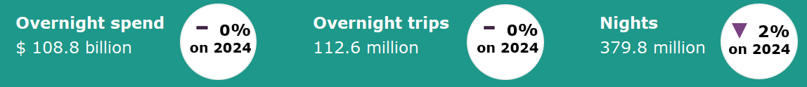

Domestic tourism results remain stable*
Domestic tourism results were stable in the June quarter 2025 across key measures when compared with the same quarter last year. Overnight visitor spend was on par, trips were up by 2% and nights away were up by 2%. June quarter 2025 results were supported by holiday travel, with Easter falling within the period this year. Results for the June quarter suggest that Australians remain eager to undertake holiday travel, while remaining cautious with their spending.
The year ending June 2025 results were also stable compared to the year ending June 2024. Spend and overnight trips were on par, and nights were down by 2%. The results for the June quarter 2025 and the year ending June 2025 show that domestic travel demand continues to remain stable.
Figure 1. Percent change for spend, trips and nights compared with the same period in the previous year, September quarter 2024 to June quarter 2025

*Results prior to 2025 are backcast and adjusted to account for differences in methodology between the National Visitor Survey (NVS) and the new Domestic Tourism Statistics which came into effect January 2025. Due to data limitations and the complexity of measuring the differences in spend caused by the methodology changes, TRA recommends exercising caution when interpreting comparisons incorporating the use of backcast spend data.
For more information please visit: Changes to the Australian resident tourism statistics collection in 2025 | Tourism Research Australia
Female Australians travel for longer, but spend less per trip
In the June quarter 2025, female travellers took longer overnight trips on average than male travellers. Female domestic overnight travellers were away an average of 3.4 nights per trip, compared with the average 3.2 nights per trip by male travellers.  Figure 2 shows that on average female domestic overnight travellers across all age groups had longer trips than male domestic overnight travellers in the June quarter 2025. The difference in length of trip between genders was higher for travellers aged 60 and over.  While female travellers took longer trips, they reported a lower average spend per trip in the June quarter 2025. In the June quarter 2025, female domestic overnight travellers spent an average of $887 per trip, compared with an average $937 per trip by male travellers. This can be attributed to differences in the purpose of travel between genders. A higher proportion of female travellers took lower cost trips to visit friends and relatives (VFR), compared with male travellers who took a higher proportion of higher cost trips for business purposes in the June quarter 2025 (Figure 3). In the June quarter 2025, the average spend on a VFR trip was $623 compared to business trips which had an average spend of $1,111 per trip. | Figure 2: Average nights per trip by gender and age group, June quarter 2025  Figure 3: Proportion of trips by gender and main purpose of trip, June quarter 2025
Expenditure items

In the June quarter 2025, domestic overnight travellers spent $6.8 billion on accommodation. This was followed by $3.9 billion on domestic airfares and $3.9 billion on takeaway and restaurant meals, $2.8 billion on petrol, $1.5 billion on shopping and $1.4 billion on groceries for self-catering.

Figure 4: Top expenditure items by domestic overnight travellers, June quarter 2025

States and territories*
Results for overnight trips remained stable for most states and territories in the year ending June 2025 when compared with the year ending June 2024, except for the Northern Territory which saw an increase of 163,000 trips or 21%. Increases were also seen in trips in Western Australia (up 156,000 or 2%) and Tasmania (up 31,000 or 1%). Trips in New South Wales, Victoria and South Australia was on par with the year ending June 2024. Queensland and the Australian Capital Territory saw a slight decrease in trips, down 200,000 or 1% and 17,000 or 1% respectively.
Overnight spend results were mixed. Increases were seen in New South Wales (up $1.3 billion or 4%) and the Northern Territory (up $186 million or 15%). Decreases were seen in Western Australia (down $1.4 billion or 11%), South Australia (down $293 million or 4%) and Tasmania (down $108 million or 3%). Results for Victoria, Queensland and the Australian Capital Territory was on par with the year ending June 2024.
Figure 5. Overnight trips and spend by state and territory, year ending June 2025 compared with year ending June 2024
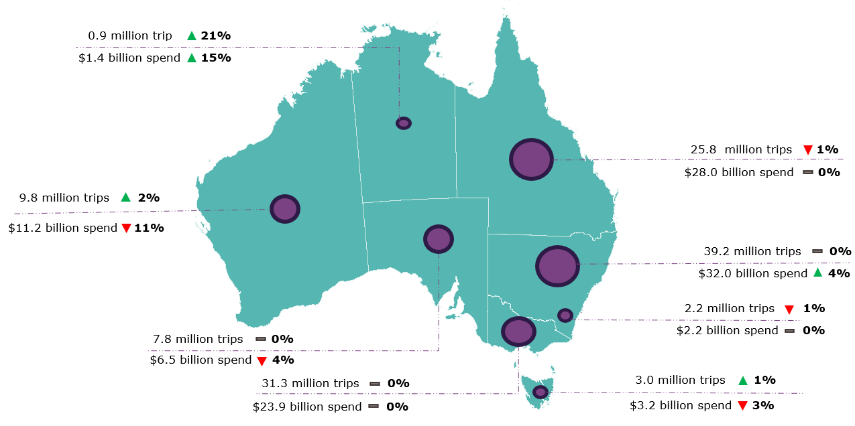
*Results prior to 2025 are backcast and adjusted to account for differences in methodology between the National Visitor Survey (NVS) and the new Domestic Tourism Statistics which came into effect January 2025. Due to data limitations and the complexity of measuring the differences in spend caused by the methodology changes, TRA recommends exercising caution when interpreting comparisons incorporating the use of backcast spend data. Greater caution should be used for less populated states and regions, as the statistical error is higher due to low sample numbers in the underlying survey data.
For more information please visit: Changes to the Australian resident tourism statistics collection in 2025 | Tourism Research Australia
Daytrips
In the June quarter 2025, Australians took 69.0 million daytrips, spending $11.2 billion.
Of these:
- 34.7 million daytrips were for holidays
- 20.9 million daytrips were for visiting friends and relatives
- 5.4 million daytrips were for business.
In the year ending June 2025, Australians took 266.1 million daytrips, spending $41.2 billion.
This report has been prepared by the Commonwealth of Australia represented by the Australian Trade and Investment Commission (Austrade). The report is a general overview and is not intended to provide exhaustive coverage of the topic. The information is made available on the understanding that the Commonwealth of Australia is not providing professional advice. While care has been taken to ensure the information in this report is accurate, the Commonwealth does not accept any liability for any loss arising from reliance on the information, or from any error or omission, in the report.

