


Know

DOMESTIC TOURISM STATISTICS RESULTS


DECEMBER QUARTER 2025

December quarter 2025*

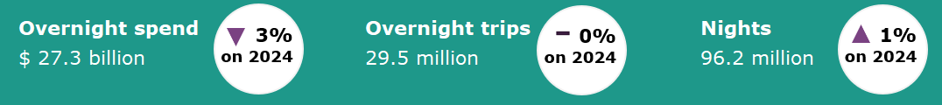

Year ending December 2025*
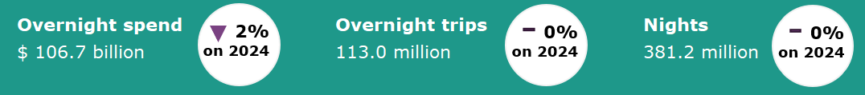

Domestic tourism results remain stable*
Domestic tourism showed mixed results for the December quarter 2025 compared with the same period the previous year. Although overnight spend was down by 3%, overnight trips were on par and nights away were up by 1% compared with the December quarter 2024. This continues the trend observed in recent quarters of Australians continuing to travel domestically, but remaining cautious with their spending.
The year ending December 2025 saw similar results. Overnight spend was down by 2%, whilst overnight trips and nights away were on par with the year ending December 2024.
Figure 1. Percent change for spend, trips and nights compared with the same period in the previous year, March quarter to December quarter 2025*

*Results prior to 2025 are backcast and adjusted to account for differences in methodology between the National Visitor Survey (NVS) and the new Domestic Tourism Statistics which came into effect January 2025. Due to data limitations and the complexity of measuring the differences in spend caused by the methodology changes, TRA recommends exercising caution when interpreting comparisons incorporating the use of backcast spend data. For more information please visit: Changes to the Australian resident tourism statistics collection in 2025 | Tourism Research Australia

Older Australians lead the way in longer stays
Longer trips are more likely to be undertaken by older Australians, while shorter trips are more evenly distributed among age groups.  In the December quarter 2025, 21.0 million (71%) of overnight trips were between 1 to 3 nights in length. These trips were balanced across age groups, with 30 to 44 year-olds representing the largest share and accounting for 27% or 5.7 million trips. This was followed by 14 to 29 year-olds and those 60 years and over, both accounting for 25%, while 45 to 59 year-olds made up 23% of short trips.  As trips get longer, older Australians make up a larger share. In the December quarter 2025, 6.5 million (22%) overnight trips were between 4 to 7 nights in length. For these trips, the share of travellers 60 years and over increased to 30% (2.0 million). The trend was most pronounced for trips longer than 15 nights, where half (366,000 trips) the travellers were aged 60 years and over.  Comparatively, the 30 to 44 year age group saw the largest decrease in share of overnight trips as the length of the trip increased, accounting for 27% of 1-to-3-night trips but only 17% of trips 15 nights or longer. | Figure 2: Proportion of trips by age group and length of trip, December quarter 2025

Top cycling activities
In the year ending December 2025, there were 4.5 million overnight trips that undertook a cycling activity, either as a participant or spectator. Of these trips, 2.9 million or 64% of cycling trips had a main purpose of a holiday.  Cycling for sightseeing was the most popular type of cycling activity for overnight travellers, totalling 2.8 million or 62% of cycling trips (using own bike and hire/share bikes). This was followed by road cycling, with 784,000 trips or 17.4%, mountain biking including cross country with 552,000 or 12.2%, and rail trails with 305,000 or 6.8% of cycling trips.  For those travellers that are cycling for sightseeing, the majority of travellers use their own bike (2.4 million or 86% of sightseeing trips), while a smaller portion use hire or share bikes (380,000 or 14%). | Figure 3: Top 5 cycling activities undertaken by overnight travellers, year ending December 2025

States and territories*
Results for overnight trips were flat for most states and territories in the year ending December 2025 when compared with the year ending December 2024, except for the Northern Territory which saw an increase of 151,000 trips or 18%, and Western Australia which saw a small increase of 222,000 trips or by 2%. Trips for New South Wales, Victoria, Queensland and the Australian Capital Territory were on par. South Australia and Tasmania saw a mild decrease, down 86,000 or 1% and 17,000 or 1% respectively.
Overnight spend results were mostly down on the previous year. Victoria saw the largest decrease (down $1.2 billion or 5%). This was followed by New South Wales (down $410 million or 1%), the Australian Capital Territory (down $380 million or 15%), Queensland (down $379 million or 1%), Western Australia (down $359 million or 3%) and Tasmania (down $83 million or 3%). Northern Territory is the only to state or territory to see an increase when compared with the year ending December 2024, up by $523 million or 43%.
Figure 4. Overnight trips and spend by state and territory, year ending December 2025 compared with year ending December 2024*
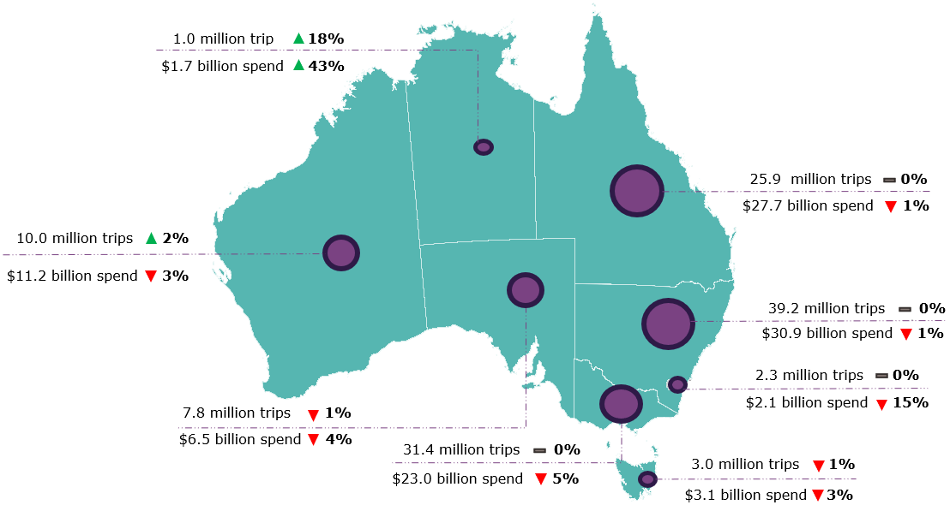
*Results prior to 2025 are backcast and adjusted to account for differences in methodology between the National Visitor Survey (NVS) and the new Domestic Tourism Statistics which came into effect January 2025. Due to data limitations and the complexity of measuring the differences in spend caused by the methodology changes, TRA recommends exercising caution when interpreting comparisons incorporating the use of backcast spend data. Greater caution should be used for less populated states and regions, as the statistical error is higher due to low sample numbers in the underlying survey data. For more information please visit: Changes to the Australian resident tourism statistics collection in 2025 | Tourism Research Australia
Daytrips
In the December quarter 2025, Australians took 70.7 million daytrips, spending $12.7 billion.
Of these:
- 36.6 million daytrips were for holidays
- 21.5 million daytrips were for visiting friends and relatives
- 5.0 million daytrips were for business.
In the year ending December 2025, Australians took 277.4 million daytrips, spending $46.4 billion.
This report has been prepared by the Commonwealth of Australia represented by the Australian Trade and Investment Commission (Austrade). The report is a general overview and is not intended to provide exhaustive coverage of the topic. The information is made available on the understanding that the Commonwealth of Australia is not providing professional advice. While care has been taken to ensure the information in this report is accurate, the Commonwealth does not accept any liability for any loss arising from reliance on the information, or from any error or omission, in the report.

