


Australia’s visitor economy in 2025

Annual benchmark report: Trends and characteristics of Australia’s travel and tourism sector

June 2026
Tourism Research Australia
Australian Trade and Investment Commission (Austrade)
Email: tourism.research@tra.gov.au
Web: www.tra.gov.au
Publication date: 17 June 2025

Acknowledgement of Country
We acknowledge the Traditional Custodians of lands throughout Australia and pay our respects to their Elders past and present. We recognise the enduring connection of First Nations people to land, sea and waters, and their deep care for Country over 65,000 years. We honour the enormous contribution First Nations cultures and traditions make to the visitor experience in Australia and commit to protecting and nurturing these cultures in partnership with First Nations communities.

Copyright © Commonwealth of Australia 2025
The material in this document is licensed under a Creative Commons Attribution – 4.0 International licence, with the exception of:
- the Commonwealth Coat of Arms
- the Australian Trade and Investment Commission’s logo
- any third-party material
- any material protected by a trade mark
- any images and photographs.
More information on this CC BY licence is set out at the creative commons website: https://creativecommons.org/licenses/by/4.0/legalcode.
Attribution
Before reusing any part of this document, including reproduction, public display, public performance, distribution, dissemination, communication, or importation, you must comply with the Attribution requirements under the CC BY licence. Enquiries about this licence and any use of this document can be sent to: advisory@austrade.gov.au.
This work should be attributed as Australia’s visitor economy in 2025: Annual benchmark report, Tourism Research Australia, Austrade, Canberra.
This report is available at https://www.tra.gov.au/en/economic-analysis/annual-benchmark-report
Further enquiries are welcome at tourism.research@tra.gov.au
Using the Coat of Arms
The terms of use for the Coat of Arms are available on the Department of the Prime Minister and Cabinet website.
Disclaimer
This report has been prepared by the Commonwealth of Australia represented by the Australian Trade and Investment Commission (Austrade). The report is a general overview and is not intended to provide exhaustive coverage of the topic. The information is made available on the understanding that the Commonwealth of Australia is not providing professional advice.
While care has been taken to ensure the information in this report is accurate, the Commonwealth does not accept any liability for any loss arising from reliance on the information, or from any error or omission, in the report.
Any person relying on this information does so at their own risk. The Commonwealth recommends the person exercise their own skill and care, including obtaining professional advice, in relation to their use of the information for their purposes. The Commonwealth does not endorse any company or activity referred to in the report, and does not accept responsibility for any losses suffered in connection with any company or its activities.

Foreword – tourism and travel in 2025
In 2025, Tourism Research Australia (TRA) significantly modernised Australia’s official tourism statistics and focused on delivering insights that support decision-making by governments, tourism operators, investors, and industry partners, by further modernising its methods for data collection, reporting, and communication.
TRA’s work in 2025 focused on implementing a world-leading approach to measuring domestic tourism that integrates new data sources and an innovative data collection process. TRA also published additional regional-level mobility data, generated in-depth insights into a range of markets and enhanced reporting and information dissemination practices. These efforts ensure TRA research is more accessible and relevant, and that TRA data is more granular and timely, while taking advantage of the best available data.
This annual benchmark report from TRA brings together key metrics, published report snapshots, and detailed analysis to examine the performance of the sector in 2025 from both demand and supply perspectives. It also includes valuable case studies contributed by our research partners, recognising their critical role in shaping Australia’s visitor economy, and reflecting the importance of collaboration across government and industry stakeholders in delivering the THRIVE 2030 strategy for the visitor economy.
This annual benchmark report outlines the opportunities and challenges facing the sector. It provides nuanced insights into visitor movement, regional dispersion, sustainability outcomes and industry performance, and adds to the evidence base for policy development and investment decision-making.
Across a range of metrics, 2025 was a positive year for the visitor economy. Its success in building momentum and improving resilience should support the industry in 2026 and beyond.
Grant Ferres
Head of Tourism Research Australia

Table of Contents
Australia’s visitor economy in 2025 0
Acknowledgement of Country 1
Foreword – tourism and travel in 2025 3
Visitor economy review 6
Domestic travel: the powerhouse of regional tourism 9
International visitor economy 17
Global and outbound travel 25
Industry, operators and investment 29
Accommodation 29
Aviation and connectivity 33
Businesses and jobs 37
Investment 43
Visitor economy outlook 46
International outlook 47
Domestic outlook 48
Sources 49

Visitor economy review
This benchmark report provides evidence and insights into how Australia’s visitor economy performed in 2025. Tourism Research Australia (TRA) produces this annual overview of the capacity of providers in the Australian tourism sector (supply side), as well as trends in demand, to:
- explain major developments in the visitor economy
- highlight challenges and opportunities for the visitor economy
- help the industry and governments understand and adapt to the changing demand and supply environment.
Unexpected challenges emerged in early 2026
As this report focuses on 2025, the Middle East crisis that commenced March 2026, which is having an impact on the visitor economy and the global economy, is not detailed in the report.
This report focuses on analysing and highlighting the conditions of 2025. Understanding the drivers behind trends and changes in 2025 may assist the sector to continue to adapt and maintain momentum in 2026 and beyond in the context of more recent challenges.

Australia’s visitor economy shows momentum
In 2025, Australians and international travellers continued to prioritise travel, and there was strong interest in Australia’s tourism offerings.
Domestically, demand for domestic trips remained high, particularly for day trips. However, growth in domestic overnight travel was muted as travellers continued to adjust spending patterns in response to household financial pressures.
Internationally, there was continued growth in arrivals from many source markets. The positive impact of major international sporting events was obvious with a significant boost in visitation and spending from the United Kingdom (UK) in 2025. While there were still fewer international visitors to Australia in 2025 than in 2019, visitors in 2025 on average stayed longer and spent more in Australia, leading to a significantly higher total international visitor spend in Australia in 2025.
On the supply side, the capacity of the visitor economy expanded in 2025, with more flight routes and connections, more hotels and accommodation offerings, a substantial increase in the visitor economy workforce, and continued growth in the investment pipeline of major tourism related public and private investment projects.
These are significant achievements that give confidence for the future growth of the sector and its ability to withstand emerging challenges.
In 2025, Australia’s visitor economy in 2025 consisted of:
- 8.9 million international visitor arrivals (up by 8% on 2024)
- 113 million domestic overnight trips in 2025 (up by 0.2% on 2024)
- 381.2 million domestic visitor nights in 2025 (down by 0.4% on 2024)
- $192.4 billion visitor economy spend in Australia in 2025 (up by 6.5% on 2024)
Figure 1: Total visitor spend in Australia in 2025 by traveller type (excluding long-stay international students)
The visitor economy had a significant impact on GDP, investment, businesses and jobs in 2024.
- Tourism contribution to GDP was $81.1 billion in 2024–25, this was 2.9% of national GDP. The tourism contribution to GDP increased by $3 billion from 2023–24.
- The tourism investment pipeline increased to $74.5 billion in 2024–25 and contained 363 major tourism-related projects. The tourism investment pipeline has increased each year since 2018−19.
- The number of tourism-related businesses operating was 361,272 in June 2025. This accounted for one in 8 businesses in Australia and was up by 237 (0.1%) compared with June 2024.
- The number of tourism filled jobs reached a record high in December 2025 or 736,800. This represented one in 22 jobs in Australia and was up by 33,000 filled jobs (4.7%) compared with December 2024.

2025 domestic travel: Analysis of demand trends
Australians’ love of travel continued in 2025 with 390.4 million domestic trips being taken. Domestic travel was a key contributor to tourism in 2025 with spend of $153.2 billion across both overnight and day trips.
Australians also love to explore the world with over 8 million overseas trips being taken from January – September. This number increased by 10% from the same period in 2024.
Australia maintained its international visitor growth, with an 8.4% increase in international visitors. Spend in Australia outpaced visitor growth increasing by 19% on the previous year to reach $39.2 billion.
Table 1: Summary of trips, nights, spend by traveller cohort
 | Trips | Nights | Spend in Australia | Average spend per trip
Domestic overnight | 113.0 million | 381.2 million | $106.7 billion | $945
Domestic day trip | 277.4 million | – | $46.4 billion | $167
Outbound Australians* | 8.3 million | 161.2 million | $65 billion* | $7,774
International visitors | 8.3 million | 312.7 million | $39.2 billion | $4,738
Outbound travel data refers to January – September 2025 only. In 2025, production of Australian resident tourism statistics by TRA changed. Methodology changes have resulted in a series break since outbound trips data is now collected from face-to-face interviewing (previously mobile phone), population estimates now include residents aged 14+ (previously 15+) and the survey recall period has increased to 4 months (previously 3 months). For more detail, please visit https://www.tra.gov.au/en/domestic/changes-to-the-australian-resident-tourism-statistics-collection.

A full year of DoTS data is now available for 2025
From January 2025, TRA introduced the Domestic Tourism Statistics (DoTS) collection, a new, world-leading approach to measuring Australian resident tourism.
DoTS combines rich survey information with large-scale mobility data to deliver more detailed, reliable and timely tourism insights. It is also a future-proofed framework that can incorporate new data sources as they become available.
Most core variables under the National Visitor Survey (NVS) remain available under DoTS, with survey content largely unchanged.
The methodology changes include:
- A move from telephone interviews to a combination of face-to-face and online interviews
- Integration of large-scale, de-identified mobility data, drawing on over five billion data points each day
- Updated treatment of fly-in fly-out (FIFO) travel to exclude routine work-related movement
- Expanded scope and revised recall periods to improve trip capture across domestic day, overnight and outbound travel.
These changes also mean that TRA can now provide data for an increased number of local government areas (LGAs), including capital city LGAs, which were previously not reportable.
Trips and nights data for LGAs is now available on an annual basis, while LGA data had previously only been possible on a 2-year or 4-year average basis.
However, the DoTS methodological change means that it is not recommended to directly compare DoTS data with the historical NVS data.

Domestic travel: the powerhouse of regional tourism
Domestic overnight travel in 2025 was relatively stable when compared to 2024 numbers. This aligned with TRA forecasts that expected overnight trips to increase by 0.3%.
Several factors may have impacted Australian’s propensity to travel domestically including environmental events such as North Queensland floods, and algal blooms in South Australia, as well as increased airfares and high cost of living pressures.
Average nights per trip remained stable, indicating there was still a desire to connect, explore, and experience Australia. With a slightly reduced average spend per trip, travellers were making their trips more cost effective where possible.
Compared to 2024, in 2025:
• there were 215,850 more domestic overnight trips (up 0.2%)
• the average spend was $945 (down 2.1%)
• domestic overnight spend was $106.7 billion (down 1.9%)
In 2025, domestic overnight trips generated $106.7 billion of spend, or 55% of total tourism spend in Australia.
Almost half, 49%, of all domestic overnight spend was spent in regional Australia. The average spend per night in regional Australia was $230, lower than the $353 average spend per night including a capital city. ‘Capital cities’ are defined as the 8 state and territory capital cities plus the Gold Coast.
Holiday spend for overnight trips makes up a significant portion of tourism value. Over $31 billion or 54% of holiday spend on overnight trips was spent in regional Australia.
Figure 2: Spend on domestic overnight trips by purpose in Australia in 2025
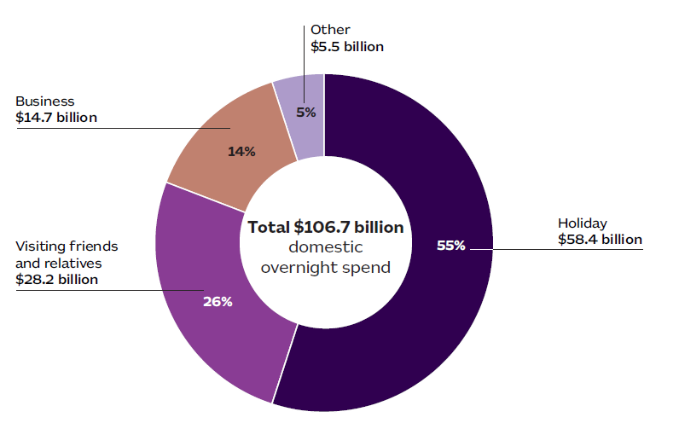
Percentage values in the chart report spend for that purpose as a share of total domestic overnight spend in Australia in 2025. Values in the label boxes report the value for that purpose of trip in 2025.
CASE STUDY:
Floriade 2025; Major branded events attracting visitors
Floriade 2025 is a reminder that some events don’t just fill a calendar; they move the needle. Held over 30 days in Commonwealth Park, Canberra’s best-known festival drew 519,413 attendees – it’s largest crowd ever – with almost half travelling from interstate or overseas. For many, it was the prompt to pack a bag and head to the Capital as winter gave way to spring.
The flow-on effects were felt well beyond the park gates. Visitor spending reached $71.5 million, including a record $56.7 million in direct in-scope economic impact, supporting hotels, restaurants, transport providers, and cultural attractions across the city. Visitors stayed 3 nights on average and generated 234,374 visitor nights.
Part of the appeal lies in how Floriade has broadened its offer. The flowers remain the hero, but they’re now complemented by free performances, local food and wine, markets, art installations, and ticketed night-time experiences. The result is an event that encourages visitors to slow down, explore Canberra and stay an extra night or two.
The response from visitors was clear. Satisfaction rated 4.2 out of 5, with a Net Promoter Score of +38.8, signalling strong word-of-mouth advocacy. Thirty-three per cent of attendees were first timers, while most said they intend to return.
With national media reach exceeding 40 million, Floriade 2025 showed how a mature, much-loved event can keep evolving – delivering real economic impact while reinforcing Canberra’s position as Australia’s spring destination.
Case study provided by VisitCanberra

Tourism Regions by State
Capital city tourism regions remain popular destinations for domestic overnight travellers, with each capital city having the highest share of trip visitation for each state or territory.
Some regional tourism regions are incredibly popular amongst overnight travellers, particularly Australia’s Southwest in Western Australia, and Launceston and the North in Tasmania.
Regional dispersal accounts for many trips taken in Australia. In 2025, roughly 2 in 3 trips in New South Wales, South Australia and Tasmania were taken in regional parts of the state and territory.
Share of trips for each state and territory that included a regional component:
- New South Wales 72%
- Tasmania 66%
- South Australia 65%
- Victoria 63%
- Queensland 53%
- Northern Territory 50%
- Western Australia 45%

Figure 3: Total trips, nights, spend and top tourism regions
Share of trips taken within the state shown in brackets (%)
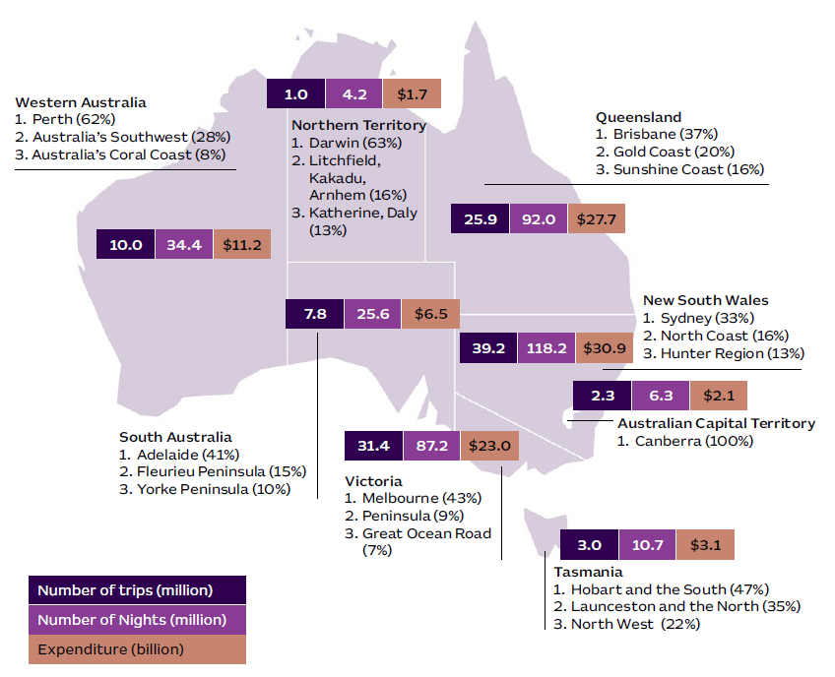

Regional trip spend bolstered by accommodation and petrol compared to capital city spend
Domestic overnight travel to Australian capital cities had higher share of spend on higher cost items such as airfares and transport than trips to regional Australia.
Regional share of spend is largely accommodation, food, drink and petrol. Australians going on trips to regional Australia spend approximately $300 less than trips that include capital cities.
Figure 4: Share of spend on items regionally vs capital cities
% share of expenditure per item
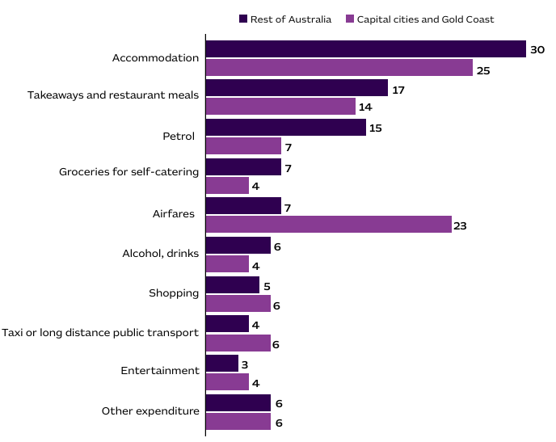
Analysis of regional nights show a broader variation of commercial visitation compared to capital city nights. Accommodation is the highest share of spend on domestic overnights trips in Australia. Hotels account for the largest share of spend among available accommodation types (46% of total accommodation spend).
Regional Australia’s share of nights is split between friends and relatives, hotels and caravan parks contributing to the success of many operators around Australia. Capital city nights are primarily spent with friends or relatives, or in hotels. Much fewer nights are spent in caravan parks within cities which is to be expected.
Figure 5: Accommodation nights by regional vs capital cities
Share of nights (%)
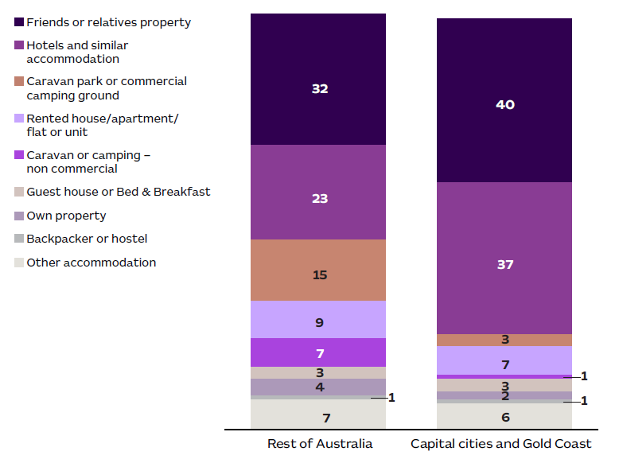
Regional visits have more outdoor and active activities than visits in the capital city. Visits to regional Australia are more likely than capital city visits to involve outdoor, and nature-based activities such as going to the beach, visiting national parks, bushwalking, and fishing.
Arts and heritage activities are more likely to happen in capital cities such as attending the theatre, museums, and attending festivals and cultural events. Social activities such as eating out, going to pubs and clubs, and shopping and sightseeing happen on all trips highlighting the great options Australia must connect wherever you are.

Figure 6: Regional Australia vs Capital Cities activities
Share of visits (%)
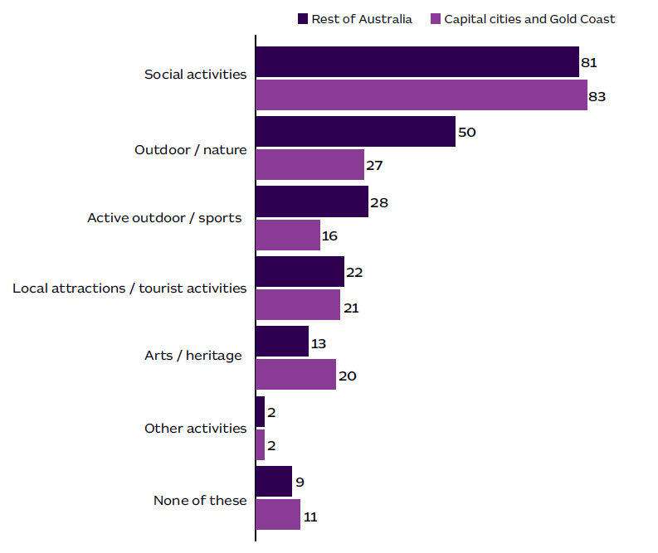

CASE STUDY:
Monarto Safari Resort; Destination-led tourism development
Monarto Safari Resort has played an important role in strengthening overnight visitation to regional South Australia. By providing premium accommodation alongside a major wildlife attraction, the resort adds a high-value product to South Australia’s regional tourism offer.
With its $40 million luxury accommodation development that opened in May 2025 offering 78 guest rooms and suites, Monarto Safari Resort is evolving the attraction from a day-visit into an overnight destination and enhancing the appeal of the Murray River, Lakes and Coorong region as a stay-and-explore destination.
Monarto Safari Park, as Australia’s largest open-range zoo, provides a vast sanctuary for more than 500 animals, and its primary mission is centred on the conservation and protection of African wildlife within its expansive, naturalistic habitats. The new integrated accommodation offering supports a more complete visitor experience rather than simply servicing existing demand. Its design and setting reflect a nature-based tourism model, with the hotel positioned to complement the park’s wildlife and conservation-focused identity.
Monarto Safari Resort is an example of destination-led tourism development, demonstrating how investment in a major attraction can create longer stays, a stronger visitor offer, and a more distinctive regional tourism product.
Case study provided by South Australian Tourism Commission

International visitor economy
Australia attracted high spend travellers in 2025. In 2025, Australia saw strong growth in international visitor spend with travellers on average spending more per night and more per visit, despite having a slightly shorter average stay than 2024. The growth in spend was shared across a range of Australian destinations.
China, Australia’s largest source market by value, accounted for half of the total increase in international visitor spend in Australia in 2025. Visitors from the UK also contributed strongly to the growth in spend, with a 10% increase in their average spend per trip in 2025 compared with 2024. Visitors from the USA, New Zealand, Europe and Hong Kong also contributed to the strong growth in spend with these markets showing a notable increased in average trip spend in 2025.
By purpose of trip, there was growth in both the number and value of international trips for all the main reasons for travel except business travel in 2025.
Facts and figures for 2025:
- there were 638,800 more international trips to Australia (up 8%)
- international spend in Australia rose to $39.2 billion (up 19%)
- average spend per trip was $4,738 (up 10%)
- Average trip length was 38 nights (does 2%)
- 3.6 million overseas travellers came for a holiday (up 11%)
- 2.4 million trips went to regional Australia (up 4%)
- International trip spending in regional Australia reached $5.7 billion (up 21%)
- China was Australia’s largest source market by value again in 2025, worth $11.2 billion
- (spend in Australia by visitors from China was up 39% on 2024)
International visitation in 2025 increased from most markets. New South Wales (NSW) welcomed the most international visitors in 2025, with half of all short-term international visitors reporting a stopover in that state.
Growth in international visitation was particularly strong in 2025 in Western Australia (WA), the Northern Territory (NT), Tasmania (Tas), Victoria (Vic) and Queensland (Qld).
Trip numbers from the UK contributed the most to growth in WA in the year, while the USA and India contributed the most to growth in international visitation to the NT. Increased visitation from the USA, Hong Kong and New Zealand contributed the most to growth in Tasmania, while growth in Queensland was driven by visitors from China, the UK, Hong Kong and Taiwan.
In contrast, international visitation to the Australian Capital Territory (ACT) declined in 2025, reflecting fewer travellers from the USA, China, New Zealand, Indonesia, and Europe.

Figure 7: International trips to Australia in 2025, with top 5 source markets by state/territory
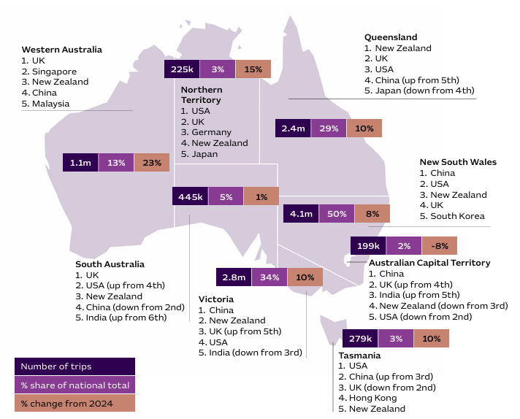
CASE STUDY:
The Approved Destination Status (ADS) Scheme; Progressing a modernised, fit-for-purpose scheme, shaped by robust industry engagement
Genuine collaboration with industry is the cornerstone of Austrade’s approach to modernising and enhancing the Approved Destination Status (ADS) scheme.
From early 2025, meetings between peak industry bodies, government stakeholders and key ADS operators in China have permitted the exchange of market insights and emerging concerns and opportunities. This bilateral government-industry cooperation between the two countries has enabled key ADS stakeholders to align their efforts to strengthen Australia’s appeal as a group tourism destination.
Bilateral cooperation is complemented domestically by a structured, year-round industry outreach program. This includes visits to major cities, attractions and industry events to meet with ADS operators, suppliers and tourism officials to gather feedback on the scheme’s administration. Industry feedback has ensured that measures implemented for the transition phase of the scheme’s reopening hit the right areas of focus and met the evolving realities of industry.
These engagements have shaped the design of the ADS Transition Phase Roadmap (which was unanimously endorsed by over 50 ITOs) and the ADS Interim Compliance Framework, which were both launched in 2025. Robust industry engagement and co-design workshops will also feed directly into the new ADS Code of Business Standards and Ethics (the Code), which will prescribe minimum standards for the scheme.
Since the ADS scheme’s recommencement (September 2023), the number of Chinese tour groups arriving in Australia on the scheme has steadily grown. The number of ADS visa lodgements increased by 105% in 2024–25 compared with 2023–24. (Home Affairs data)

Record high international visitor spend in 2025
International short-term visitor* spend in Australia reached $39.2 billion in 2025. This was a record high and an increase of $6.3 billion (19%) on the previous year.
By purpose of travel, education provided the biggest contribution to spend in Australia in 2025, accounting for 37% of total short-term international visitor spend in Australia.
‘Leisure’ travel, consisting of both holiday and visiting friends/relatives (VFR), accounted for almost $1 in every $2 spent in Australia in 2025.
*International visitors are classified as short-term visitors if they remain in Australia for less than 12 months. Therefore, long-stay students, such as those engaged in multi-year degrees, that stay in Australia without returning home for more than 12 months are excluded from the IVS measures.

Figure 8: International spend in Australia in 2025 by main purpose of trip
Top 5 source markets in 2025 for each main purpose of trip
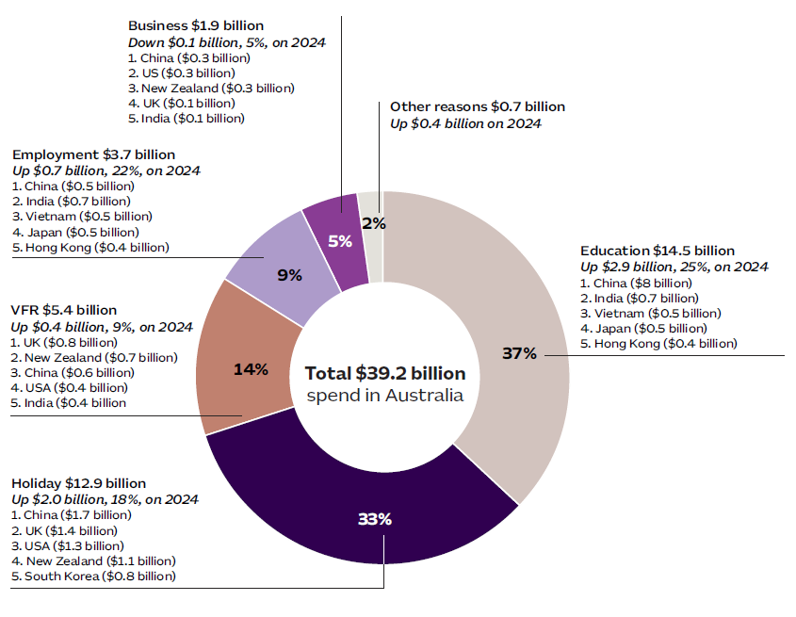

International visitor spend increased substantially across Australia
The growth in international visitor spend in Australia was shared across regional Australia and the capital cities. In 2025, international visitor spend:
- was $33.5 billion in capital cities and the Gold Coast (85% of total) up by
- $5.3 billion (19%), on last year
- was $5.7 billion in regional Australia (15% of total), up by $1 billion (21%) on 2024.
Growth in spend by international visitors in regional Australia was strongest in Victoria (Vic) in 2025 (up 30%), with strong contributions to the growth in spend by visitors from China, Japan and India. Queensland (up 26%) had strong contributions to the growth in spend by visitors from China, the UK and New Zealand. It was weakest in South Australia (down by 2%).
By purpose of trip, holiday travel in regional Australia accounted for 51% of total international spend, while holiday travel accounted for a smaller share, 30%, of spend in capital cities. The growth in international spend in regional Australia for holiday trips specifically was not as strong as for all purposes, notably in NSW and SA.
Figure 9: International visitor spend by region visited
Change from 2024 to 2025, %
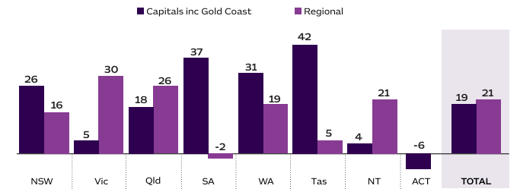
Figure 10: International visitor spend by region, for holiday trips only
Change from 2024 to 2025, %
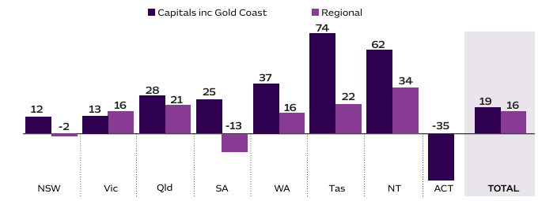
CASE STUDY:
Wallabies v British & Irish Lions test; Major sporting events generate broad tourism impact
The Wallabies v British & Irish Lions Test at Suncorp Stadium in July 2025 delivered strong tourism outcomes for Queensland, driving visitor dispersal beyond Brisbane.
Hosting the first Test positioned Brisbane as the primary international gateway for the tour. Airline booking data showed a substantial uplift in UK arrivals to Brisbane during July 2025, indicating the Test materially influenced travel decisions. This influx created a base for onward travel across Queensland and Australia.
The match was estimated to have generated over 120,000 visitor nights statewide, with around one-fifth of these nights spent outside the Brisbane region. Interstate and international visitors were the key contributors to dispersal. Overseas visitors averaged more than six nights away from home, increasing opportunities for multi-destination travel.
Accommodation data indicates regional spillover around the Test window, particularly in Southeast Queensland, where the Gold Coast experienced a moderate uplift in bookings. While some northern destinations e.g. Tropical North Queensland, were already operating at peak seasonal demand, they continued to benefit from strong occupancy during the Lions tour period.
Overall, the Test acted as a statewide tourism catalyst, delivering economic benefits that extended beyond Brisbane and supporting enduring value for Queensland’s visitor economy.
Case study provided by Tourism and Events Queensland

International working holiday makers are a high-spending market
According to TRA’s International Visitor Survey (IVS) data, almost 5% of international trips to Australia in 2025 were by those holding a working holiday visa.
The number of international travellers that reported being on a working holiday visa increased by 11% to 405,000 in 2025, which was faster growth than international travel for other purposes. Working holiday makers (WHMs) also reported faster growth in nights stayed in Australia in 2025 than the non-WHM cohort, but slower growth in their trip spend in Australia.
International WHMs spent $1.1 billion in regional Australia, accounting for 20% of the total international spend in regional Australia in 2025 and $3.3 billion in capital cities (10% of international capital city spend).
By source market, WHMs from the UK drove the growth in trip numbers and spend, followed by visitors from France. There were also strong increases in WHMs from Japan, China, Hong Kong and Malaysia.

International business trips
In 2025, the number of international business trips to Australia declined, and the average length of those trips declined. This continued a trend seen in the previous year, when business travel budgets seemed to put pressure on business travellers to condense their itineraries. While total trip spend declined for business travellers in 2025 due to the shorter trips, the average spend per night increased by 9%.
Within the main trip purpose of ‘business’ travellers can identify whether their trip purpose was ‘business’ or convention/ conference’. This detail highlights that the number of international travellers to Australia for the purpose of attending
a convention or conference specifically increased in 2025. Those conference travellers spent more in Australia in 2025 than the previous year. Their spend per trip on tours and entertainment increased in 2025 (in contrast to routine ‘business’ travellers who reported reduced spend per trip on tours, transportation, food and drink, and accommodation, and entertainment).

Table 2: International travellers to Australia by purpose (business related) 2025 compared with 2024
 | Trips (% change) | Average length of trip (change in days) | Spend in Australia  (% change)
Business travel | -2.7 | -1.4 | -5.4
Of which
Business | -7.1 | -1.5 | -9.2
Convention/conference | 14.7 | 0.0 | 11.6
Total (all purposes of travel) | 8.4 | -0.8 | 19.1
By source market, the decline in business trips in 2025 was spread across a range of markets including Europe and North Asia. There were fewer routine ‘business’ travellers in 2025 from France, Italy, Switzerland, Canada, Vietnam, Thailand, South Korea, Indonesia, Hong Kong, Other Asia, Japan, and the USA. In contrast, business trips to Australia from China, Singapore, Philippines, New Zealand, India and the UK increased in 2025.
CASE STUDY:
Business events; Attracting high spend domestic and international visitors through business events
In 2025, there were 20.7 million visitors either attending or accompanying attendees to business events in Australia. This generated $17.2 billion in visitor spend in Australia, highlighting the sector’s strong contribution to the visitor economy.
Beyond business events’ economic impact, visitors contributed an additional $1.6 billion in overseas spend, bringing total trip spend to $18.8 billion. Of the total spend in Australia, $2.3 billion (13%) came from international visitors, while $14.9 billion (87%) was driven by domestic travel.
Domestic overnight visitors were the largest contributors, accounting for $12 billion, with a further $2.9 billion generated through domestic daytrips for business events.
On average, international business event visitors spent 50% more per night compared to international leisure visitors. In 2025, international travellers that attended (or accompanied) a business event from China had the most significant growth, followed by India, New Zealand and UK.
These insights are based on TRA data collected from business event questions embedded into the IVS and DoTS (previously NVS) surveys.

The value of visiting friends and relatives
In 2025, Australia had a population of 8.8 million residents that were born overseas, or 32% of Australia’s total population.
The number of international VFR trips to Australia has trended higher and surpassed its previous peak in 2025. It is expected to continue rising supported by Australia’s growing internationally born population.
Australia’s population is largest for people born in:
- India (where the population has doubled over the past 10 years)
- England (this population has been declining over the past 10 years, and the average age of this population is high and rising)
- China (this population has also grown strongly and is now larger than the population that was born in New Zealand − which is now ranked 4th largest population of people born overseas)
- followed by countries including the Philippines, Vietnam, Nepal and Malaysia which are large and rapidly growing populations.
VFR travel to Australia from a range of nations including many European nations reached new peaks in 2025, while other purposes of travel have been slower to grow. This reflects the strong motivation of travelling to visit friends/relatives and lower average cost of this type of travel, since expenses may be shared or reduced.

Global and outbound travel
Globally, international tourism arrivals reached a record high in 2025 of 1.5 billion, up 4% from 2024. The growth rate slowed compared to 11% in the previous year yet indicates ongoing demand for global travel as people continue to prioritise travel.
Asia and the Pacific and Africa were the fastest growing regions in 2025, while the Americas was the slowest. In the Asia and the Pacific region, growth was driven by the North Asia region, while global international arrivals to the South Asia region declined in 2025.
Very mild growth the Americas region reflected a 1.4% decline in global international arrivals to the North America region (still 7.6% below 2019 level), while arrivals to Central and South America saw strong growth.
Figure 11: Global international tourism arrivals in 2024 and 2025
Number relative to 2019 level, Index 2019 = 100
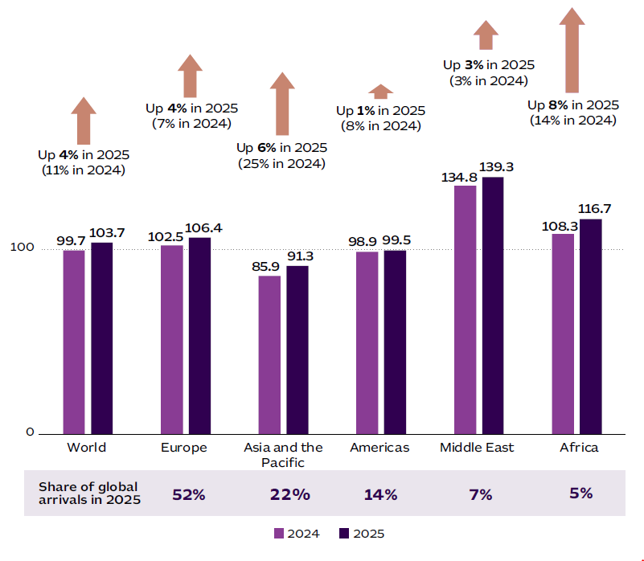

More Aussies travelled overseas in 2025
ABS data on overseas arrivals and departures shows Australians continued to increasingly travel overseas in 2025. There were 12.5 million short-term overseas trips (defined as less than a year) in 2025, up 8% on the previous year.
Most overseas trips in 2025 were for the purpose of a holiday (60%, 7.5 million trips) with strong growth compared with 2024 (up 9%). VFR was the second-largest reason for overseas trips (26%, or 3.3 million trips) and rose by 6% compared with 2024. By destination, the strongest growth markets in 2025 for Australian outbound travellers were Japan, China and Vietnam (all up by 19% compared with 2024).
Growth in outbound holiday travel in 2025 was strongest among older age groups. Indonesia was the top holiday destination in 2025 for all age groups. Japan was the 2nd most popular holiday destination for outbound travellers aged 15–29, 30–44 and 45–60, and the 3rd most popular destination for older Australians, behind New Zealand. 77% of outbound business trips were taken by 30–59-year-olds, of which the majority (71%) were males.
Travellers aged 75+ are the most likely to travel for VFR purposes (39% of trips by 75+ year olds); in contrast, the youngest travellers have the lowest tendency to travel for VFR purposes (20% of trips by 15–29-year-olds).
The ABS Tourism Satellite Account reports that Australian overseas travel in 2024–25 generated $6 billion in spend in Australia from domestic purchases before/after the trip.
Table 3: Short-term resident returns
Top 10 destinations in 2025
 | Trips in 2025  (000) | Change from 2024  to 2025
1. Indonesia | 1,750 | 4%
2. New Zealand | 1,450 | 6%
3. Japan | 950 | 19%
4. United States | 710 | -3%
5. China | 690 | 19%
6. Thailand | 640 | 9%
7. United Kingdom | 640 | 3%
8. India | 600 | 9%
9. Vietnam | 520 | 19%
10. Fiji | 413 | 1%
TOTAL | 12,550 | 8%

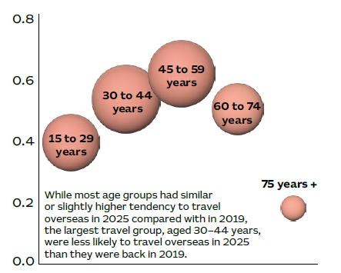
Figure 12: Short-term resident returns; Trips per person in 2025 by age group

Older travellers spend up overseas
TRA’s DoTS data collection allows analysis of spending habits of outbound travellers. In the first 9 months of 2025, Australians aged 60–74 spent an average of $11,000 on their outbound trips and on average spent 22 nights away, making them a high spend per night ($511) age group, along with those aged 45–59 years (average spend of $529 per night).
In contrast, Australians aged 14–29 years typically spent an average of just under $6,000 per trip. They also took the longest outbound trips, and had the lowest average spend per night ($245).
Older age groups typically spent more on organised tours and package tours, than younger age groups. By destination, the older age groups were more likely to travel to the UK or Europe on their outbound trip (24% of trips) compared with younger generations (13% of trips). Meanwhile, younger generations were much more likely to travel to China, Japan, India and ‘other Asia’ (27% of trips) compared with the older generations (14% of trips).
International outbound holidays in 2025 were typically much longer (averaging 16.6 nights) than domestic overnight holidays (averaging 3.6 nights), with higher average spend per night of $523 for outbound holidays compared with $332 per night for domestic overnight holidays.

Figure 13: International outbound trips by Australians
Average spend per trip in 2025 by age group, $ per trip
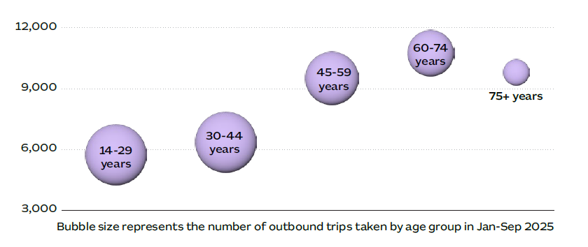
Figure 14: Holiday trips by length of trip
Share of trips in 2025 (year to September), %
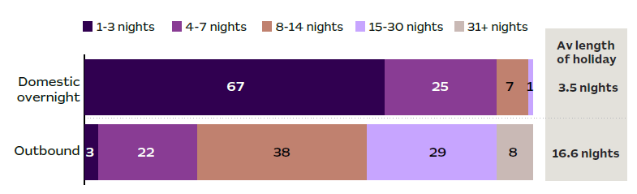

Industry, operators and investment
In 2025, Australia’s visitor economy capacity increased, helping to service more travellers.
Table 4
Metric | Description | 2025 value | Change between 2024 and 2025
Accommodation rooms | Total number of rooms available in accommodation establishments with 10 rooms or more (as at December) | 340,662 | +0.8% ▲
Accommodation occupancy | Percentage of rooms sold, or occupied, in establishments with 10 rooms or more (average for the year) | 72.0% | +3.6ppt ▲
International aviation seats | Total number of inbound seats available on flights to Australia | 27.9 million | +7.5% ▲
International aviation load factor | Percentage of seats on flights into Australia occupied by revenue passengers | 82.6% | +0.5ppt ▲
Domestic aviation seats | Number of seats available to people flying within Australia | 74.5 million | +0.2% ▲
Domestic aviation load factor | Percentage of seats on domestic flights occupied by revenue passengers | 82.5% | +0.9ppt ▲
Tourism jobs | Number of filled jobs in the tourism industry (as of December 2025) | 736,800 | +4.7% ▲
Tourism job vacancies | Number of tourism-related job vacancies advertised online (as of December 2025) | 12,000 | -23.9% ▼
Tourism businesses | Number of Australian businesses in tourism-related industries (as at end June 2025) | 361,270 | +0.1% ▲
Tourism investment | Total value of investment in tourism infrastructure projects valued over $20 million (as at end June 2025) | $74.5 billion | +17.5% ▲

Accommodation
Accommodation capacity continued to increase, primarily on the east coast. Commercial accommodation capacity increased to a record high of over 340,000 rooms in 2025, according to STR data. This is an increase of 2,787 rooms, or 0.8% nationally, with growth on par or slightly below previous years. Consistent steady growth in a mature market such as accommodation implies sustainable growth with stable demand rather than volatility.
South Australia saw the biggest increase in capacity (2.2%), then Victoria (1.6%), Queensland (1%), and New South Wales (0.8%). Other states and territories had either low growth, or a decline on 2024 rooms.
Nationally there has been the most growth in luxury rooms (2.5%). South Australia has the highest growth rate of luxury rooms (7.6%), followed by Victoria (6.8%).
Figure 15: Number of rooms available in establishments with 10 rooms or more as of December 2022 to 2025
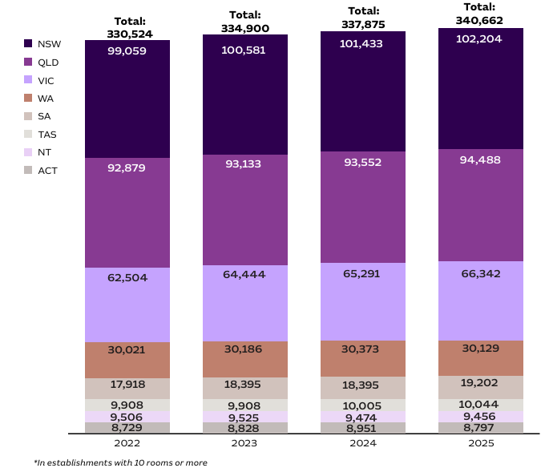
Occupancy-rate analysis shows high demand (70%+) for much of 2025. The average occupancy rate for commercial accommodation continued to trend higher in 2025 averaging 73% across the year, with a peak through October and November. March 2025 occupancy was notably lower than the previous year likely due to tropical cyclone Alfred hitting Southeast Queensland and Northern New South Wales.
Towards the end of 2025, Average Daily Rate (ADR) and Revenue per available room (RevPAR) were trending upward. This was seen in all states and territories except the Northern Territory.
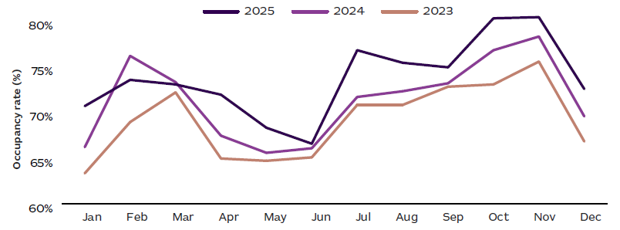
Figure 16: Monthly occupancy rate of Australian accommodation establishments, 2023–2025
Figure 17: ADR and RevPAR for Australia, 2021 to 2025
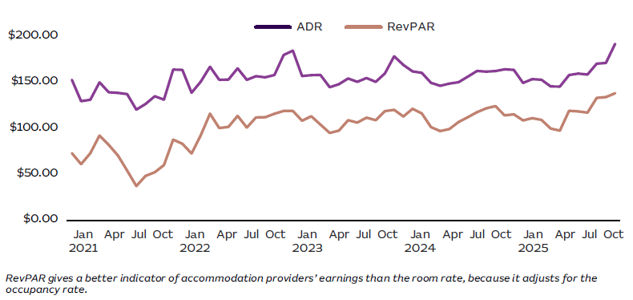
Accommodation preferences vary by traveller. Commercial accommodation in 2025 was largely hotels and similar, accounting for 46% of nights, primarily from domestic overnight travellers.
Domestic travellers drive the commercial caravan and camping nights taken, accounting for 94% of the commercial holiday nights for this style of accommodation.
International travellers have similar numbers of nights between hotels and rented house, apartments, or unit style accommodation.

Figure 18: Commercial accommodation used by international and domestic overnight nights in 2025
For holiday trips, or for trips where ‘holiday’ was the main reason for trip
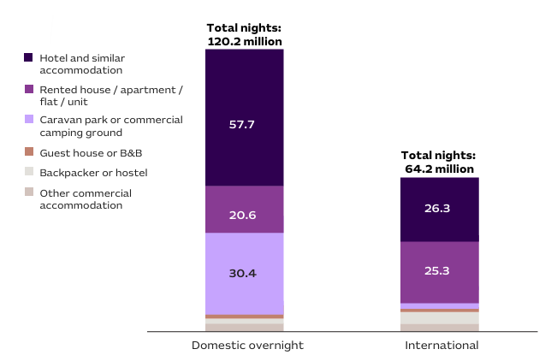
*Values les than 10 million are not shown.

Caravan and camping
Caravan and camping trips (including glamping) reached a record 17.3 million trips in 2025 — the highest year on record. Almost one in every 7 domestic overnight trips was a caravan and camping trip. Caravan and campervan registrations reached 938,000 which is a record. Total spend on caravan and camping trips reached $12.6 billion, well above pre-COVID levels of $10.2 billion.
Commercial caravan parks and camping grounds dominated the market, accounting for 67% of trips, 70% of nights, and 75% of spend across all caravan and camping trips. The primary purpose being holiday, which accounted for 77% of trips.
The sector also continues to play a pivotal role in regional Australia, where 87% of caravaning and camping nights are spent in regional Australia, contributing $8.6 billion. In regional Australia, caravan and camping trips account for one in every three domestic overnight holiday trips and nights, and one in every four dollars spent on holidays.

Table 5: Caravan and camping data for 2025
Registration data | Trip data | Regional Australia
938,000 campervan or caravan registrations | 17.3 million caravan and camping domestic overnight trips | $8.6 billion
Growth of 3.8% on 2024 registrations | 57.9 million nights | 87% nights in regional Australia
Queensland has the highest share of registrations at 27.5% | $12.6 billion spent on their caravan and camping trips | New South Wales had the highest share of regional nights at 35%
 | In 2025, the average national occupancy for powered sites and short-term lodgings/occupancy was 62.7% | New South Wales also had the highest share of regional spend at 35%
 | October had the highest month of occupancy (69.1%) in 2025

Aviation and connectivity
Domestically, business and best discount airfares have largely stabilised while there is still variation reported for Economy prices. The ACCC’s Domestic Airline Competition report found increased demand for domestic air travel towards the end of 2025 led to increased seat utilisation and led to higher airfares.
Following an extended period of voluntary administration, REX airlines was taken over by US based aviation group Air T, supported by the Australian Government to stabilise the company.
Airline performance measures continue to improve with more on time departures and arrivals, and lower cancellations nationally. Highest route cancellation in 2025 was seen between Canberra – Sydney route (both ways), Port-Lincoln – Adelaide and Sydney – Melbourne.
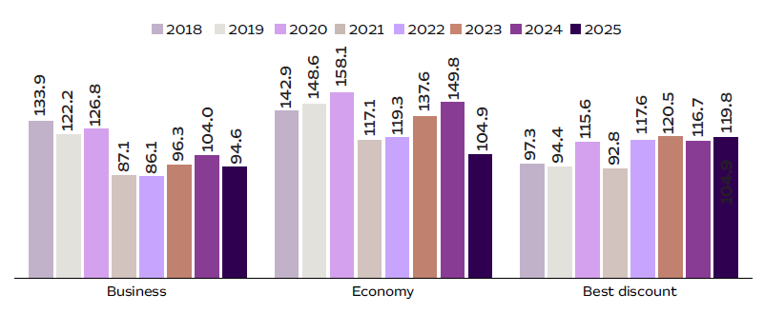
Figure 19: Domestic airfares by category, January 2018 to March 2026
Smoothed index level relative to July 2003
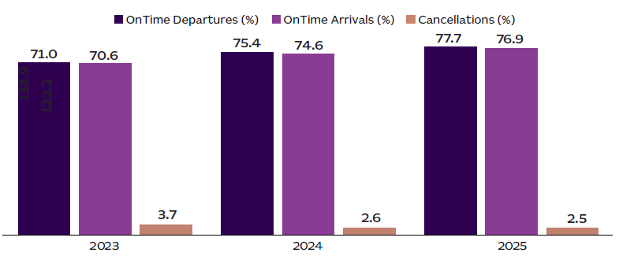
Figure 20: Airline performance 2023–2025

Increases in domestic and international seat capacity
In October 2025, Qantas and Virgin Australia added more than 45 additional flights, increasing capacity because of high demand.
Overall, domestic aviation capacity increased by 1% on 2024, slightly slower than seen in the year prior. Seat utilisation also increased by 1% as many sporting events throughout the nation were held.
Two of the highest seat capacity increases in 2025 connected with regional Australia, while one was between capital cities. The highest increase in domestic seat capacity in 2025 were between:
- Devonport – Melbourne (+20%)
- Brisbane – Darwin (+17%)
- Brisbane – Mackay (+14%)
International aviation capacity into Australia increased by 7.5% in 2025, bringing 1.9 million international seats online. The international aviation load factor increased to 82.6% reaching a new height.
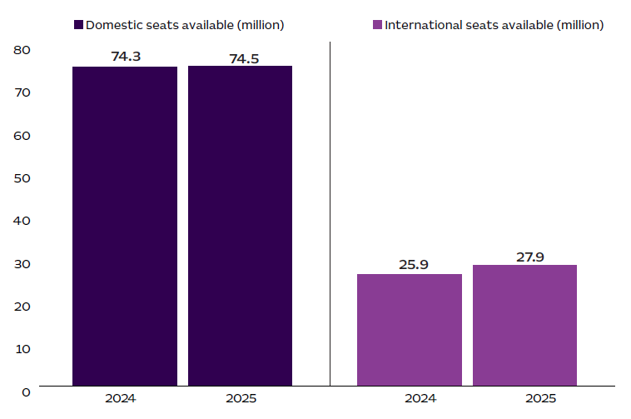
Figure 21: Domestic and international flight seat capacity in 2024 and 2025
More flights than ever before have flown into Australia in 2025 with airlines opening new routes and flying more frequently, allowing for increased capacity in international travel
The top 10 markets with the highest increase in number of inbound flights from 2024 to 2025 were:
- New Zealand
- United Arab Emirates
- Hong Kong
- Singapore
- Malaysia
- Indonesia
- Qatar
- Thailand
- China
- Philippines
Figure 22: Total flights into Australia 2005–2025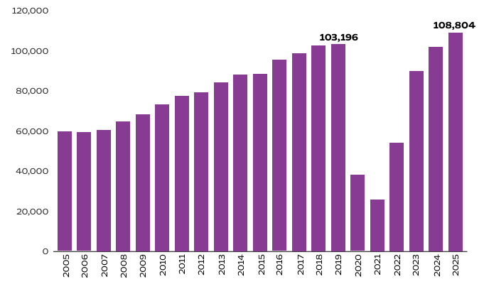
Seat capacity into Australia increased 7% from 2024 to 2025. This overall growth aligned with Australia’s largest market, Southeast Asia, which was particularly driven by growth in capacity from the Philippines and Thailand, both increasing 19%, and Malaysia that increased 12%.
Increased seat capacity was seen in more developing markets for Australian international tourism of South America and Africa. More established markets show modest, sustainable growth such as the Middle East, Europe and Northeast Asia.
Slight reductions in capacity for North America and South Asia, particularly India, as airlines reduced capacity during low season, redistributing resources.
Change in seat capacity into Australia from 2024 to 2025 by region:
- South America – 61%
- Africa – 42%
- Middle East – 19%
- Europe – 16%
- Northeast Asia – 8%
- Southeast Asia – 7%
- Islands – 7%
- New Zealand – 5%
- North America – -3%
- South Asia – -12%

Businesses and jobs
Tourism-related businesses accounted for 1 in 8 Australian businesses in 2025. The number of tourism-related businesses in Australia continued to trend higher in 2025.
Across the states and territories, the strongest growth in tourism-related businesses were in WA, ACT, NT and Qld. These jurisdictions saw growth in the ‘cafes, restaurants and takeaway food services’, ‘cultural services’, and ‘other sports and recreation services’ industries.
In contrast, Tas and Vic recorded declines in the number of tourism-related businesses, led by the ‘accommodation’, ‘casinos and other gambling services’, ‘passenger transport’, ‘taxi transport’, and ‘other retail trade’ industries.
The survival rate of tourism-related businesses from 2020 to 2025 was 56%, lower than for all Australian businesses (63%) over the same period. The survival rate of tourism-related businesses was highest for larger businesses and lowest for smaller businesses.
Figure 23: Tourism businesses in Australia in 2025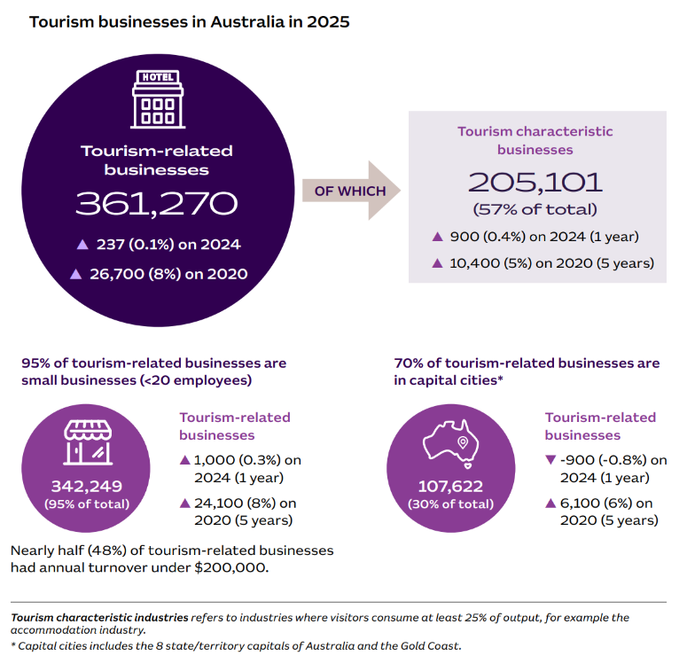
CASE STUDY:
Quality First Peoples Tourism Business Program; Investment in First Peoples tourism
The $2.5 million Quality First Peoples Tourism Business Program will expand First Peoples cultural tourism in Victoria, showcase the state’s competitive edge and deliver meaningful, connected experiences for travellers seeking authentic cultural experiences.
The program is funded by the Victorian Government and will be delivered in partnership with the Victoria Tourism Industry Council and the Kinaway Chamber of Commerce who have co-designed workshops, mentoring and market-readiness support for existing and emerging First Peoples tourism businesses.
The initiative was established through community consultation, which called for a platform for First Peoples communities to develop tourism products and experiences while offering visitors a chance to learn about traditional knowledge, culture and truth telling.
The program reflects priorities in the Experience Victoria 2033 strategic plan, which identifies First Peoples-led experiences as a key pillar that the government will invest in to shape the future of the state’s visitor economy, and builds on the First Peoples Tourism Plan for Victoria 2025–2030, which aims to empower and strengthen cultural pride, while fostering sustainable, authentic tourism experiences.
It is also an important step towards First Peoples self-determination and progress towards Treaty and backs in the Victorian Government’s Yuma Yirramboi (Invest in Tomorrow) Aboriginal economic development strategy.
Case study provided by Department of Jobs, Skills, Industry and Regions (Victoria)
Costs of doing business continues to rise
The operating environment for tourism businesses remains challenging with the costs of doing business continuing to trend higher. Higher logistics, and energy and insurance costs are often cited as contributing factors. These may impact tourism experience operators and those involved with transportation even more than the industries reported here.
As measured by the ABS’s producer price index, the cost of providing accommodation accelerated in 2025 compared with 2024, as did the cost of providing café, restaurant, and takeaway food services. In contrast, the nationwide average growth rate eased in 2025.
Growth in producer prices likely contributed to the ongoing strong increases in the consumer price index for domestic holidays. This is in stark contrast to the price of overseas holidays which declined over much of 2025, which may partly be explained by lower international airfares and exchange rate differentials.
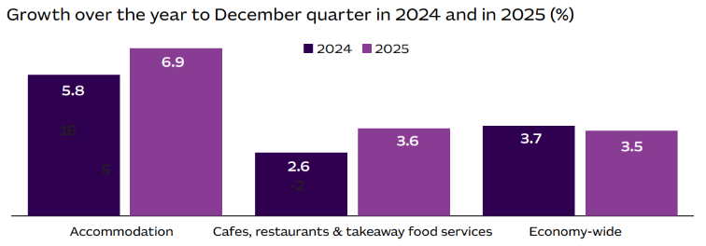
Figure 24: Producer price index growth – visitor economy sectors compared with the total Australian economy

Figure 25: Consumer price index growth – domestic and international holiday and accommodation prices
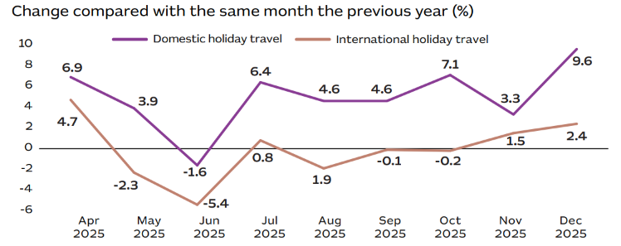

Tourism filled jobs reached a record high in December 2025
At the end of 2025, there were 736,800 jobs in the tourism sector: 33,100 (4.7%) higher than a year ago. It was also a record high number of jobs in the tourism sector. Jobs growth in the visitor economy over the year was significantly faster than in the broader economy overall, where the number of filled jobs increased by just 1.3% over the same period.
The increase in tourism filled jobs in 2025 was led by the accommodation industry, along with growth in many other industries including the ‘cultural services’, ‘sports & recreation services’, and ‘air, water & other passenger transport’ industries.
On the other hand, there were fewer jobs in the ‘travel agency & information centre services’ and ‘casinos & other gambling services’ industries in 2025. These are 2 of the industries where the number of tourism filled jobs remained lower than in 2019, suggesting ongoing challenges from issues such as economic conditions, workforce and skills shortages, and changing customer preferences.
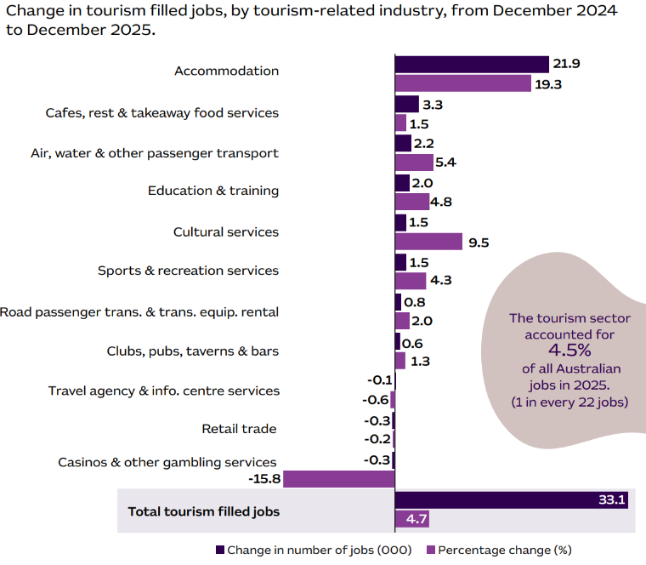
Figure 26: Tourism filled jobs
Despite easing, significant skill shortages remain. Online job vacancies for tourism-related roles soared in the post-pandemic years. However, in aggregate, the internet vacancies index for tourism-related roles declined in 2024 and again in 2025.
Online job vacancies for tourism related roles dropped by 7% in 2025, which was a smaller decline than vacancies for all jobs(economy-wide) which dropped by 11% on average. They also remained more elevated relative to 2019 – 48% higher in 2025 for tourism related roles compared to 21% higher in 2025 for all jobs (economy-wide) relative to 2019.
Across tourism related sectors, online job vacancies remained highest in 2025 for café workers, cooks and kitchenhands. On the other hand, online vacancies were well below their 2019 level in 2025 for travel and tourism advisers and travel attendants and other tourism managers.
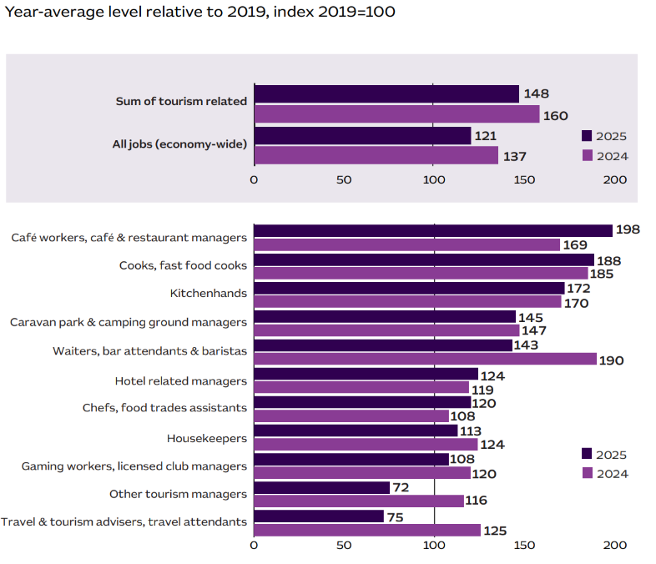
The Occupational Shortage List continued to show several tourism roles in shortage across the country including tour guides, charter and tour bus drivers, travel consultants and cooks. It also listed nationwide regional shortages for chefs, pastrycooks, and flight attendants.
Figure 27: Online job vacancies advertised for tourism-related occupations

Support for the visitor economy workforce
In line with priorities of the THRIVE 2030 national visitor economy strategy and in response to ongoing skills shortages across the visitor economy, policy support in various forms continued throughout 2025. These included:
- Tourism and hospitality courses continued to be part of the Fee-Free TAFE program in 2025. Running since 2023, there have been 27,815 enrolments in, and 11,305 completions of, tourism and hospitality Fee-Free TAFE courses, as at the end of December 2025.
- Targeted apprenticeship incentive support payments for the occupations of Chef, Cook, Tour Guide and Travel Agent. As of June 2025, there had been 4,225 commencements in, and 2,460 completions of, tourism and hospitality apprenticeship courses
- 18 visitor economy-related occupations were on the Core Skills Occupation List and eligible for skilled migration. In FY2024–25, there was strong growth in the number of temporary skilled visas granted for visitor economy occupations such as Chef and Cook.
The new visitor economy jobs platform, ‘eeger’, was launched in July 2025. eeger functions as a central hub for industry, career and training information. It connects job seekers with employers; provides education, training and career pathway information; and offers businesses insights and resources to help them advertise jobs and find employees.
CASE STUDY:
Future Leaders Program (Tourism & Hospitality); Educating and empowering the next generation of tourism leaders
The Western Australian Government’s Future Leaders Program is a targeted state-based response to workforce capability gaps in tourism and hospitality, informed directly by industry insights. Delivered by Tourism Western Australia in partnership with Edith Cowan University (ECU) Executive Education, and fully subsidised by the State, the program supports emerging and frontline employees to progress into essential senior and middle management roles.
Since 2024, the Western Australian Government has invested $200,000 through its Tourism Workforce Development Program, supporting 62 participants across 4 cohorts, including 24 participants from regional WA. The investment responds to challenges in attracting and retaining skilled workers, particularly in management roles essential to business performance and service standards.
The intensive Leadership Masterclass builds practical management capability in areas of demonstrated demand, and delivers a clear education pathway, via ECU’s Graduate Certificate of Business or Master of Business Administration, strengthening longer term career progression. Feedback from participants and industry partners indicates the program is effective in upskilling identified talent, while also providing valuable opportunities to network, share experiences and build peer connections across regions and subsectors.
The Future Leaders Program aligns with Western Australia’s WAVES 2033 tourism strategy and broader economic diversification objectives by strengthening management capability, supporting workforce retention, and building a sustainable leadership pipeline for the visitor economy.
Case study provided by Tourism Western Australia

Investment
Table 6: Investment in the tourism sector increased across most sectors in 2025
Aviation | Arts, recreation, and business services | Accommodation | Mixed use developments
$29.0 billion  (Up $5.9 billion) | $34.2 billion  (Up $5.4 billion) | $11.3 billion  (Down $0.2 billion) | $83.6 billion  (Down $1.6 billion)
24 projects  (Up 2 projects) | 184 projects  (Up 24 projects) | 155 projects  (Down 9 projects)  21,300 rooms  (Down 2,400 rooms) | 184 projects  (Down 7 projects)  33,000 rooms  (Up 2,800 rooms)
Continued expansion of the tourism investment pipeline shows positive sentiment. The number of large projects and investment in tourism continues to increase each year, as measured by TRA’s tourism investment pipeline of announced major tourism projects worth over $20 million.
There were 363 projects in the tourism investment pipeline in 2025, up 17 projects on 2024, and project value reached $74.5 billion, up $11.1 billion compared with 2024. In addition to enhancing the tourism offerings, increased investment indicates optimism about the future of tourism in Australia.
All states and territories saw growth in the value of major tourism investment projects except for the NT. Victoria and Queensland saw the strongest growth, with sporting and accommodation investment ahead of the 2032 Brisbane Olympic and Paralympic Games adding to investment activity in Queensland.
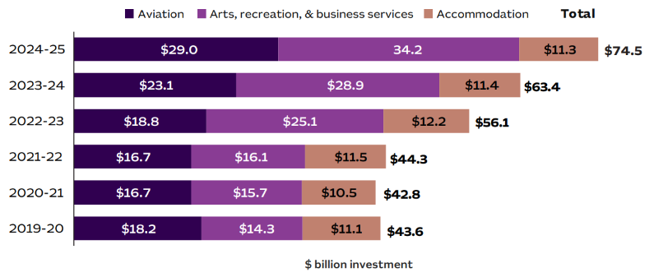
Figure 28: Value of the tourism investment pipeline in Australia by sector, 2019–20 to 2024–25, $ billions

Figure 29: Value of the tourism investment pipeline by state/territory, 2023–24 and 2024–25, $ billions
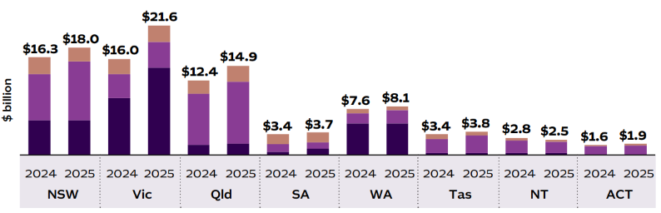
CASE STUDY:
All seasons houseboats; Investing in accessibility
The Victorian Government is investing in tourism infrastructure with a focus on accessibility and inclusion, making it easier for all visitors to explore and enjoy Victoria. This investment supports innovative
experiences, encourages longer stays, and strengthens a visitor economy that delivers opportunities for people of all abilities, cultures, and backgrounds. Accessibility is embedded as a core principle alongside sustainability and quality experiences in Experience Victoria 2033, guiding the development of a more inclusive, resilient, and growing visitor economy over the next decade.
All Seasons Houseboats, a family-owned and operated business with more than 20 years on the Murray River, received $500,000 through the Regional Tourism Investment Fund to deliver Australia’s first fully supported accessible luxury houseboat.
The funding supported the design and construction of Elevate Luxury, a six-bedroom vessel purpose-built to combine high-end comfort with full accessibility. Features include wheelchair access throughout, wider corridors, an accessible ensuite, adjustable-height kitchen benches, safety railings, and premium amenities such as a spa and expansive living areas.
To meet growing demand for inclusive travel, All Seasons Houseboats integrated a wheelchair-accessible elevator, making Elevate Luxury the first houseboat in the Southern Hemisphere with this feature.
The project has received industry recognition, winning Gold in the Unique Accommodation category at the 2025 Victorian Tourism Awards and Silver at the 2025 Australian Tourism Awards.
Case study provided by Department of Jobs, Skills, Industry and Regions (Victoria)

Visitor economy outlook
The outlook for Australia’s visitor economy had been relatively positive and stable leading into 2026, supported by the local and global love of travel. However, the Middle East conflict that began in February 2026 has had a significant impact on flights through the Middle East, the outlook for jet fuel prices, and local diesel and petrol prices, which may weigh on the aviation and travel sector.
It is too early to confirm the full impact this event will have, yet travel will continue to play an important role in connecting people, supporting business, encouraging investment, strengthening family bonds, and improving mental health and wellbeing. The high and rising popularity of sporting, music and cultural events as incentive to travel are also likely to support travel decisions going forward. Nevertheless, geopolitical, economic and affordability considerations are likely to be greater barriers to travel in 2026.
In this environment, Australia’s enduring reputation as a safe, clean, friendly, and aspirational travel destination is incredibly important. Effective promotional work to grow markets and attract visitors to Australia remains in place and Australia maintains a positive reputation as a destination that attracts business, employment, and education arrivals as well as leisure travellers.
CASE STUDY:
Sustainable tourism initiatives; Green is Australia’s Gold – shaping higher value tourism demand
In 2025–26, Tourism Australia launched Green is Our Gold, a national initiative to align the tourism sector around a shared approach to sustainable travel and visitor behaviour.
The initiative was rolled out across all states and territories, spanning both leisure and business events. It introduced a Green and Gold Promise, supported by five practical principles to guide how visitors can engage with, and care for Australia’s communities, cultures, environments and wildlife. Complimented by a practical toolkit with key resources such as the Sustainable Tourism Toolkit to inspire sustained action across the sector, the rollout was supported by industry communications across digital platforms, trade engagement and Tourism Australia’s owned and earned channels, ensuring consistent messaging across the sector.
This approach moves beyond traditional destination promotion to influence the quality of demand. By setting clear expectations for visitor behaviour and experience, it supports higher value travel, encourages deeper engagement with destinations and contributes to greater dispersal of visitor spend, particularly into regional and Indigenous communities. The principles also help to protect the natural and cultural assets that underpin Australia’s tourism offering.
Green is Our Gold aligns with shifts in global travel demand, where sustainability, authenticity and community connection are increasingly influencing destination choice. By aligning industry delivery with visitor expectations, the initiative aims to strengthen Australia’s positioning as a credible and differentiated destination in a competitive global market.
As adoption of the principles builds across industry, the initiative is expected to support more resilient demand, improved seasonality and stronger long-term outcomes for the visitor economy.
Case study provided by Tourism Australia

International outlook
TRA’s forecasts point to a positive outlook for international arrivals and ongoing growth in international visitor spend in Australia.
The forecast report also outlined optimistic and pessimistic scenarios given the high level of interest in the role of various influencing factors, and the high level of uncertainty inherent in any forecasting exercise. These scenarios were not designed to capture potential growth paths in the case of extreme events, such as the impact of another global pandemic or other crisis. However, the pessimistic scenario did assume an ongoing risk of global conflicts, including conflicts that lead to occasional impacts on travel routes, which weigh on travel sentiment.
Under this scenario, TRA assumed that Australia continues to reap the benefit of its reputation as a safe and friendly destination. Nevertheless, international arrivals growth, particularly from long-haul destinations, is projected to be more muted than in the central case and growth in international spend is slower.
Growth in international spend in Australia is forecast to average 4% over the next 5 years. International arrivals are forecast to increase to around 11 million in 2030, up from 8.9 million in 2025 – that’s a 22% increase over 5 years.
Drivers of growth
- Global travel intentions have held up, and Australia remains an aspirational, safe and low-risk destination for global travellers.
- Australia’s strong forward portfolio of major international events – including many major sporting events in the lead up to the 2032 Brisbane Olympics, such as the 2027 Men’s Rugby World Cup, 2027 Netball World Cup, 2029 Women’s Rugby World Cup as well as significant annual sporting events across rugby league, rugby, motorsports, tennis and horseracing.
- Positive demographics with strong population growth and rising incomes in several important source markets for Australia.
- The opening of Australia’s new international airport in Western Sydney in late 2026.
Risks to the outlook
- Geopolitical concerns and the risk of conflict have increased and have generated broad economic impacts across the world that may impact the cost and ability to travel going forward. The extent to which this unfolds is still developing and may be greater than had been considered in TRA’s pessimistic forecast scenario.
- The risk of higher airfares and increased uncertainty may have a larger impact on longer haul destinations such as Australia, where the airfare component is significant and bookings are often made well in advance of travel dates.

Domestic outlook
Australians have demonstrated an enduring willingness to prioritise their travel needs. However, persistent household budget pressures have seen Australians choosing to travel closer to home, opting for shorter trips and day trips to manage costs while still enjoying travel. This pattern is expected to persist into 2026, with decisions about when, where, and how to travel shaped by ongoing cost-of-living pressures and the appeal of affordable domestic and international travel options.
As economic conditions gradually improve, we anticipate a modest increase in growth in overnight trips, while day trips remain a popular and cost-effective choice for many households. As travellers seek value-for-money they are potentially aiming to benefit more from every trip – seeking combinations of personal fulfilment, connections to community, adventure, wellness, and quality food experiences.
Growth in overnight and day trip spend is forecast to outpace expected inflation over the next 5 years. Domestic overnight trip spend is forecast to increase to $130 billion in 2030, and domestic day trip spend is forecast to increase to $57 billion in 2030.
Drivers of growth
- Consumer travel intentions have held up, demonstrating an enduring and compelling need and desire for Australians to travel to connect, explore, unwind and recharge.
- There may be greater affinity for domestic travel during times of greater global uncertainty.
- Australia’s strong forward portfolio of events – sporting, musical, and cultural events are key drivers of travel intentions.
Risks to the outlook
- Higher domestic airfares, either because of higher costs such as jet fuel or reduced airline competition, could weigh on travel demand to destinations relatively more reliant on air travel.
- Changes in the outlook for household budgets and the pass through of higher costs to domestic travel components may affect demand for domestic travel. This may have a larger impact on those sectors with high reliance on fuel such as caravanning holidays.
- Increasingly large, uncontrolled, unpredictable and/or damaging weather events could dampen demand for travel to more destinations throughout the year.

Sources
For more information, please visit the below sources.
- https://www.tra.gov.au/
- https://www.tra.gov.au/en/economic-analysis/tourism-investment-monitor
- https://www.tra.gov.au/en/economic-analysis/tourism-forecasts
- https://www.tra.gov.au/en/economic-analysis/tourism-businesses
- https://www.tra.gov.au/en/economic-analysis/quarterly-tourism-labour-force-statistics
- https://www.abs.gov.au/
- https://www.bitre.gov.au/
- https://www.jobsandskills.gov.au/data/internet-vacancy-index#downloads
- https://www.iata.org
- https://www.unwto.org/tourism-data/un-tourism-tracker

