NATIONAL VISITOR SURVEY RESULTS

DECEMBER QUARTER 2023

December quarter 2023

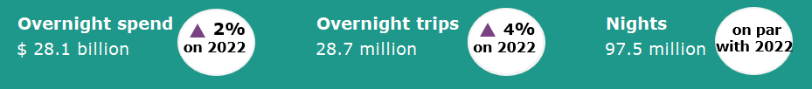

Year ending December 2023
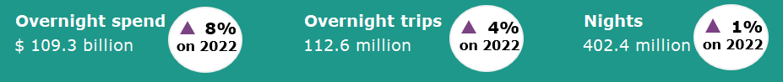

Moderate growth in domestic tourism continued
Domestic tourism growth continued to moderate in the December quarter 2023 following strong results in 2022. In December quarter 2023 spend was up 2%, trips were up 4% while nights away were flat when compared with the December quarter 2022. The strength in intrastate travel was mostly offset by softer interstate travel.
The results suggest that cost-of-living pressures are continuing to encourage travel closer to home and for shorter lengths of time.
The year ending December 2023 saw a similar pattern of results with spend up 8%, trips up 4% and nights up 1% when compared with the previous year.
Figure 1. Percent change for spend, trips and nights compared the same period in the previous year, March quarter 2023 to December quarter 2023
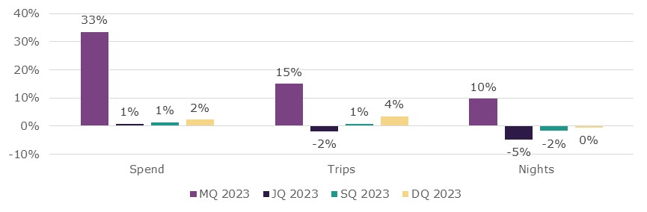

Intrastate travel drove stronger quarterly results  Intrastate travel drove the positive results in the December quarter 2023 when compared with the December quarter 2022.  Intrastate trips were up 4%, nights away were up 3% and spend was up 11%, while spend and nights away for interstate travel fell as visitors opted for shorter and less expensive travel closer to home.  Historically the average interstate trip has been 2.5 times the cost of an intrastate trip. Interstate travel spend was softer down 4%, nights were down 5%, however trips were up 2%.  Figure 2: Change in inter/intrastate spend, trips and nights, DQ23 compared to DQ22  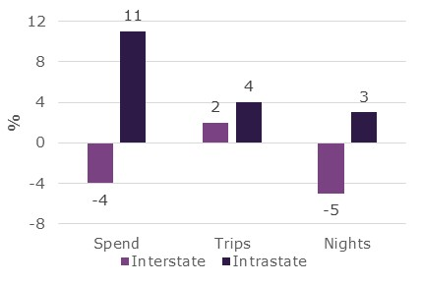 | Business travel supports growth in 2023  Figure 3: Change in trips by main purpose, by quarter in 2023, compared the same quarter in 2022  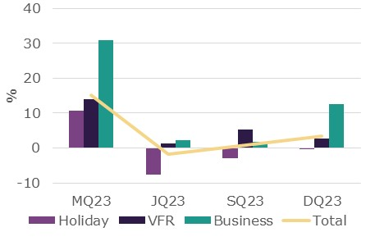  In the December quarter 2023 business travel continued to improve when compared with the same period in 2022, following an initially slower recovery from COVID-19.  When compared with the December quarter 2022, travel for:  - business purposes was up 13% or 744,000 trips  - visiting friends and relatives was up 3% or 265,000 trips  - holiday purposes was slightly softer, down by less than 1% or 45,000 trips.
Travellers are opting for shorter trips
Australians were taking shorter trips in 2023 compared with 2022 (Figure 4). In the year ending December 2023:
- 1 to 2 nights trips increased by 3.7 million, or 6%
- 3 to 4 nights trips increased by 1.5 million, or 6%
- 5 to 7 nights trips fell by 298,000, or 2%
- Trips lasting 8 nights or more fell by 551,000, or 6%.
Figure 4: Change in length of stay, year ending December 2023 compared with 2022
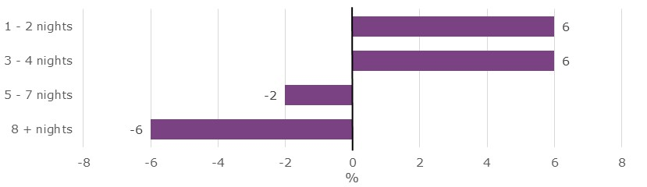

States and territories
Results for overnight trips and spend in the December quarter were mixed when compared with the December quarter 2022 (Figure 5).
New South Wales, Victoria, Tasmania and the Australian Capital Territory recorded increases in both overnight trips and spend, while Queensland and South Australia saw decreases. Results for Western Australia were mixed; spend was up 14% while the number of trips fell by 2%.
New South Wales saw the largest increase in trips (up 608,000 or 7%) followed by Victoria (up 489,000 or 7%). The largest decrease was in Queensland (down 222,000 or 3%).
New South Wales saw the largest increase in spend (up $744 million or 10%) followed by Western Australia (up $420 million or 14%). The largest decrease was in Queensland, down $795 million or 11%.
Figure 5. Overnight trips and spend by state and territory, December quarter 2023 compared to December quarter 2022
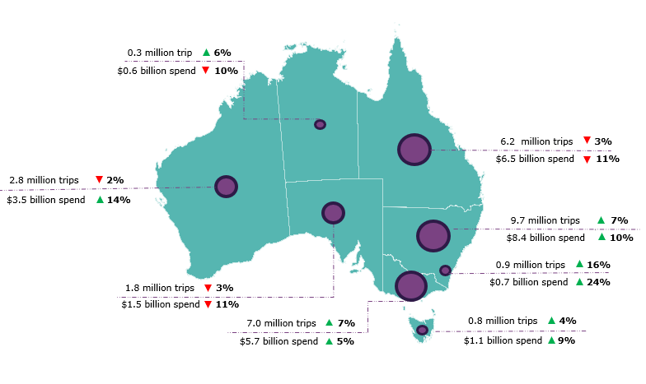
Year ending December 2023
In the year ending December 2023, Australians took 112.6 million trips for 402.4 million nights away and spent $109.3 billion. Compared with the year ending December 2022 this was:
- up 4.4 million or 4% for overnight trips
- up 2.7 million or 1% for nights away
- up $8.1 billion or 8% for spend.

This report has been prepared by the Commonwealth of Australia represented by the Australian Trade and Investment Commission (Austrade). The report is a general overview and is not intended to provide exhaustive coverage of the topic. The information is made available on the understanding that the Commonwealth of Australia is not providing professional advice. While care has been taken to ensure the information in this report is accurate, the Commonwealth does not accept any liability for any loss arising from reliance on the information, or from any error or omission, in the report.

